PRESS RELEASE

Würth Elektronik has connectors independently tested for fire resistance
Glow Wire Tests for Safety Testing Household Appliances
Waldenburg (Germany), April 16, 2024 – Würth Elektronik has a series of connectors checked by Groupe SGS France. The plastic insulation materials of electromechanical components are subjected to glow wire tests to determine their fire resistance. The test facilitates IEC 60335-1 certification for customers using these connectors in electrical appliances for domestic use.
Manufacturers of consumer products must ensure that their devices do not contribute to spreading fire. The requirement from the standard: The product shall withstand a glow wire heated to 850°C and shall not produce a flame that lasts longer than two seconds when exposed to a 750°C glow wire. The tests are GWIT (Glow Wire Ignition Temperature – IEC 60695-2-13) to determine the ignition temperature using a test plate, GWFI (Glow Wire Flammability Index – IEC 60695-2-12) to determine the flame behavior on the test specimen and GWT (Glow Wire Temperature – IEC 60695-2-11) to determine the ignition temperature on the finished part.
The following Würth Elektronik components are subjected to these procedures: THT mountable connectors with 5.08 and 7.62 mm pitch (WR-FAST), screwless terminal blocks (WR-TBL3), and the wire-to-board connector series WR-MPC3, WR-MPC4 and WR-MPC5.

Available images
The following images can be downloaded from the Internet in printable quality: https://kk.htcm.de/press-releases/wuerth/

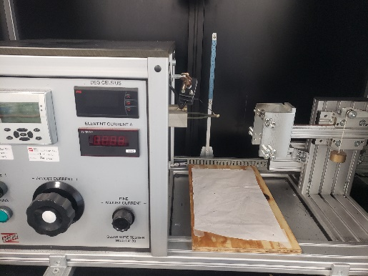Image source: Würth Elektronik
Würth Elektronik also has its own glow-wire testing machine in its lab in Lyon, but now has its products certified by the SGS accredited lab.

About the Würth Elektronik eiSos Group
Würth Elektronik eiSos Group is a manufacturer of electronic and electromechanical components for the electronics industry and a technology company that spearheads pioneering electronic solutions. Würth Elektronik eiSos is one of the largest European manufacturers of passive components and is active in 50 countries. Production sites in Europe, Asia and North America supply a growing number of customers worldwide.
The product range includes EMC components, inductors, transformers, RF components, varistors, capacitors, resistors, quartz crystals, oscillators, power modules, Wireless Power Transfer, LEDs, sensors, radio modules, connectors, power supply elements, switches, push-buttons, connection technology, fuse holders and solutions for wireless data transmission. The portfolio is complemented by customized solutions.
The unrivaled service orientation of the company is characterized by the availability of all catalog components from stock without minimum order quantity, free samples and extensive support through technical sales staff and selection tools.
Würth Elektronik is part of the Würth Group, the global market leader in the development, production, and sale of fastening and assembly materials, and employs 7,900 people. In 2023, the Würth Elektronik Group generated sales of 1.24 Billion Euro.
Würth Elektronik: more than you expect!
Further information at www.we-online.com

Further information:  Würth Elektronik eiSos GmbH & Co. KG  Sarah Hurst  Clarita-Bernhard-Strasse 9  81249 Munich  Germany  Phone: +49 7942 945-5186  E-mail: sarah.hurst@we-online.de  www.we-online.com | Press contact:  HighTech communications GmbH  Brigitte Basilio  Brunhamstrasse 21  81249 Munich  Germany  Phone: +49 89 500778-20  E-mail: b.basilio@htcm.de  www.htcm.de

