PRESS RELEASE

Award from the technical magazine Chip
Würth Elektronik Group is Digital Innovator 2023
Waldenburg (Germany), May 12, 2023 - The renowned trade magazine, Chip, has awarded a prize to Germany's most innovative companies in 2023 on the basis of submitted patents and innovations on company websites. This year, for the first time, the prestigious prize went to the Würth Elektronik Group.
With its independent tests, the computer and technology magazine is an important medium for consumers and decision-makers. Together with its partner Globis, the Chip researches companies and institutions that advance the German economy with their innovations.
The study examined worldwide patent registrations in various sectors between 2020 and 2021, which included 17,400 initial patent registrations for comparison. Their quality is assessed via the so-called non-family forward citations; meaning the more often a patent is mentioned in the applications of other patents, the higher the innovation score. The companies' websites were also analyzed, where bonus points were awarded for the focus on innovations and their presentation.
In the Chip and Globis ranking, the Würth Elektronik Group is clearly ahead; awarded as the Digital Innovator 2023. The honor emphasises the innovative strength of the Würth Elektronik Group in the electronics market, and is further incentive for continuous further development.

Available images
The following images can be downloaded from the Internet in printable quality: https://kk.htcm.de/press-releases/wuerth/

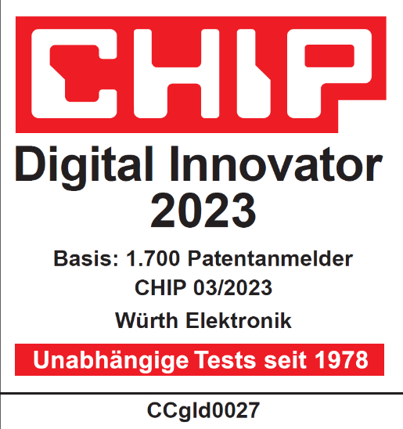
Image source: Chip
Award-winning innovation: The Würth Elektronik Group was named Digital Innovator 2023 by the editors of the independent trade magazine Chip.

About the Würth Elektronik group of companies
The Würth Elektronik group of companies, founded in Niedernhall, Baden-Wuerttemberg, Germany, has about 8,200 employees worldwide and generated global sales of 1.33 Billion Euro in 2022.
With over 23 production locations worldwide, Würth Elektronik is one of the most successful companies of the Würth Group.
Würth Elektronik operates internationally with its three company areas in various markets:
- Electronic & electromechanical components (Headquarters: Waldenburg)
Würth Elektronik eiSos (electronic and electromechanical components) is one of Europe's biggest manufacturers of electronic & electromechanical components. More than 700 sales representatives worldwide make up a direct sales network that is unique for the electronics market. The customer is offered excellent design-in support on-site from the manufacturer. The production plants in Germany, Czech Republic, Bulgaria, USA, Mexico, Taiwan and China guarantee high availability on all markets. All catalog products are available from stock and samples are free of charge.

- PCBs (Headquarters: Niedernhall)
Founded in 1971, Würth Elektronik Circuit Board Technology is today Europe's leading PCB manufacturer and, thanks to the comprehensive portfolio, a reliable partner for both individual entrepreneurs and large corporations. Whether basic or high-end technologies, customer-specific requirements are met from the initial idea for a design to the production of prototypes on the online shop and finally, manufacturing of medium and large volumes in Germany or Asia.
- Intelligent Power & Control Systems (Headquarters: Niedernhall-Waldzimmern)
As a specialist for the development and production of electronic and electromechanical system solutions, such as central electronics, Würth Elektronik ICS (Intelligent Power & Control Systems) is a longtime partner for many commercial vehicles. Professional project management accompanies business partners from the product idea through to series maturity.

Further info at www.we-online.com

More information:  Würth Elektronik eiSos GmbH & Co. KG  Sarah Hurst  Max-Eyth-Strasse 1  74638 Waldenburg  Germany  Phone: +49 7942 945-5186  E-mail: sarah.hurst@we-online.de  www.we-online.com | Press contact:  HighTech communications GmbH  Brigitte Basilio  Brunhamstrasse 21  81249 Munich  Germany  Phone: +49 89 500778-20  Telefax: +49 89 500778-77  E-mail: b.basilio@htcm.de  www.htcm.de

