PRESS RELEASE

Start-up support: Würth Elektronik presents modern laboratory equipment for Turkish ideas at Teknopark Istanbul
Ideas become innovations
Waldenburg (Germany), May 8, 2023 – Since October 2022, Würth Elektronik eiSos has been cooperating in Turkey with the non-profit organization, Cube Incubation, in Istanbul's Teknopark, where it is helping to equip an electronics laboratory for the incubation center. On May 5 customers, business partners, and members of the press were able to see for themselves on site what the new laboratory can do, and how Würth Elektronik is making innovations possible in Istanbul.
As one of the leading manufacturers of electronic and electromechanical components, Würth Elektronik eiSos is an international partner for developers and innovative start-ups. This includes turning ideas into reality in Turkey, says Alexander Gerfer, CTO Würth Elektronik eiSos. "There is a very agile start-up scene in Istanbul, which finds the best conditions here in the incubation center. We are pleased to be able to make our contribution to this."
"If you want to promote the best, you've come to the right place," confirms Ahmet Çakır, Managing Director of Würth Elektronik eiSos in Turkey. "With our modern laboratory equipment, ideas become innovations."
Würth Elektronik equips the laboratory with a wide range of special devices and instruments for testing and developing electronic components, circuits, and systems. These include Würth Elektronik design kits, soldering stations, and microscopes for prototype development. Along with the equipment support, Würth Elektronik also provides technical training and mentoring support at certain periods.
After the tour under the expert guidance of Mr. Gerfer and Mr. Çakır, everyone agreed that: the new electronics lab creates excellent working conditions.
Teknopark Istanbul and Incubation Center
Teknopark Istanbul was founded in May 2010. Today brings together around 300 national and international companies that conduct research and development in the field of high technology, including aviation and shipping, electronics, energy, or health. Teknopark still continues to grow. When the final stage is completed, approximately 30,000 R&D engineers will work there and it will be Europe's 3rd largest Technopark.
In the "Incubation Center for DeepTech Entrepreneurs" of Cube Incubation, more than 450 entrepreneurs and 14 universities have been supported in the development of new technologies and products to date. A wide range of consulting services and infrastructures are available to the founders free of charge or at particularly favorable prices during the first 18 months. Innovations related to automatic inventory, fraud prevention or coworking space management have recently been supported.

Available images
The following images can be downloaded from the Internet in printable quality: https://kk.htcm.de/press-releases/wuerth/
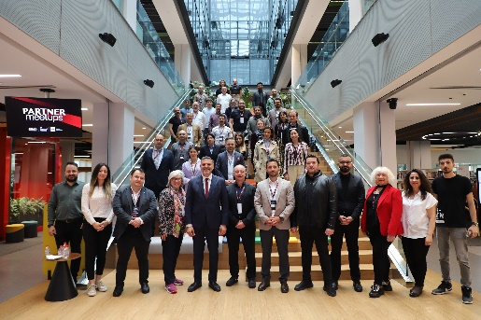
Great public interest during the visitor tour of Teknopark: The guests, a delegation from business and science of the Future Network DLD as well as customers and start-ups, were curious to see which promising ideas are being realized here.
Image source: Würth Elektronik

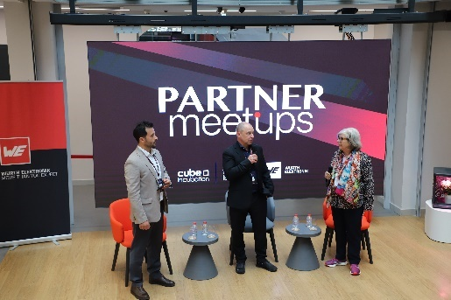  Image source: Würth Elektronik  Alexander Gerfer, CTO Würth Elektronik eiSos (centre) on the podium: "There is a very agile start-up scene in Istanbul, which finds the best conditions here in the incubation center. We are pleased to be able to make our contribution to this."  With in the picture: Ahmet Çakır, General Manager Würth Elektronik eiSos in Turkey (left), Steffi Czerny Co-Founder & Managing Director, DLD Conference (right) | 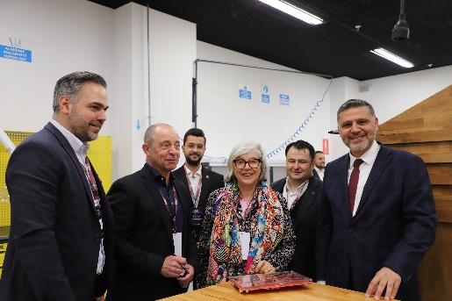Image source: Würth Elektronik  During the visitor tour (in the foreground, from left):  Harun Özgür, Division Manager Optoelectronics at Würth Elektronik eiSos, Alexander Gerfer, CTO at Würth Elektronik eiSos, Steffi Czerny Co-Founder & Managing Director, DLD Conference, Ahmet Kerim Nalbant General Manager of Cube Incubation, Bilal Topçu, General Manager of Teknopark Istanbul

About the Würth Elektronik eiSos Group
Würth Elektronik eiSos Group is a manufacturer of electronic and electromechanical components for the electronics industry and a technology company that spearheads pioneering electronic solutions. Würth Elektronik eiSos is one of the largest European manufacturers of passive components and is active in 50 countries. Production sites in Europe, Asia and North America supply a growing number of customers worldwide.
The product range includes EMC components, inductors, transformers, RF components, varistors, capacitors, resistors, quartz crystals, oscillators, power modules, Wireless Power Transfer, LEDs, sensors, connectors, power supply elements, switches, push-buttons, connection technology, fuse holders and solutions for wireless data transmission.
The unrivaled service orientation of the company is characterized by the availability of all catalog components from stock without minimum order quantity, free samples and extensive support through technical sales staff and selection tools.
Würth Elektronik is part of the Würth Group, the global market leader in the development, production, and sale of fastening and assembly materials, and employs 8,200 people. In 2022, the Würth Elektronik Group generated sales of 1.33 Billion Euro.
Würth Elektronik: more than you expect!
Further information at www.we-online.com

Further information:  Würth Elektronik eiSos GmbH & Co. KG  Sarah Hurst  Max-Eyth-Strasse 1  74638 Waldenburg  Germany  Phone: +49 7942 945-5186  E-mail: sarah.hurst@we-online.de  www.we-online.com | Würth Elektronik Ithalat Ihracat ve Ticaret Ltd. Sti.  Merze Yegen  Şerifali Mh, Barbaros Cad. No:63  34775 Ümraniye/Istanbul  Turkey  Phone: +90 532 057 1466  E-mail: merze.yegen@we-online.com  www.we-online.com

