Würth Elektronik advances Europe’s technological sovereignty

Würth Elektronik participates in EU initiative PROACTIF for cutting-edge drone and robotics solutions

Niedernhall, Germany – October 10, 2025 – Würth Elektronik is a partner in the visionary EU project **PROACTIF**, funded under the **Chips Joint Undertaking (Chips JU)**. The international consortium of 42 partners from 13 countries aims to strengthen Europe’s technological sovereignty in electronic components and systems, with a particular focus on drones and robotics for civilian applications.

At the core of the project is the development of state-of-the-art, secure, and environmentally friendly unmanned vehicle systems (**UxV**) designed to protect critical infrastructure and create new opportunities for emergency response operations. Key priorities include interoperability, autonomy, and rapid deployability.

Würth Elektronik contributes its expertise in **printed circuit board (PCB) technology** and collaborates with project partners to develop intelligent drone systems for rescue and disaster scenarios. Equipped with advanced sensors and radar technologies, these autonomous aerial vehicles can detect temperature changes, hotspots, or people in danger in real time—even in inaccessible terrain. This generates precise situational awareness to support emergency responders in the rapid and targeted coordination of firefighting and rescue operations.

A central contribution from Würth Elektronik lies in the development of **miniaturized, high-frequency PCBs with integrated components**, capable of delivering peak performance under extreme conditions. Through innovative materials, flexible designs, and precise signal routing, these solutions set new benchmarks in reliability and efficiency.

Through PROACTIF, the deployment of intelligent, connected technologies contributes significantly to **civil security and disaster management across Europe.**

**About PROACTIF**PROACTIF is a visionary European research project focused on the development of unmanned vehicle systems for civilian applications. The three-year project commenced in June 2025, with a total budget of €41.8 million, including EU and Member State funding of €27.2 million.  
PROACTIF brings together 42 leading European technology companies from 13 countries to redefine emergency response and the protection of critical infrastructure. The project consortium is coordinated by the Fraunhofer Institute for Reliability and Microintegration (IZM), Berlin**.**

**Funding acknowledgment**  
Funded by the European Union’s Chips Joint Undertaking. Supported by the Federal Ministry of Research, Technology, and Space, Germany**.**

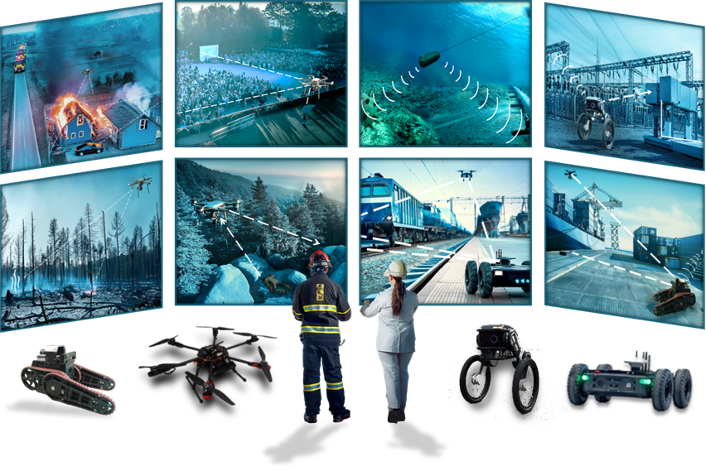

Image 1: Applications of unmanned vehicle systems (UxV) for the protection of critical infrastructure. (Source: PROACTIF)

*About Würth Elektronik Circuit Board Technology*

*Founded in 1971, Würth Elektronik Circuit Board Technology is today one of Europe's leading PCB manufacturers, serving 4,000 customers worldwide with both domestic and international sales teams, and generating annual revenues in the triple-digit million-euro range.*

*Production takes place at German sites as well as through qualified partners in Asia. From* *basic to high-end technologies, Würth Elektronik Circuit Board Technology meets customer-specific requirements from prototypes and samples to medium and large-scale production runs. With the development of innovative product technologies, the company positions itself as a market pioneer.*

*Experts from the most diverse divisions provide intensive consultation and support, from the initial idea to the finished product and beyond. Würth Elektronik Circuit Board Technology sees itself as a reliable partner for both individual entrepreneurs and large corporations. The comprehensive portfolio is rounded off by an* [*online shop*](https://www.wedirekt.com/en/)*, where PCBs can be ordered around the clock.*

*Würth Elektronik. More than you expect!*

*More information at*  [*https://www.we-online.com/pcb*](https://www.we-online.com/pcb)

*Social Media:*

[*https://www.we-online.com/youtube*](https://www.we-online.com/youtube)

[*https://www.linkedin.com/company/wuerth-elektronik-group*](https://www.linkedin.com/company/wuerth-elektronik-group)

[*https://www.instagram.com/we_group/*](https://www.instagram.com/we_group/)