Würth Elektronik Circuit Board Technology receives EcoVadis Platinum rating
Sustainability performance at the highest level: German PCB manufacturer ranks among the top 1% worldwide

Niedernhall, May 05, 2026 – Würth Elektronik GmbH & Co. KG Circuit Board Technology has been awarded the Platinum rating by EcoVadis. This places the company among the top 1% of all companies assessed worldwide - and currently makes it the only printed circuit board manufacturer globally to achieve this level.

The independent sustainability assessment by EcoVadis (www.ecovadis.com) is considered one of the leading international standards for evaluating sustainability performance in global supply chains. Companies are assessed based on 21 criteria across four themes: environment, labor and human rights, ethics, and sustainable procurement. The evaluation is based on internationally recognized frameworks such as the principles of the UN Global Compact, the Global Reporting Initiative (GRI) guidelines, the International Labour Organization (ILO) conventions, and the ISO 26000 standard.

Würth Elektronik achieved outstanding scores, particularly in the areas of environment (95 points) and labor and human rights (90 points). The company also delivered strong results in ethics (87 points) and sustainable procurement (84 points).

“Platinum is a real statement and shows how powerful sustainability becomes when strategy, focus, and passion come together. Our Sustainability Board sets the framework—our team brings it to life with ideas, drive, and a genuine spirit of innovation,” says Martina Beckert, Sustainability Manager at Würth Elektronik Circuit Board Technology.

Added value for customers and supply chains
For customers, the award represents a high level of transparency and security across the supply chain. The EcoVadis rating helps companies improve their ESG performance, reduce risks, and meet compliance requirements. At the same time, it demonstrates that environmental and social responsibility are consistently implemented at production sites.

Sustainability embedded in strategy
This success is based on a clearly defined, long-term sustainability strategy. Key focus areas include climate, circular material flows, and social standards. These are implemented through concrete measures such as energy efficiency programs, resource conservation, circular economy initiatives, and responsible supplier development. The approach is complemented by close collaboration with research institutes, partners, and other stakeholders. All measures are documented in the environmental program of the validated EMAS environmental statement and are regularly reviewed.

Outlook: sustainability as a driver of innovation
Würth Elektronik views the Platinum rating not as a final achievement, but as motivation to continue pursuing its path actively and consistently. Sustainability will remain a key driver of innovation, progress, and competitiveness in the future.

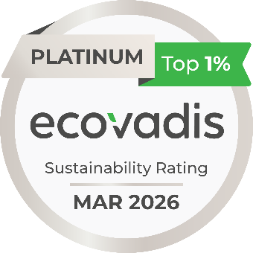

Image 1: EcoVadis Platinum rating – Würth Elektronik GmbH & Co. KG Circuit Board Technology

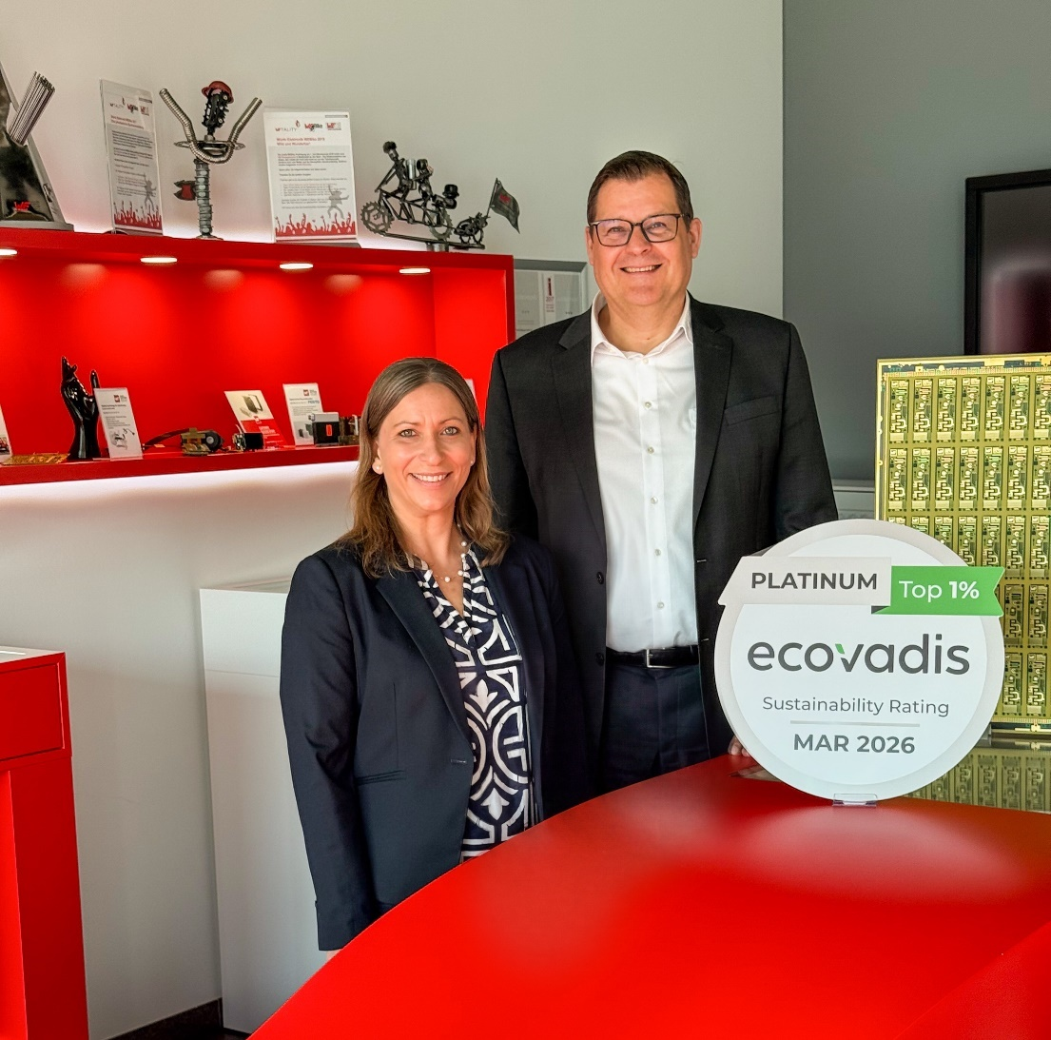

Image 2: Martina Beckert, Sustainability Manager, and Daniel Klein, Managing Director, Würth Elektronik GmbH & Co. KG Circuit Board Technology

About Würth Elektronik Circuit Board Technology
Founded in 1971, Würth Elektronik Circuit Board Technology is today one of Europe's leading PCB manufacturers, serving 4,000 customers worldwide with both domestic and international sales teams, and generating annual revenues in the triple-digit million-euro range.
Production takes place at German sites as well as through qualified partners in Asia. From basic to high-end technologies, Würth Elektronik Circuit Board Technology meets customer-specific requirements from prototypes and

samples to medium and large-scale production runs. With the development of innovative product technologies, the company positions itself as a market pioneer.
Experts from the most diverse divisions provide intensive consultation and support, from the initial idea to the finished product and beyond. Würth Elektronik Circuit Board Technology sees itself as a reliable partner for both individual entrepreneurs and large corporations. The comprehensive portfolio is rounded off by an online shop, where PCBs can be ordered around the clock.

Würth Elektronik. More than you expect!

More information at https://www.we-online.com/pcb

Social Media:
https://www.we-online.com/youtube
https://www.linkedin.com/company/wuerth-elektronik-group
https://www.instagram.com/we_group/

