PRESS RELEASE
Würth Elektronik makes its outdoor facilities bee-friendly
Plant Site Brought to Blossom
Waldenburg (Germany), 28 April 2021 —Würth Elektronik has been offering bees a home in Waldenburg for a year now. In the spring, the “WEBee – We’re making a beeline for Würth Elektronik!” initiative set up four bee colonies on an open space on the company's site. Now the company's environmental management is taking care of feeding: Supported by six apprentices and student trainees—the so-called "Young Talents”—who planted an insect-friendly flower seed mixture in front of the plant site, as well as thirty perennials, nine bushes and two trees. Another detail in the nature-friendly redesign: A rock pile was built up as a biotope for lizards. Further renaturisation and flower planting measures are planned for the period following corona, with more participants and the possibility of working more closely hand in hand.
“This visible transformation at the Waldenburg site is intended to create awareness of nature and the environment among our employees. Now we are looking forward to when the plants start to blossom," says Anika Wegmann, Environmental Manager at Würth Elektronik eiSos.

Available images
The following images can be downloaded from the Internet in printable quality: http://www.htcm.de/kk/wuerth
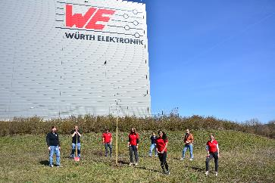  Image source: Würth Elektronik  Apprentices and student trainees from Würth Elektronik take pride in their commitment to nature. | 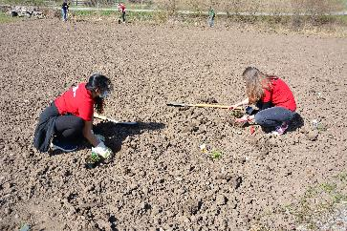  Image source: Würth Elektronik  Renaturisation and flower planting activities take place on the Würth Elektronik plant site in Waldenburg.

About the Würth Elektronik eiSos Group
Würth Elektronik eiSos Group is a manufacturer of electronic and electromechanical components for the electronics industry and a technology company that spearheads pioneering electronic solutions. Würth Elektronik eiSos is one of the largest European manufacturers of passive components and is active in 50 countries. Production sites in Europe, Asia and North America supply a growing number of customers worldwide.
The product range includes EMC components, inductors, transformers, RF components, varistors, capacitors, resistors, quartz crystals, oscillators, power modules, Wireless Power Transfer, LEDs, sensors, connectors, power supply elements, switches, push-buttons, connection technology, fuse holders and solutions for wireless data transmission.
The unrivaled service orientation of the company is characterized by the availability of all catalog components from stock without minimum order quantity, free samples and extensive support through technical sales staff and selection tools.
Through its technology partnership with the Audi Sport ABT Schaeffler Formula E Team and its support for the Formula Student racing series, the company demonstrates its innovative strength in eMobility
(www.we-speed-up-the-future.com).
Würth Elektronik is part of the Würth Group, the world market leader for assembly and fastening technology. The company employs 7,300 staff and generated sales of 823 million euros in 2020.
Würth Elektronik: more than you expect!
Further information at www.we-online.com

Further information:  Würth Elektronik eiSos GmbH & Co. KG  Sarah Hurst  Max-Eyth-Strasse 1  74638 Waldenburg  Germany  Phone: +49 7942 945-5186  E-mail: sarah.hurst@we-online.de  www.we-online.de | Press contact:  HighTech communications GmbH  Brigitte Basilio  Brunhamstrasse 21  81249 Munich  Germany  Phone: +49 89 500778-20  Telefax: +49 89 500778-77  E-mail: b.basilio@htcm.de  www.htcm.de

