PRESS RELEASE

IQD is pleased to announce updates on our IQRB-1 rubidium oscillator
Updates on IQRB-1 available
Waldenburg (Germany), 15 February 2021 – Originally released 8 years ago, the IQRB-1 is now a key component of many synchronisation systems across the world. After elaborate testing IQD has compiled an extensive and comprehensive handbook summarizing tests undertaken, including results and implications thereof, and this is now available to all customers. At its test and design facilities at the company headquarters in Crewkerne, UK, IQD, a subsidiary of the Würth Elektronik eiSos Group, is able to perform numerous standard as well as customized tests.
With the increasing cross-linkage of people, machines, applications and devices the need for accurate timing is an essential factor for success. A smart world can only run smoothly with all participants being on time. IQD’s IQRB-1 contributes to the worldwide timing infrastructure with its accuracy, tight short term as well as superb long term stability. It’s perfectly suited as frequency and timing reference for example for communication base stations, broadcasting or industrial equipment.
The IQRB-1 is the fundament of IQD’s growing rubidium oscillator portfolio which was only recently enhanced by the ICPT-1 and the IQRB-4. For more information on our IQRB-1 or our rubidium portfolio in general, please visit our website on www.iqdfrequencyproducts.com. If you have further questions or would like to get a copy of the IQRB-1 handbook, please contact our sales office.

Available images
The following images can be downloaded from the Internet in printable quality: http://www.htcm.de/kk/wuerth

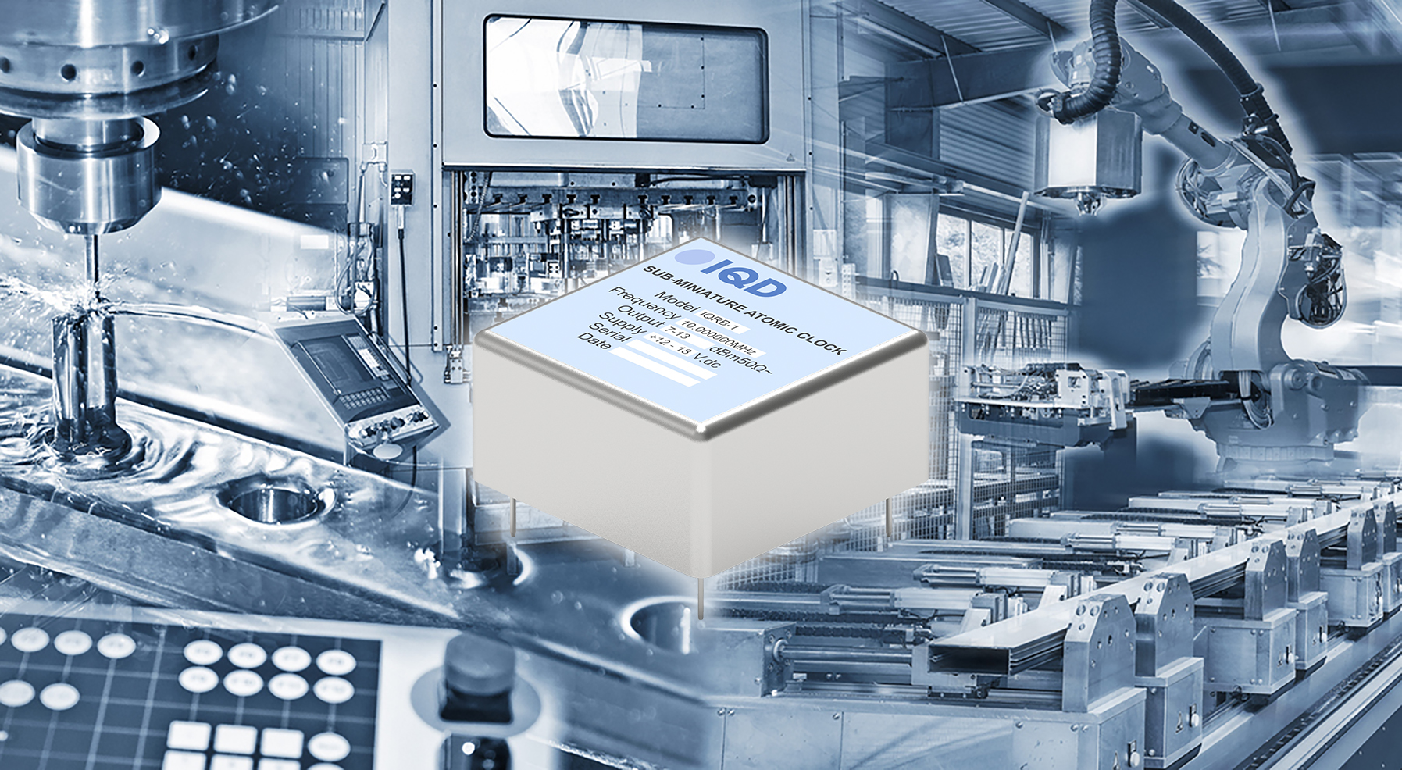
Image source: IQD
IQRB-1, IQD's Rubidium Oscillator

About IQD
Backed by over 40 years’ experience in the manufacture of frequency products, IQD is a recognised market leader in the frequency control market and part of the Würth Elektronik eiSos Group, one of the leading European manufacturers of passive components. With active customers in over 80 countries, IQD offers one of the most comprehensive frequency product ranges available, from low cost commercial grade product to that used in high reliability industrial and automotive applications including: Quartz Crystals, Clock Oscillators, AEC-Q200 Crystals & Oscillators, VCXOs, TCXOs, OCVCSOs & OCXOs, GPS Disciplined OCXOs, and Rubidium Oscillators.
Further info at www.iqdfrequencyproducts.com

About the Würth Elektronik eiSos Group
Würth Elektronik eiSos Group is a manufacturer of electronic and electromechanical components for the electronics industry and a technology company that spearheads pioneering electronic solutions. Würth Elektronik eiSos is one of the largest European manufacturers of passive components and is active in 50 countries. Production sites in Europe, Asia and North America supply a growing number of customers worldwide.
The product range includes EMC components, inductors, transformers, RF components, varistors, capacitors, resistors, quartz crystals, oscillators, power modules, Wireless Power Transfer, LEDs, sensors, connectors, power supply elements, switches, push-buttons, connection technology, fuse holders and solutions for wireless data transmission.
The unrivaled service orientation of the company is characterized by the availability of all catalog components from stock without minimum order quantity, free samples and extensive support through technical sales staff and selection tools.
Through its technology partnership with the Audi Sport ABT Schaeffler Formula E Team and its support for the Formula Student racing series, the company demonstrates its innovative strength in eMobility
(www.we-speed-up-the-future.com).
Würth Elektronik is part of the Würth Group, the world market leader for assembly and fastening technology. The company employs 7,300 staff and generated sales of 822 million euros in 2019.
Würth Elektronik: more than you expect!
Further information at www.we-online.com

Further information:  IQD Frequency Products Ltd  Rebecca Long  Station Road  Crewkerne  Somerset  TA18 8AR  United Kingdom  Phone: +44 1460 270270  E-mail: rebecca.long@iqdfrequencyproducts.com  www.we-online.com  www.iqdfrequencyproducts.com | Press contact:  HighTech communications GmbH  Brigitte Basilio  Brunhamstrasse 21  81249 Munich  Germany  Phone: +49 89 500778-20  Telefax: +49 89 500778-77  E-mail:  b.basilio@htcm.de  www.htcm.de

