PRESS RELEASE
Würth Elektronik presents automotive bar core choke WE-CHSA Performance
High current inductance with excellent saturation behavior
Waldenburg (Germany), February 24, 2022—With the magnetically shielded bar core choke WE-CHSA Performance, Würth Elektronik expands its portfolio of qualified products for automotive applications. The SMT high-current inductor represents an extension to the proven WE-CHSA series and differs from it only by a newly developed core material. As a result, WE-CHSA P - "P" as in performance - achieves the best saturation behavior among comparable components on the market. The choke has a current carrying capacity of up to 28 A and an operating temperature range of -55 °C to +150 °C.
The WE-CHSA bar core choke series is available in sizes 1011, 1212 and 8090 and features a special product design with an air gap. This improves component tolerance, while the recessed solder pads ensure optimum co-planarity. The new core material enables extremely high saturation currents up to over 48.5 A (ΔL=10 %).
The AEC-Q200-qualified high-current inductors are suitable, for example, for use as input filter chokes in engine control systems or in infotainment systems. A design kit and free samples are available for the product group.
WE-CHSA P and WE-CHSA can be ordered immediately from stock with different inductance values from 0.22 to 15 µH without minimum order quantity.

Available images
The following images can be downloaded from the Internet in printable quality: https://kk.htcm.de/press-releases/wuerth/

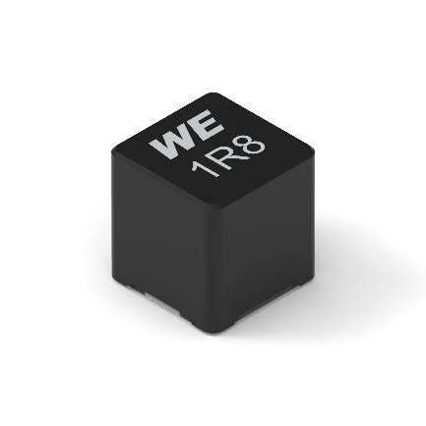
Source: Würth Elektronik
Automotive bar core choke WE-CHSA P

About the Würth Elektronik eiSos Group
Würth Elektronik eiSos Group is a manufacturer of electronic and electromechanical components for the electronics industry and a technology company that spearheads pioneering electronic solutions. Würth Elektronik eiSos is one of the largest European manufacturers of passive components and is active in 50 countries. Production sites in Europe, Asia and North America supply a growing number of customers worldwide.
The product range includes EMC components, inductors, transformers, RF components, varistors, capacitors, resistors, quartz crystals, oscillators, power modules, Wireless Power Transfer, LEDs, sensors, connectors, power supply elements, switches, push-buttons, connection technology, fuse holders and solutions for wireless data transmission.
The unrivaled service orientation of the company is characterized by the availability of all catalog components from stock without minimum order quantity, free samples and extensive support through technical sales staff and selection tools.
Würth Elektronik is part of the Würth Group, the world market leader for assembly and fastening technology. The company employs 8,000 staff and generated sales of 1.09 Billion Euro in 2021.
Würth Elektronik: more than you expect!
Further information at www.we-online.com

Further information:  Würth Elektronik eiSos GmbH & Co. KG  Sarah Hurst  Max-Eyth-Strasse 1  74638 Waldenburg  Germany  Phone: +49 7942 945-5186  E-mail: sarah.hurst@we-online.de  www.we-online.com | Press contact:  HighTech communications GmbH  Brigitte Basilio  Brunhamstrasse 21  81249 Munich  Germany  Phone: +49 89 500778-20  Telefax: +49 89 500778-77  E-mail: b.basilio@htcm.de  www.htcm.de

