PRESS RELEASE
Würth Elektronik introduces its WE-MCI multilayer ceramic inductors
Automotive-Qualified High Frequency Inductors with Tight Tolerances
Waldenburg (Germany), December 8, 2022—Würth Elektronik now offers WE-MCI — a series of high-frequency inductors boasting a wide range of values: The 0402 package covers inductance values from 1 to 270 nH, while the WE-MCIs in a 0603 package range from 1 to 470 nH. A special feature of these automotive-approved components is their unusually tight tolerances of ±5% or ±0.3 nH for those models below 5.6 nH.
AEC-Q200 qualified, with an operating temperature range -55 to +125°C, the SMT mountable components are suitable for applications in infotainment, keyless access systems, Bluetooth and filter circuits, to name but a few. The WE-MCIs are provided with polarity markings on both sides for improved production control.
Important service for developers
Design kits are available for both inductor package types, so components with the right values are always at hand. Würth Elektronik will always replenish these design kits free of charge.

Available images
The following images can be downloaded from the Internet in printable quality: https://kk.htcm.de/press-releases/wuerth/
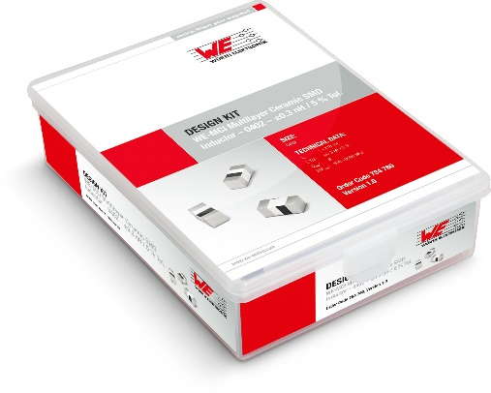Image source: Würth Elektronik
Tray box with lifelong free refill service: Würth Elektronik offers its popular design kits for the new WE-MCI high-frequency inductors.

About the Würth Elektronik eiSos Group
Würth Elektronik eiSos Group is a manufacturer of electronic and electromechanical components for the electronics industry and a technology company that spearheads pioneering electronic solutions. Würth Elektronik eiSos is one of the largest European manufacturers of passive components and is active in 50 countries. Production sites in Europe, Asia and North America supply a growing number of customers worldwide.
The product range includes EMC components, inductors, transformers, RF components, varistors, capacitors, resistors, quartz crystals, oscillators, power modules, Wireless Power Transfer, LEDs, sensors, connectors, power supply elements, switches, push-buttons, connection technology, fuse holders and solutions for wireless data transmission.
The unrivaled service orientation of the company is characterized by the availability of all catalog components from stock without minimum order quantity, free samples and extensive support through technical sales staff and selection tools.
Würth Elektronik is part of the Würth Group, the world market leader for assembly and fastening technology. The company employs 8,000 staff and generated sales of 1.09 Billion Euro in 2021.
Würth Elektronik: more than you expect!
Further information at www.we-online.com

Further information:  Würth Elektronik eiSos GmbH & Co. KG  Sarah Hurst  Max-Eyth-Strasse 1  74638 Waldenburg  Germany  Phone: +49 7942 945-5186  E-mail: sarah.hurst@we-online.de  www.we-online.com | Press contact:  HighTech communications GmbH  Brigitte Basilio  Brunhamstrasse 21  81249 Munich  Germany  Phone: +49 89 500778-20  Telefax: +49 89 500778-77  E-mail: b.basilio@htcm.de  www.htcm.de

