PRESS RELEASE
Würth Elektronik supports Start ups
Innovative drone project for medical care
Waldenburg (Germany), 8 February 2021 – As a leading manufacturer of electronic and electromechanical components, Würth Elektronik actively promotes sustainable innovations, start-ups and young developers. In addition to providing components free of charge, the assistance includes, in particular, support from experienced electronics and design experts as well as the transfer of technical know-how. A current example is the support of the humanitarian project Yonah by the Würth Elektronik branch in Singapore. The start-up has developed a robust cargo drone for medicine deliveries to impassable areas.
A hospital in the difficult-to-access highlands of Papua New Guinea and the fight against a rampant measles epidemic there were the impetus for the Yonah founders to develop an innovative cargo drone for transporting medicines. The portable, particularly robust and low-maintenance robotic aircraft has a long range and can take off and land vertically. An indispensable component in the electronics-hostile environment are particularly robust and vibration-insensitive connectors, which were provided to the developers by Würth Elektronik. The first operational drone from the Yonah development is a hybrid aircraft that combines the flexibility of a multi-rotor helicopter with the endurance performance of a fixed-wing aircraft.
Electronics helps
"The team at Wurth Electronics Singapore Pte.Ltd loves this wonderful project. It is a meaningful and peaceful use of unmanned aerial technology where electronics helps save lives," says a delighted Ching Man Lau, HR Manager at Würth Elektronik eiSos, who is coordinating the project with the University of Singapore and Team Yonah. "The success of such a drone depends on being robust and low-maintenance. A flying robot with a two-stroke engine sounds unusual, but Yonah is finding solutions that fit the conditions in remote rural areas. We are pleased that components from Würth Elektronik and the cooperation with our experts are an important part of this solution, and wish Yonah continued success," continues Field Application Engineer Daryl Wong.
"You can find out more about this exciting project at www.yonah.sg. I warmly invite start-up companies to contact us for the electronic parts of their innovative product ideas," says Sebastian Tan, General Manager, Würth Electronics Singapore Pte. Ltd. "Start-up support is all about being in the right place at the right time and being able to support from the beginning of the design phase. When it comes to realizing prototypes or first small series, developers are often faced with the simple challenge of finding the right components and being able to get expert advice on design. This is where we are ready with our solutions within the framework of the Würth Elektronik Technology Partnerships for start-up support."

Available images
The following images can be downloaded from the Internet in printable quality: http://www.htcm.de/kk/wuerth
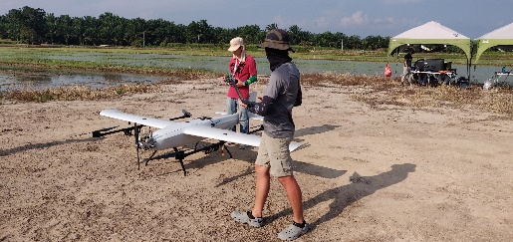  Image source: Würth Elektronik & Yonah  Würth Elektronik Singapore supports the humanitarian project Yonah | Image source: Würth Elektronik & Yonah  A cargo drone was developed for the transport of medicines.

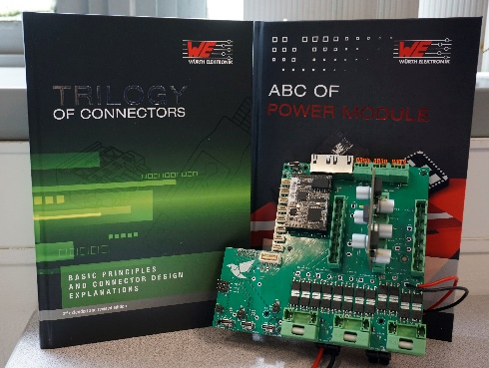  Image source: Würth Elektronik & Yonah  Würth Elektronik is providing components and know-how for the project free of charge. | 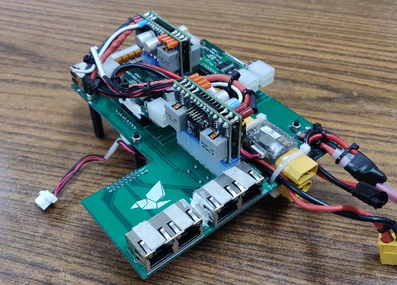Image source: Würth Elektronik Yonah  Particularly robust and vibration-resistant connectors and spacers

About the Würth Elektronik eiSos Group
Würth Elektronik eiSos Group is a manufacturer of electronic and electromechanical components for the electronics industry and a technology company that spearheads pioneering electronic solutions. Würth Elektronik eiSos is one of the largest European manufacturers of passive components and is active in 50 countries. Production sites in Europe, Asia and North America supply a growing number of customers worldwide.
The product range includes EMC components, inductors, transformers, RF components, varistors, capacitors, resistors, quartz crystals, oscillators, power modules, Wireless Power Transfer, LEDs, sensors, connectors, power supply elements, switches, push-buttons, connection technology, fuse holders and solutions for wireless data transmission.
The unrivaled service orientation of the company is characterized by the availability of all catalog components from stock without minimum order quantity, free samples and extensive support through technical sales staff and selection tools.
Through its technology partnership with the Audi Sport ABT Schaeffler Formula E Team and its support for the Formula Student racing series, the company demonstrates its innovative strength in eMobility
(www.we-speed-up-the-future.com).
Würth Elektronik is part of the Würth Group, the world market leader for assembly and fastening technology. The company employs 7,300 staff and generated sales of 822 million euros in 2019.
Würth Elektronik: more than you expect!
Further information at www.we-online.com

Further information:  Würth Elektronik eiSos GmbH & Co. KG  Sarah Hurst  Max-Eyth-Strasse 1  74638 Waldenburg  Germany  Phone: +49 7942 945-5186  E-mail: sarah.hurst@we-online.de  www.we-online.de | Press contact:  HighTech communications GmbH  Brigitte Basilio  Brunhamstrasse 21  81249 Munich  Germany  Phone: +49 89 500778-20  Telefax: +49 89 500778-77  E-mail: b.basilio@htcm.de  www.htcm.de

