PRESS RELEASE
Würth Elektronik presents its WA-SMCH Surface Mounted Cable Holder
Small Innovation with a Big Effect
Waldenburg (Germany), 11 February 2021—With the WA-SMCH (Surface Mounted Cable Holder), Würth Elektronik introduces an innovative, space-saving replacement for PCB-mounted, bonded or snapped cable holders intended to accommodate cable ties. The automatically mountable and solderable holder made of tin-plated phosphor bronze offers a very stable fastening solution with a holding force up to 370 N. Cables or cable ties can be routed lengthwise or crosswise through the 10 × 6 × 2 mm component.
Subsequent manual placement of individual components in surface mounted manufactured assemblies requires additional processes and thus generates error risks and additional costs. This is where the cable holder developed by Würth Elektronik comes into its own with a lean and elegant solution: WA-SMCH is surface-mounted and thus eliminates additional processes and costs in production. WA-SMCH is available from stock without a minimum order quantity. As a special service for small quantities, Würth Elektronik offers a re-reeling service: Customers can order individual component quantities in belt sections on a reel with a minimum of 40 cm leader and trailer. Würth Elektronik also provides developers free samples on request.

Available images
The following images can be downloaded from the Internet in printable quality: http://www.htcm.de/kk/wuerth
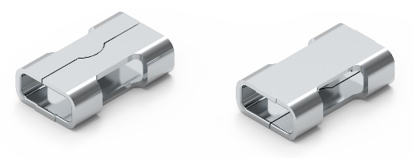
Image source: Würth Elektronik
WA-SMCH Surface Mounted Cable Holder

About the Würth Elektronik eiSos Group
Würth Elektronik eiSos Group is a manufacturer of electronic and electromechanical components for the electronics industry and a technology company that spearheads pioneering electronic solutions. Würth Elektronik eiSos is one of the largest European manufacturers of passive components and is active in 50 countries. Production sites in Europe, Asia and North America supply a growing number of customers worldwide.
The product range includes EMC components, inductors, transformers, RF components, varistors, capacitors, resistors, quartz crystals, oscillators, power modules, Wireless Power Transfer, LEDs, sensors, connectors, power supply elements, switches, push-buttons, connection technology, fuse holders and solutions for wireless data transmission.
The unrivaled service orientation of the company is characterized by the availability of all catalog components from stock without minimum order quantity, free samples and extensive support through technical sales staff and selection tools.
Through its technology partnership with the Audi Sport ABT Schaeffler Formula E Team and its support for the Formula Student racing series, the company demonstrates its innovative strength in eMobility
(www.we-speed-up-the-future.com).
Würth Elektronik is part of the Würth Group, the world market leader for assembly and fastening technology. The company employs 7,300 staff and generated sales of 822 million euros in 2019.
Würth Elektronik: more than you expect!
Further information at www.we-online.com

Further information:  Würth Elektronik eiSos GmbH & Co. KG  Sarah Hurst  Max-Eyth-Strasse 1  74638 Waldenburg  Germany  Phone: +49 7942 945-5186  E-mail: sarah.hurst@we-online.de  www.we-online.de | Press contact:  HighTech communications GmbH  Brigitte Basilio  Brunhamstrasse 21  81249 Munich  Germany  Phone: +49 89 500778-20  Telefax: +49 89 500778-77  E-mail: b.basilio@htcm.de  www.htcm.de

