PRESS RELEASE
Würth Elektronik introduces its WL-VCSL infrared laser
IR Source for Environmental Recognition
Waldenburg (Germany), 18 February 2021—Würth Elektronik launches its own infrared laser for the first time to extend its comprehensive portfolio of infrared emitters. The WL-VCSL Vertical Cavity Surface Emitting Laser scores with its high-quality materials, high efficiency of 35 percent and almost two Watts of radiant power. Designed to emit short, high-energy pulses, the new IR laser is ideal for 3D environmental recognition solutions, for example in industrial automation or LiDAR.
The Würth Elektronik experts make use of high-quality materials in the 3.5 × 3.5 × 1.8 mm, very robust housing of the WL-VCSL: A thermally conductive ceramic substrate, gold-plated contacts and a high-quality quartz diffuser ensure a highly homogeneous radiation pattern. Two variants are available: 60° × 45° and 110° × 85° beam angles. The laser with a wavelength of 940 nm is aimed at applications in which precision is essential. The possible areas of use range from 3D recognition, LiDAR and distance measurement (time of flight) to solutions in industrial automation and robotics, through to applications in the field of biometric recognition.
Würth Elektronik will soon make a tested reference design available for pulsating controls free of charge. WL-VCSL Vertical Cavity Surface Emitting Laser is now available from stock without a minimum order quantity. Electronics developers can request free samples.

Available images
The following images can be downloaded from the Internet in printable quality: http://www.htcm.de/kk/wuerth

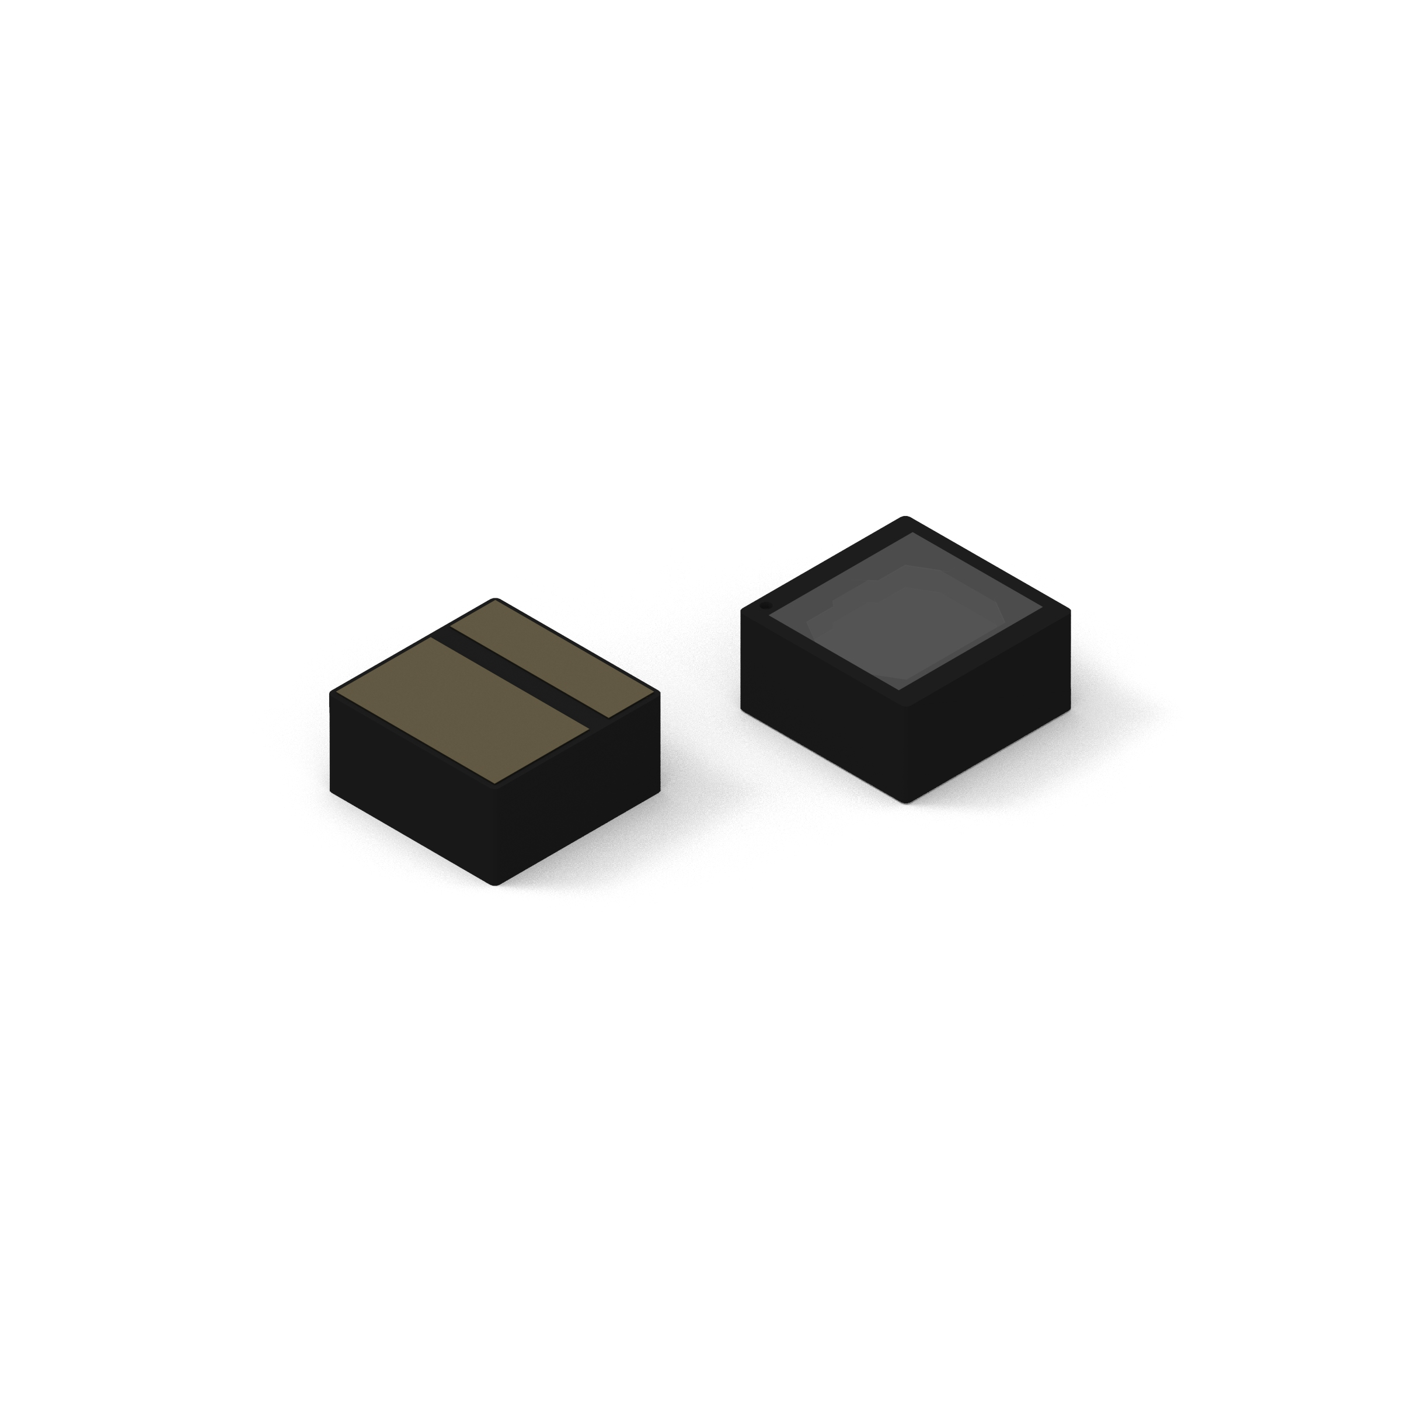Image source: Würth Elektronik
WL-VCSL infrared lasers

Available videos
You can find the following videos on our YouTube channel:
https://www.youtube.com/watch?v=ii2eUkFOT2s
Source: Würth Elektronik
WE meet @ Digital Days 2020: Optoelectronics: Introduction of new products - Product presentation by Dr. Zhelio Andreev, Product Manager Optoelectronics at Würth Elektronik eiSos

About the Würth Elektronik eiSos Group
Würth Elektronik eiSos Group is a manufacturer of electronic and electromechanical components for the electronics industry and a technology company that spearheads pioneering electronic solutions. Würth Elektronik eiSos is one of the largest European manufacturers of passive components and is active in 50 countries. Production sites in Europe, Asia and North America supply a growing number of customers worldwide.
The product range includes EMC components, inductors, transformers, RF components, varistors, capacitors, resistors, quartz crystals, oscillators, power modules, Wireless Power Transfer, LEDs, sensors, connectors, power supply elements, switches, push-buttons, connection technology, fuse holders and solutions for wireless data transmission.
The unrivaled service orientation of the company is characterized by the availability of all catalog components from stock without minimum order quantity, free samples and extensive support through technical sales staff and selection tools.
Through its technology partnership with the Audi Sport ABT Schaeffler Formula E Team and its support for the Formula Student racing series, the company demonstrates its innovative strength in eMobility
(www.we-speed-up-the-future.com).
Würth Elektronik is part of the Würth Group, the world market leader for assembly and fastening technology. The company employs 7,300 staff and generated sales of 822 million euros in 2019.
Würth Elektronik: more than you expect!
Further information at www.we-online.com

Further information:  Würth Elektronik eiSos GmbH & Co. KG  Sarah Hurst  Max-Eyth-Strasse 1  74638 Waldenburg  Germany  Phone: +49 7942 945-5186  E-mail: sarah.hurst@we-online.de  www.we-online.de | Press contact:  HighTech communications GmbH  Brigitte Basilio  Brunhamstrasse 21  81249 Munich  Germany  Phone: +49 89 500778-20  Telefax: +49 89 500778-77  E-mail: b.basilio@htcm.de  www.htcm.de

