PRESS RELEASE
Würth Elektronik extends its product family of WE-KI ceramic SMT inductors
High Quality Factor, High Rated Current, Huge Selection
Waldenburg (Germany), 20 January 2021—Würth Elektronik has expanded its WE-KI product family with further ceramic inductor variants in 0603 and 0805 packages. Now the portfolio includes over 300 models in four sizes from 0402 to 1008, optionally with ±2 and ±5 per cent tolerance. With the new range of models, the available inductance values cover 1 to 1800 nH.
The SMT-mountable ceramic inductors are aimed specifically at high frequency applications. A WE-KI variant is often used in telecommunications and antenna matching, for just one example. The Antenna Matching Service is an additional design assistance from Würth Elektronik offering developers a means of reliably optimizing efficiency and range.
Compared to other technologies like multilayer ceramic inductors or thin-film inductors, WE-KI offer a high Q factor and very high rated currents. WE-KI is characterized by high thermal stability and is specified for the operating temperature range from -40 to +125ºC. The highest possible specified self-resonant frequency extends to 12.5 GHz. In order to facilitate selection in designs, Würth Elektronik provides Spice models (LT Spice and PSpice) for simulation of all variants.
Design Kits are offered for WE-KI, i.e., sample collections with which developers always have different value inductors available. These "sorting boxes" are refilled by Würth Elektronik free of charge. Individual samples too are provided at any time. All products from the inductor series are available from stock without a minimum order quantity.

Available images
The following images can be downloaded from the Internet in printable quality: http://www.htcm.de/kk/wuerth

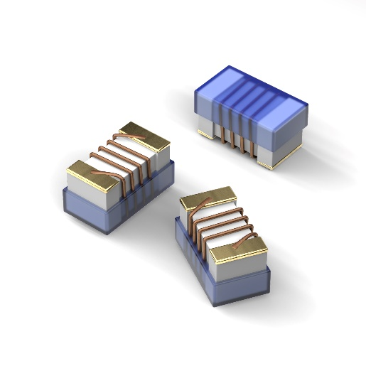
Image source: Würth Elektronik
WE-KI ceramic SMT inductors in 0603 and 0805 packages

About the Würth Elektronik eiSos Group
Würth Elektronik eiSos Group is a manufacturer of electronic and electromechanical components for the electronics industry and a technology company that spearheads pioneering electronic solutions. Würth Elektronik eiSos is one of the largest European manufacturers of passive components and is active in 50 countries. Production sites in Europe, Asia and North America supply a growing number of customers worldwide.
The product range includes EMC components, inductors, transformers, RF components, varistors, capacitors, resistors, quartz crystals, oscillators, power modules, Wireless Power Transfer, LEDs, sensors, connectors, power supply elements, switches, push-buttons, connection technology, fuse holders and solutions for wireless data transmission.
The unrivaled service orientation of the company is characterized by the availability of all catalog components from stock without minimum order quantity, free samples and extensive support through technical sales staff and selection tools.
Through its technology partnership with the Audi Sport ABT Schaeffler Formula E Team and its support for the Formula Student racing series, the company demonstrates its innovative strength in eMobility
(www.we-speed-up-the-future.com).
Würth Elektronik is part of the Würth Group, the world market leader for assembly and fastening technology. The company employs 7,300 staff and generated sales of 822 million euros in 2019.
Würth Elektronik: more than you expect!

Further information at www.we-online.com

Further information:  Würth Elektronik eiSos GmbH & Co. KG  Sarah Hurst  Max-Eyth-Strasse 1  74638 Waldenburg  Germany  Phone: +49 7942 945-5186  E-mail: sarah.hurst@we-online.de  www.we-online.de | Press contact:  HighTech communications GmbH  Brigitte Basilio  Brunhamstrasse 21  81249 Munich  Germany  Phone: +49 89 500778-20  Telefax: +49 89 500778-77  E-mail: b.basilio@htcm.de  www.htcm.de

