PRESS RELEASE
Würth Elektronik offers Intel SHDSL Evaluation Kit
Best transmission despite long cable
Waldenburg (Germany) 12 January 2021 – With the SHDSL standard, data can be transmitted over extremely long copper cables. This makes this technology the first choice in applications where Power over Ethernet and DSL technologies like G.FAST, VDSL are not possible. With its SHDSL Evaluation Kit Würth Elektronik now offers developers the possibility to test applications with the SHDSL transceiver from Intel. Typical applications are video surveillance, infotainment systems in airports and subway stations, vending machines, bank terminals, traffic control systems and industrial communication systems. It can cover distances of up to 15 kilometers and achieve data rates of up to 15 Mbps using twisted pair copper wires A throughput of 60Mbps (symmetrical rate) has also been achieved using 4 copper pairs (a CAT5e cable has 4 copper pairs).
The evaluation board included in the kit can be used as an EFM modem, SHDSL EFM module or plug & play Ethernet extender. It has a selectable bit rate including auto mode and USB-EIA232 emulation or TTL compatible EIA232 interface. There are over 122 components from Würth Elektronik used on this board such as the LAN transformer, PMI inductor, ferrites, LEDs, capacitors, connectors and switches. The board also includes a custom transformer The board also includes a custom transformer “It is customized to be compact (17.7 x 13.4 x 12.7mm height) and provides very good total harmonic distortion. This transformer meets UL and IEC standards, has a low leakage inductance (less than 35µH) and offers excellent longitudinal balance”, explained Swaroop Vaidyanath, Product Manager of this kit.The kit contains the evaluation board with the Intel chipset, two CAT6 Ethernet cables, a micro-USB cable and a guide for the first steps.
The Intel SHDSL Evaluation Kit is available from the Würth Elektronik homepage. A technical blog about SHDSL technology can be found here.

Available images
The following images can be downloaded from the Internet in printable quality: http://www.htcm.de/kk/wuerth
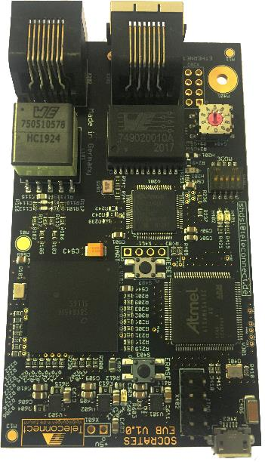Image source: Würth Elektronik
Intel SHDSL Evaluation Kit

About the Würth Elektronik eiSos Group
Würth Elektronik eiSos Group is a manufacturer of electronic and electromechanical components for the electronics industry and a technology company that spearheads pioneering electronic solutions. Würth Elektronik eiSos is one of the largest European manufacturers of passive components and is active in 50 countries. Production sites in Europe, Asia and North America supply a growing number of customers worldwide.
The product range includes EMC components, inductors, transformers, RF components, varistors, capacitors, resistors, quartz crystals, oscillators, power modules, Wireless Power Transfer, LEDs, sensors, connectors, power supply elements, switches, push-buttons, connection technology, fuse holders and solutions for wireless data transmission.
The unrivaled service orientation of the company is characterized by the availability of all catalog components from stock without minimum order quantity, free samples and extensive support through technical sales staff and selection tools.
Through its technology partnership with the Audi Sport ABT Schaeffler Formula E Team and its support for the Formula Student racing series, the company demonstrates its innovative strength in eMobility
(www.we-speed-up-the-future.com).
Würth Elektronik is part of the Würth Group, the world market leader for assembly and fastening technology. The company employs 7,300 staff and generated sales of 822 million euros in 2019.
Würth Elektronik: more than you expect!
Further information at www.we-online.com

Further information:  Würth Elektronik eiSos GmbH & Co. KG  Sarah Hurst  Max-Eyth-Strasse 1  74638 Waldenburg  Germany  Phone: +49 7942 945-5186  E-mail: sarah.hurst@we-online.de  www.we-online.de | Press contact:  HighTech communications GmbH  Brigitte Basilio  Brunhamstrasse 21  81249 Munich  Germany  Phone: +49 89 500778-20  Telefax: +49 89 500778-77  E-mail: b.basilio@htcm.de  www.htcm.de

