PRESS RELEASE

Würth Elektronik Celebrates 25 Years of Apprenticeship Programs
A Clear Path for Tomorrow's Talents
Waldenburg/München (Germany), September 3, 2026 –Twenty-five years of apprenticeship training, 28 new Young Talents (YT), and an anniversary gift on four wheels: Würth Elektronik eiSos marked the start of the 2026 apprenticeship program with something special. On September 1, 28 apprentices and students began their professional journeys across 16 apprenticeship and degree programs at the Waldenburg and Munich locations. To mark the 25th anniversary of its apprenticeship program, the company is providing an extra boost with the YT-Car: Starting in October, a different Young Talent will be able to use the electric vehicle free of charge each month.
The now well-established Welcome Week helped ensure a successful start to the program. Through interactive activities, it gave new apprentices and students guidance from day one and introduced them firsthand to Würth Elektronik’s culture and values. The highlight was a group outing with all the Young Talents and their mentors, designed to help participants get to know one another and fostering team spirit across all cohorts.
Creating opportunities, opening pathways, developing talent
For 25 years, Würth Elektronik has supported young people at its Waldenburg location as they take their first steps into professional life and develop their individual talents and strengths. The program offers a broad range of opportunities, from business, technical, and IT-related apprenticeships to dual-study programs and the “Studium PLUS Ausbildung” cooperative model, which combines an IHK-recognized apprenticeship with a university degree. Personal guidance, individualized support, and a strong focus on practical experience form the foundation of the training program.
An anniversary gift that moves people
To mark the program’s 25th anniversary, Würth Elektronik eiSos is offering its Young Talents a special benefit: Starting in October, the company will provide an electric vehicle, the “YT-Car,” for their use. Each month, a different Young Talent can use the vehicle completely free of charge, including for personal trips and vacations. The company will cover charging costs via a charging card provided with the vehicle.
There are two ways to be selected to receive the keys for a month. The YT-Car represents outstanding academic or professional achievements as well as exceptional social commitment. Some months will also be awarded by lottery, giving every Young Talent the chance to use the electric car for a month.
“We are proud to have been helping young people launch successful careers for the past 25 years. The fact that we continue to hire on this scale shows that our management firmly supports the concept of dual vocational training. With the YT-Car, we want to offer our young talents something special to mark our anniversary and show that we recognize and value their achievements and dedication,” says Sabine Lindner, Training Coordinator at Würth Elektronik eiSos.
25 Years of Apprenticeship Training: Listen Here
Anyone interested in learning more about apprenticeship opportunities at Würth Elektronik’s Waldenburg and Munich locations can gain first-hand insights from the German-language career podcast “WE start your career!”
To mark the anniversary of the apprenticeship program, two new episodes have been released, focusing entirely on apprenticeships and career paths within the company. The podcast is available in German only on Spotify and other major platforms:
https://open.spotify.com/show/5qDqG5xIU2rGKEBljQkXml
For information on apprenticeships, dual degree programs, and the “Study PLUS Apprenticeship” program at Würth Elektronik, visit:
https://www.we-online.com/en/career

Available images
The following images can be downloaded from the Internet in printable quality: https://kk.htcm.de/press-releases/wuerth/
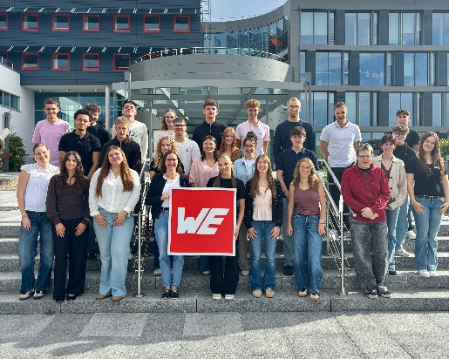 Image source: Würth Elektronik
New recruits for Würth Elektronik:
28 new young talents are starting an apprenticeship or a degree program.

About the Würth Elektronik eiSos Group
Würth Elektronik eiSos Group is a manufacturer of electronic and electromechanical components for the electronics industry and a technology company that spearheads pioneering electronic solutions. Würth Elektronik eiSos is one of the largest European manufacturers of passive components and is active in 50 countries. Production sites in Europe, Asia and North America supply a growing number of customers worldwide.
The product range includes passive components, power modules, digital isolators, optoelectronics, electromechanical components, thermal management solutions, sensors and wireless modules. The portfolio is rounded off by customer-specific solutions.
The unrivaled service orientation of the company is characterized by the availability of all catalog components from stock without minimum order quantity, free samples and extensive support through technical sales staff and selection tools.
Würth Elektronik is part of the Würth Group, the global market leader in the development, production, and sale of fastening and assembly materials, and employs around 7,300 people. In 2025, the Würth Elektronik Group generated sales of 1.06 Billion Euro.
Würth Elektronik: more than you expect!
Further information at www.we-online.com

Further information:  Würth Elektronik eiSos GmbH & Co. KG  Sarah Hurst  Clarita-Bernhard-Strasse 9  81249 Munich  Germany  Phone: +49 7942 945-5186  E-mail: sarah.hurst@we-online.de  www.we-online.com | Press contact:  HighTech communications GmbH  Brigitte Basilio  Brunhamstrasse 21  81249 Munich  Germany  Phone: +49 89 500778-20  E-mail: b.basilio@htcm.de  www.htcm.de

