PRESS RELEASE

Würth Elektronik updates its online DC-DC Converter Designer
REDEXPERT: From Application Parameters to the Bill of Materials
Waldenburg (Germany), August 6, 2026 – The DC-DC Converter Designer is the most frequently used calculation tool in REDEXPERT. Würth Elektronik has now completely revised and expanded its online service. The heart of the new tool is its proprietary, highly accurate method for calculating inductor losses, based on actual component characterization. It also takes DC-bias effects in inductors and capacitors into account. A new worst-case option for losses and temperature rise provides a valuable tool for robust design that is prepared to deal with all real-world operating conditions.
In practice, the inductance of a core changes significantly as a result of DC bias. Because datasheets often provide only limited information about this behavior, it is easy to select the wrong component.The same applies to ceramic capacitors, whose capacitance decreases significantly under operating voltage. The new DC-DC Converter Designer accurately reflects this reality and provides loss and temperature estimates that more closely reflect the actual behavior on the circuit board.
Automatic topology selection
The tool automatically selects the appropriate circuit topology based on the input parameters: buck (synchronous and asynchronous), boost (synchronous and asynchronous), and SEPIC. A user-defined topology mode is available to experienced users working with specialized or less common circuit topologies. Additional filters for automotive requirements, shielding, and component height simplify component selection for specific applications. A link to the MagI³C Power Module Designer enables users to compare the discrete circuit with an integrated module solution to ensure the optimal solution is selected.
Comparison of enhanced components
The tool’s analytical capabilities have been significantly extended. The system recommends the five most suitable components based on a weighted evaluation of performance and package size. Multiple components can be compared directly: The same graph displays losses as a function of output current (I_{out}) and switching frequency (F_{sw}) for all selected components. The graph options have also been significantly expanded: zooming, a crosshair cursor, and exporting as an image or Excel file. Experienced users can manually load any component from across the Würth Elektronik portfolio into the tool without being limited to the automatic recommendation list.
Including capacitor recommendations
The tool now also recommends capacitors and a suitable microchip controller for the specified input parameters. A link to the MagI³C Power Module Designer enables users to compare the discrete circuit with an integrated module solution.
The overview page summarizes all simulation results and generates a complete bill of materials with up to six components. These components can be requested as free samples or added directly to the shopping cart. The DC-DC Converter Designer is available at redexpert.we-online.com.

Available images
The following images can be downloaded from the Internet in printable quality: https://kk.htcm.de/press-releases/wuerth/
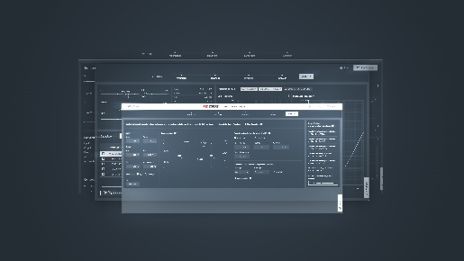
Image source: Würth Elektronik
The new DC-DC Converter Designer in REDEXPERT

About the Würth Elektronik eiSos Group
Würth Elektronik eiSos Group is a manufacturer of electronic and electromechanical components for the electronics industry and a technology company that spearheads pioneering electronic solutions. Würth Elektronik eiSos is one of the largest European manufacturers of passive components and is active in 50 countries. Production sites in Europe, Asia and North America supply a growing number of customers worldwide.
The product range includes passive components, power modules, digital isolators, optoelectronics, electromechanical components, thermal management solutions, sensors and wireless modules. The portfolio is rounded off by customer-specific solutions.

The unrivaled service orientation of the company is characterized by the availability of all catalog components from stock without minimum order quantity, free samples and extensive support through technical sales staff and selection tools.
Würth Elektronik is part of the Würth Group, the global market leader in the development, production, and sale of fastening and assembly materials, and employs around 7,300 people. In 2025, the Würth Elektronik Group generated sales of 1.06 Billion Euro.
Würth Elektronik: more than you expect!
Further information at www.we-online.com

Further information:  Würth Elektronik eiSos GmbH & Co. KG  Sarah Hurst  Clarita-Bernhard-Strasse 9  81249 Munich  Germany  Phone: +49 7942 945-5186  E-mail: sarah.hurst@we-online.de  www.we-online.com | Press contact:  HighTech communications GmbH  Brigitte Basilio  Brunhamstrasse 21  81249 Munich  Germany  Phone: +49 89 500778-20  E-mail: b.basilio@htcm.de  www.htcm.de

