PRESS RELEASE

Würth Elektronik receives the world's first TDAP Stage 2 certificate for its EMC chokes
License for Acceptance Testing
Waldenburg, Offenbach (Germany), September 9, 2026 – The Würth Elektronik lab at its Quality Design Center Asia in Shenzhen has been awarded the world’s first TDAP Stage 2 certificate for the product “choke for suppressing electromagnetic interference” by VDE Prüf- und Zertifizierungsinstitut GmbH. This entitles Würth Elektronik to conduct tests in its own lab at its Chinese site under the supervision of VDE experts. The test results are recognized by VDE and, if successful, can lead to VDE certification.
The VDE Institute’s TDAP (Test Data Acceptance Program) accelerates the certification process, thereby reducing time to market. Specifically, the certification of the laboratory in Shenzhen means that Würth Elektronik is permitted to conduct acceptance testing of its common-mode chokes in accordance with IEC 60938.
Assessment of the lab at the recently expanded Quality Design Center (QDC) Asia was accompanied by intensive technical discussions. The successful certification was followed by a presentation ceremony in Offenbach, where Yangyang Chen, Head of Würth Elektronik’s facility in Shenzhen, received the certificate.
Accelerated certification
“Since this product line is in particularly high demand, the TDAP Stage 2 certificate for our common-mode chokes and the resulting simplification of the product certification process are most welcome. However, I also see this certificate as recognition of the achievements of our colleagues on site and the outstanding quality of their lab. Not least, this also sends a signal to the market, as the QDC also provides services to external customers,” explains Yangyang Chen, Head of Würth Elektronik’s facility in Shenzhen.
Founded in August 2008, QDC Asia extends over an area of around 4,700 m². The dedicated testing area covers 1,700 m² and is equipped with more than 300 high-precision testing devices. The center operates in accordance with ISO/IEC 17025 and ISO/IEC 17043 and is accredited as a testing lab and proficiency testing provider.

Available images
The following images can be downloaded from the Internet in printable quality: https://kk.htcm.de/press-releases/wuerth/
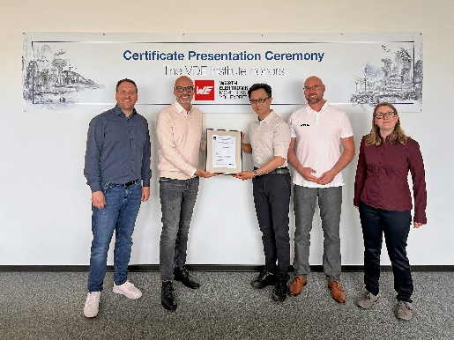
Image source: VDE
Certificate presentation in Offenbach to Yangyang Chen, Head of Quality Design Center Asia, Wurth Electronics, Shenzhen (3rd from left), Alexander Monsch, Head of Product Unit EMC Mains Filter, Würth Elektronik eiSos (1st from left), and Stefanie Birkenbach, Senior Product Manager EMC Mains Filter, Würth Elektronik eiSos (1st from right). The certificate was presented by Giuseppe Messinese, Head of Department TL3 – Electrical Systems and Components, VDE Institute (2nd from left), and Tobias Daum, Team Leader Customer Product Management, VDE Institute (2nd from right).

About the Würth Elektronik eiSos Group
Würth Elektronik eiSos Group is a manufacturer of electronic and electromechanical components for the electronics industry and a technology company that spearheads pioneering electronic solutions. Würth Elektronik eiSos is one of the largest European manufacturers of passive components and is active in 50 countries. Production sites in Europe, Asia and North America supply a growing number of customers worldwide.

The product range includes passive components, power modules, digital isolators, optoelectronics, electromechanical components, thermal management solutions, sensors and wireless modules. The portfolio is rounded off by customer-specific solutions.
The unrivaled service orientation of the company is characterized by the availability of all catalog components from stock without minimum order quantity, free samples and extensive support through technical sales staff and selection tools.
Würth Elektronik is part of the Würth Group, the global market leader in the development, production, and sale of fastening and assembly materials, and employs around 7,300 people. In 2025, the Würth Elektronik Group generated sales of 1.06 Billion Euro.
Würth Elektronik: more than you expect!
Further information at www.we-online.com

Further information:  Würth Elektronik eiSos GmbH & Co. KG  Sarah Hurst  Clarita-Bernhard-Strasse 9  81249 Munich  Germany  Phone: +49 7942 945-5186  E-mail: sarah.hurst@we-online.de  www.we-online.com | Press contact:  HighTech communications GmbH  Brigitte Basilio  Brunhamstrasse 21  81249 Munich  Germany  Phone: +49 89 500778-20  E-mail: b.basilio@htcm.de  www.htcm.de

