PRESS RELEASE

Würth Elektronik offers nanocrystalline cores for cable assembly
Broadband Suppression of Electromagnetic Interference with High Permeability
Waldenburg (Germany), June 23, 2026 – Würth Elektronik expands its cable interference suppression program. Conventional MnZn and NiZn ferrite cores for cable assembly are now complemented by nanocrystalline cable cores (www.we-online.com/we-ncc). The WE-NCC series provides broadband suppression of conducted electromagnetic interference. It features a compact design, high temperature stability and exceptionally high permeability.
Compared with conventional MnZn and NiZn ferrite cores, the nanocrystalline cores have significantly higher low-frequency impedance and broadband impedance behavior. WE-NCC is available for cable diameters from 3.7 to 21.1 mm. The initial permeability ranges from 30,000 to 90,000. Magnetic flux density reaches up to 1.2 T, while the Curie temperature is above 540°C. These properties ensure stable magnetic behavior across a wide temperature range and effective filtering over a broad frequency spectrum. The cable cores are suitable for interference suppression in cables used in industrial electronics, inverter technology, wind turbines, frequency converters, motor drive systems, among other applications. The nanocrystalline material enables smaller core dimensions with the same or better insertion loss than conventional cores. It also offers a significant weight advantage over MnZn cores.
Wide selection of EMC products
Electromagnetic compatibility has been a key focus for Würth Elektronik from the very beginning. Würth Elektronik’s broad portfolio of interference suppression components includes ferrites for cable assembly, which are now being expanded to include nanocrystalline WE-NCC. It also offers literature, webinars, individual consultation and practical design-in support for EMC challenges. The REDEXPERT online tool helps users select suitable ferrites based on parameters such as the required impedance. All interference suppression solutions are available from stock without a minimum order quantity, and free samples are provided on request.

Available images
The following images can be downloaded from the Internet in printable quality: https://kk.htcm.de/press-releases/wuerth/
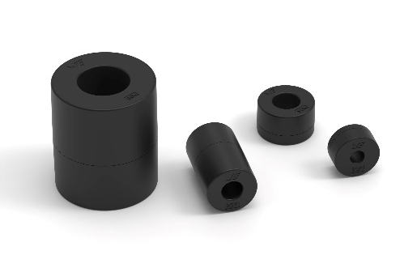
Image source: Würth Elektronik
Nanocrystalline cable cores for interference suppression have significantly higher low-frequency impedance than conventional ferrite cores.

Available images
The following images can be downloaded from the Internet in printable quality:
https://www.youtube.com/watch?v=BIh2c52AuYU
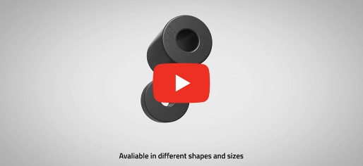
Source: Würth Elektronik
WE-NCC Nanocristalline Cable Cores

About the Würth Elektronik eiSos Group
Würth Elektronik eiSos Group is a manufacturer of electronic and electromechanical components for the electronics industry and a technology company that spearheads pioneering electronic solutions. Würth Elektronik eiSos is one of the largest European manufacturers of passive components and is active in 50 countries. Production sites in Europe, Asia and North America supply a growing number of customers worldwide.
The product range includes passive components, power modules, digital isolators, optoelectronics, electromechanical components, thermal management solutions, sensors and wireless modules. The portfolio is rounded off by customer-specific solutions.
The unrivaled service orientation of the company is characterized by the availability of all catalog components from stock without minimum order quantity, free samples and extensive support through technical sales staff and selection tools.
Würth Elektronik is part of the Würth Group, the global market leader in the development, production, and sale of fastening and assembly materials, and employs around 7,300 people. In 2025, the Würth Elektronik Group generated sales of 1.06 Billion Euro.
Würth Elektronik: more than you expect!
Further information at www.we-online.com

Further information:  Würth Elektronik eiSos GmbH & Co. KG  Sarah Hurst  Clarita-Bernhard-Strasse 9  81249 Munich  Germany  Phone: +49 7942 945-5186  E-mail: sarah.hurst@we-online.de  www.we-online.com | Press contact:  HighTech communications GmbH  Brigitte Basilio  Brunhamstrasse 21  81249 Munich  Germany  Phone: +49 89 500778-20  E-mail: b.basilio@htcm.de  www.htcm.de

