PRESS RELEASE
Würth Elektronik and the University of Valencia Celebrate Ten Years of Collaboration
A well-established institution in the field of Electromagnetic Compatibility research
Waldenburg (Germany), Valencia (Spain), June 9, 2026 – On May 20, 2026, Würth Elektronik representatives joined faculty and students to celebrate the tenth anniversary of the jointly established “Cátedra EMC Würth Elektronik – Universitat de València.” Chair holders Professor José Torres, Professor Adrian Suarez, Ph.D., Jorge Victoria, and Antonio Alcarria, Product Managers at Würth Elektronik eiSos GmbH, welcomed Alexander Gerfer, Chief Technology Officer (CTO) of the Würth Elektronik Group, as the keynote speaker at the ceremony. Representing the university, Inmaculada Coma, Vice-Rector of the Universitat de València, praised the fruitful collaboration.
The Chair of Electromagnetic Compatibility (EMC) was established ten years ago to advance both research and practical applications in this field. Since then, it has supervised doctoral dissertations as well as master’s and bachelor’s theses, delivered seminars and courses on EMC topics, and organized presentations at international conferences. Each year, Würth Elektronik proposes projects that enable internships both in the chair’s laboratory and at company’s headquarters. Coordination of these activities is overseen by PhD Jorge Victoria and Antonio Alcarria from Würth Elekronik’s Product Management team.
The chair's success reflected in graduates' careers
The event was hosted by Maria Cuesta and Victor Martinez, both former students of the department who are now working in Product Management at Würth Elektronik. Professor Adrián Suárez delivered a presentation outlining the department’s past achievements, as well as its current work and future plans. As the department’s first doctoral student, he later returned as a faculty member. He was supported in his presentation by Antonio Alcarria.
“At Würth Elektronik, it’s always about the people. For us, support isn’t limited to customers; we also stand by researchers with advice and assistance and support student initiatives, for example. EMC has always been an important field for us, and with the Cátedra EMC, we fulfilled a dream ten years ago,” said Alexander Gerfer, CTO of the Würth Elektronik eiSos Group, in his speech, and thanked everyone involved.

Available images
The following images can be downloaded from the Internet in printable quality: https://kk.htcm.de/press-releases/wuerth/
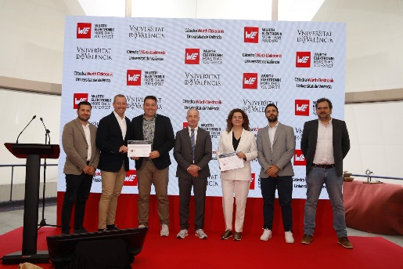  Image source: Cátedra EMC Würth Elektronik  Adrián Suárez, Assistant Professor at the Universitat de València, Prof. José Torres at the Universitat de València, Steffen Mütsch, Global Head of EMC at Würth Elektronik, Alexander Gerfer, CTO at the Würth Elektronik eiSos Group, Inmaculada Coma, Vice-Rector of the Universitat de València, Antonio Alcarria, Head of EMC Advanced Materials, Product Management at Würth Elektronik eiSos, Ph.D. Jorge Victoria, Head of Thermal Management at Würth Elektronik eiSos (from left to right) | 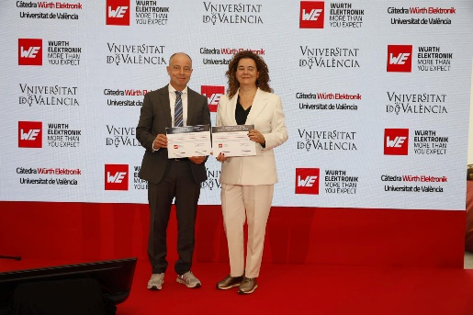  Image source: Cátedra EMC Würth Elektronik  Alexander Gerfer, CTO of the Würth Elektronik eiSos Group (left), together with Inmaculada Coma, Vice Rector of the Universitat de València
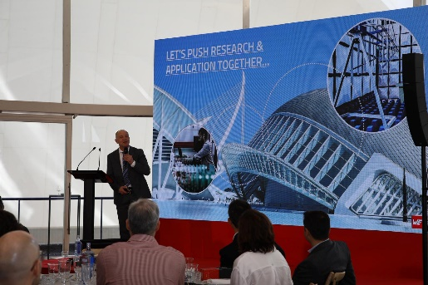  Image source: Cátedra EMC Würth Elektronik  In his speech, Alexander Gerfer, CTO of the Würth Elektronik eiSos Group, expressed his commitment to promoting research. | 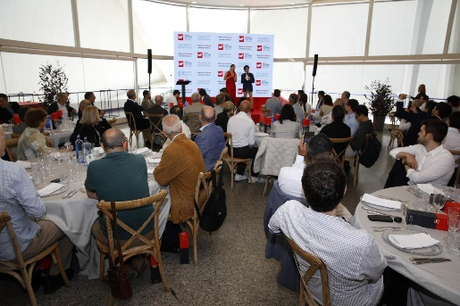  Image source: Cátedra EMC Würth Elektronik  Maria Cuesta and Victor Martinez, both product managers at Würth Elektronik eiSos, hosted the event.
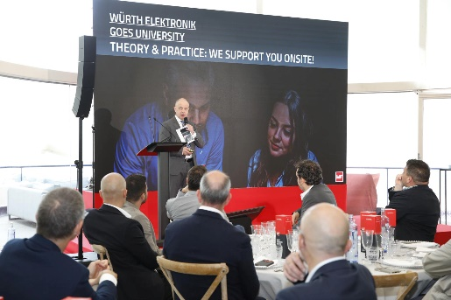
Image source: Cátedra EMC Würth Elektronik
Alexander Gerfer, CTO of the Würth Elektronik eiSos Group, spoke about supporting universities.

About the Würth Elektronik eiSos Group
Würth Elektronik eiSos Group is a manufacturer of electronic and electromechanical components for the electronics industry and a technology company that spearheads pioneering electronic solutions. Würth Elektronik eiSos is one of the largest European manufacturers of passive components and is active in 50 countries. Production sites in Europe, Asia and North America supply a growing number of customers worldwide.
The product range includes passive components, power modules, digital isolators, optoelectronics, electromechanical components, thermal management solutions, sensors and wireless modules. The portfolio is rounded off by customer-specific solutions.
The unrivaled service orientation of the company is characterized by the availability of all catalog components from stock without minimum order quantity, free samples and extensive support through technical sales staff and selection tools.
Würth Elektronik is part of the Würth Group, the global market leader in the development, production, and sale of fastening and assembly materials, and employs around 7,300 people. In 2025, the Würth Elektronik Group generated sales of 1.06 Billion Euro.
Würth Elektronik: more than you expect!
Further information at www.we-online.com

Further information:  Würth Elektronik eiSos GmbH & Co. KG  Sarah Hurst  Clarita-Bernhard-Strasse 9  81249 Munich  Germany  Phone: +49 7942 945-5186  E-mail: sarah.hurst@we-online.de  www.we-online.com | Press contact:  HighTech communications GmbH  Brigitte Basilio  Brunhamstrasse 21  81249 Munich  Germany  Phone: +49 89 500778-20  E-mail: b.basilio@htcm.de  www.htcm.de

