PRESS RELEASE

Würth Elektronik hosted the WE United Leadership Summit
Reflections on Leadership in Complex Technological Environments
Waldenburg (Germany), May 8, 2026 – WE United (“Women in Electronics”) is an international network dedicated to supporting female leaders in technology-driven industries. For its 10th Leadership Summit, the organization was hosted at Würth Elektronik’s High-Tech Innovation Center in Munich, Germany from April 22 to 24, 2026. Representatives from various sectors of the electronics supply chain and related technology fields exchanged views on current challenges in a rapidly changing industrial environment.
Claudia Speicher, Site Manager of the High-Tech Innovation Center in Munich, welcomed the participants before the event began with keynote speeches and roundtable discussions focused on shared experiences. The sessions addressed practical leadership topics, including decision-making under uncertainty, managing the gowing complexity of global supply chains, and balancing economic performance with corporate culture and long-term development. Discussions also explored how leadership can evolve in response to increasingly rapid innovation cycles.
To reflect diverse perspectives and encourage open dialogue on equal opportunity within the industry, the program featured both joint sessions and dedicated formats titled “Ladies in Leadership” and “Gentlemen in Leadership.”
Leadership in Times of Uncertainty
Under the theme “Imagine,” the discussions focused on the evolving demands placed on leaders and how organizations can remain capable of acting in an increasingly uncertain environment. Another focus was identifying and nurturing leadership talent. “I’m filled with impressions and grateful to have been part of this special event. We discussed what leadership really means today: empowering people rather than controlling them,” said Claudia Speicher.
“Our 10th anniversary is an opportunity to rethink what effective leadership looks like in today’s environment,” said Jackie Mattox, founder, president, and CEO of WE United. “Equality, collaboration, and ethical leadership are not optional—they are essential to the survival of organizations and the strengthening of the entire technology ecosystem.”

Available images
The following images can be downloaded from the Internet in printable quality: https://kk.htcm.de/press-releases/wuerth/
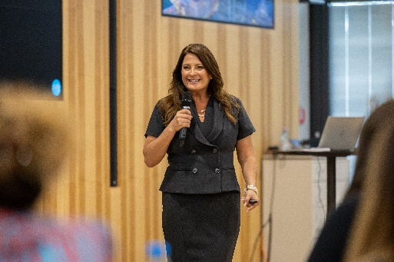  Image source: Bearr Photography  Jackie Mattox, founder, president, and CEO of WE United, presents at the anniversary summit. | 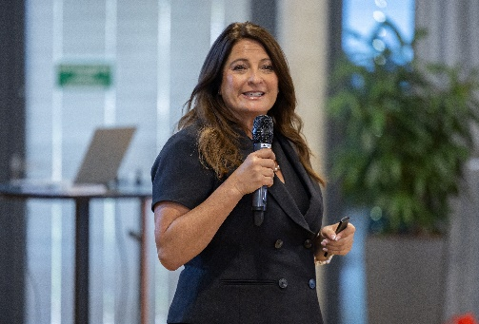  Image source: Bearr Photography  Jackie Mattox, founder, president, and CEO of WE United, visits Würth Elektronik at the anniversary summit.
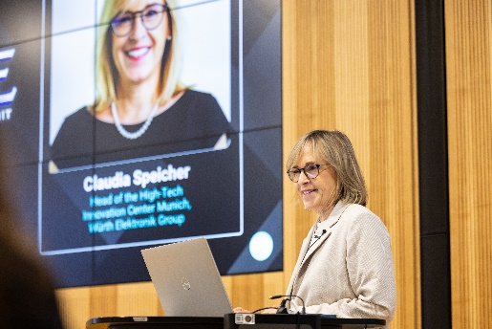  Image source: Bearr Photography  Claudia Speicher, Site Manager of the High-Tech Innovation Center in Munich, Germany welcomes the participants on behalf of Würth Elektronik. | 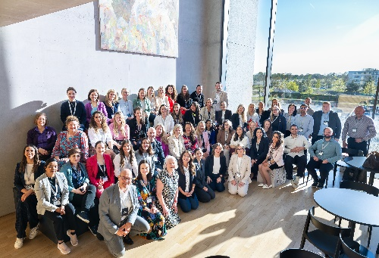  Image source: Bearr Photography  The participants of the WE United Leadership Summit gathered at Würth Elektronik’s High-Tech Innovation Center.

About WE United
WE United was founded in 2017 with the goal of strengthening the leadership pipeline needed for future-oriented innovations, including artificial intelligence. The organization pursues its mission through sponsorship and engagement across the entire electronics supply chain, including the manufacturing and distribution of semiconductors and IPCE components, as well as in the broader technology-driven industries that drive innovation in the medical, industrial, automotive, aerospace, defense, energy, and sustainability sectors, as well as in the digital and software sectors. With events and local chapters in the United States and Europe, as well as planned expansion into Mexico, Canada, and Asia, WE United is committed to building an inclusive global network of professionals who share its vision.
For more information, visit weunited.tech

About the Würth Elektronik eiSos Group
Würth Elektronik eiSos Group is a manufacturer of electronic and electromechanical components for the electronics industry and a technology company that spearheads pioneering electronic solutions. Würth Elektronik eiSos is one of the largest European manufacturers of passive components and is active in 50 countries. Production sites in Europe, Asia and North America supply a growing number of customers worldwide.
The product range includes passive components, power modules, digital isolators, optoelectronics, electromechanical components, thermal management solutions, sensors and wireless modules. The portfolio is rounded off by customer-specific solutions.
The unrivaled service orientation of the company is characterized by the availability of all catalog components from stock without minimum order quantity, free samples and extensive support through technical sales staff and selection tools.
Würth Elektronik is part of the Würth Group, the global market leader in the development, production, and sale of fastening and assembly materials, and employs around 7,300 people. In 2025, the Würth Elektronik Group generated sales of 1.06 Billion Euro.
Würth Elektronik: more than you expect!
Further information at www.we-online.com

Further information:  Würth Elektronik eiSos GmbH & Co. KG  Sarah Hurst  Clarita-Bernhard-Strasse 9  81249 Munich  Germany  Phone: +49 7942 945-5186  E-mail: sarah.hurst@we-online.de  www.we-online.com | Press contact:  HighTech communications GmbH  Brigitte Basilio  Brunhamstrasse 21  81249 Munich  Germany  Phone: +49 89 500778-20  E-mail: b.basilio@htcm.de  www.htcm.de

