PRESS RELEASE
Würth Elektronik Expands Laboratory in Shenzhen, China
Expanded capacity for validation and services
Waldenburg (Germany), Shenzhen (China), April 16, 2026 – Würth Elektronik eiSos Group celebrated the official opening of the Laboratory Phase II at its Asia Quality Design Center (QDC Asia) in Shenzhen on March 5, 2026. The inauguration ceremony was marked by a ribbon-cutting event presided over by senior leadership, including the CEO, Thomas Garz, and COO, Dirk Knorr, of the Würth Elektronik eiSos Group, alongside the Head of QDC Asia, Yangyang Chen, symbolically kicking off operations in the new facility.
Established in August 2008, QDC Asia spans approximately 4,700 m², with a dedicated testing area of 1,700 m² housing over 300 pieces of advanced high-precision testing equipment. Operating in strict compliance with ISO/IEC 17025 and ISO/IEC 17043 standards, the center holds accreditations as a testing laboratory, a proficiency testing provider, and a lab recognized by VDE (TDAP), UL (WTDP), and IEC (CTF2). Initially focused on pre-shipment product inspection for production, the Laboratory has evolved into a comprehensive testing center offering a wide range of services including product incoming inspection testing, design change validation, reliability testing, product conformity judgment, material compliance, failure analysis, etc. However, with existing lab space maximized and approaching saturation, expansion became imperative to support the Group’s growing business needs.
“With the expansion of our laboratory facilities in Shenzhen, we are making targeted investments in additional testing capacities, faster validation processes, and even better service for our customers. QDC Asia is an important pillar of our global quality and development strategy and strengthens our ability to meet growing demands for reliability, speed, and technical excellence,” explains Dirk Knorr, COO of the Würth Elektronik eiSos Group.
Future environmental testing capacity to increase by 170%
The newly added 352 m² laboratory is a strategic response to this demand. Primarily designed for environmental and electrical performance testing, the facility is equipped with an energy-efficient VFD chiller featuring advanced magnetic bearing technology, as well as a scalable electrical system capable of meeting peak load demands. A total of 38 testing devices will be gradually deployed across phases to align with actual business needs: 19 units on the ground floor, followed by an additional 19 on a second level. This phased approach maximizes spatial efficiency and delivers optimal cost-effectiveness.
The expansion thus lays the foundation for a significant increase in capacity: In future, throughput for environmental testing is expected to grow by 170 percent compared to current capacity.

Available images
The following images can be downloaded from the Internet in printable quality: https://kk.htcm.de/press-releases/wuerth/
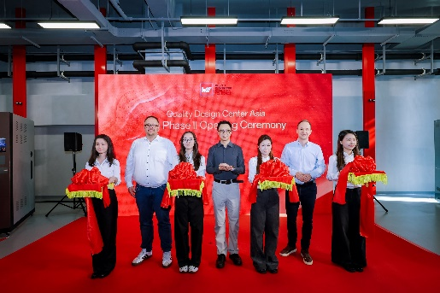Image source: Würth Elektronik
Proud of the opening of the new testing facilities in Shenzhen (China) by the Würth Elektronik eiSos Group: Dirk Knorr, COO; Yangyang Chen, Head of QDC Asia; and Thomas Garz,
CEO, accompanied by female employees from the QDC
(from left to right).

About the Würth Elektronik eiSos Group
Würth Elektronik eiSos Group is a manufacturer of electronic and electromechanical components for the electronics industry and a technology company that spearheads pioneering electronic solutions. Würth Elektronik eiSos is one of the largest European manufacturers of passive components and is active in 50 countries. Production sites in Europe, Asia and North America supply a growing number of customers worldwide.
The product range includes passive components, power modules, digital isolators, optoelectronics, electromechanical components, thermal management solutions, sensors and wireless modules. The portfolio is rounded off by customer-specific solutions.
The unrivaled service orientation of the company is characterized by the availability of all catalog components from stock without minimum order quantity, free samples and extensive support through technical sales staff and selection tools.

Würth Elektronik is part of the Würth Group, the global market leader in the development, production, and sale of fastening and assembly materials, and employs around 7,300 people. In 2025, the Würth Elektronik Group generated sales of 1.06 Billion Euro.
Würth Elektronik: more than you expect!
Further information at www.we-online.com

Further information:  Würth Elektronik eiSos GmbH & Co. KG  Sarah Hurst  Clarita-Bernhard-Strasse 9  81249 Munich  Germany  Phone: +49 7942 945-5186  E-mail: sarah.hurst@we-online.de  www.we-online.com | Press contact:  HighTech communications GmbH  Brigitte Basilio  Brunhamstrasse 21  81249 Munich  Germany  Phone: +49 89 500778-20  E-mail: b.basilio@htcm.de  www.htcm.de

