PRESS RELEASE
Capital and Statista honor the most innovative companies
Würth Elektronik Again Ranks Among Germany’s Best in 2026
Waldenburg (Germany), April 21, 2026 – “I’ve always wanted to know what lies over the hill and around the corner.” This personal motivation, expressed by Prof. Dr. h.c. mult. Reinhold Würth, company founder and Honorary Chairman of the Supervisory Board of the Würth Group’s Family Trusts, continues to shape the Würth Elektronik Group today. Openness to new approaches and a commitment to actively shaping innovation are firmly embedded in the company’s corporate culture. This commitment has once again been reaffirmed: in 2026, Würth Elektronik ranks among Germany’s most innovative companies. The group received four stars in the Capital and Statista innovation ranking, underscoring its sustained innovative strength.
In the prestigious study by business magazine Capital and statistics portal Statista, Würth Elektronik once again earned a four-star rating. For the latest edition, 2,785 innovation experts evaluated several thousand companies across 20 industries. A total of 503 companies were included in this year’s list of “Germany’s Most Innovative Companies.” The ranking is based on a comprehensive assessment of product and service innovations, process innovations, as well as cultural and social innovations.
Systematic innovation
Würth Elektronik’s innovative strength is built on the close interplay of technological expertise, such as in the field of Electromagnetic Compatibility (EMC), structured innovation processes, and an open corporate culture. At the Hightech Innovation Center in Munich, ideas are developed in collaboration with universities, customers, and partners from industry and research until they are ready for market. At the same time, Würth Elektronik is strongly committed to collaboration: startups receive targeted support to accelerate the deployment of new technologies, particularly in pioneering fields such as electromobility, intelligent components, and digital solutions.
Progress takes conviction
Innovation at Würth Elektronik is not an isolated initiative, but an integral part it’s the company’s corporate culture. Guided by the principle of “creating together,” Würth Elektronik fosters close collaboration both internally across disciplines and externally with partners, customers, and startups. The focus extends beyond technological progress to include responsibility: through its “Electronics for Positive Impact” approach, the company purposefully combines innovation with sustainable benefits for the environment and society. This conviction is especially important in a challenging economic environment. While many companies view current conditions for innovation critically, Würth Elektronik actively addresses these challenges with openness, collaboration, and a clear focus on future-oriented solutions.
The recognition in the latest Capital and Statista ranking once again underscores this aspiration. Würth Elektronik combines technological expertise with a structured approach to innovation and a clear sense of purpose, creating a strong foundation for sustainable progress in an increasingly dynamic market environment.

Available images
The following images can be downloaded from the Internet in printable quality: https://kk.htcm.de/press-releases/wuerth/
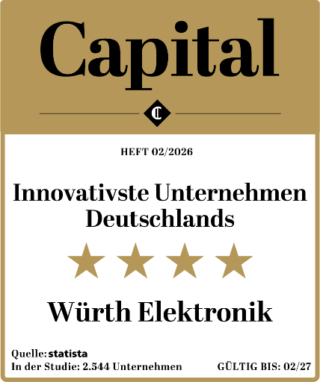  Image source: Capital, Statista  Four-star innovation rating  Würth Elektronik once again received high marks from the expert panel. | 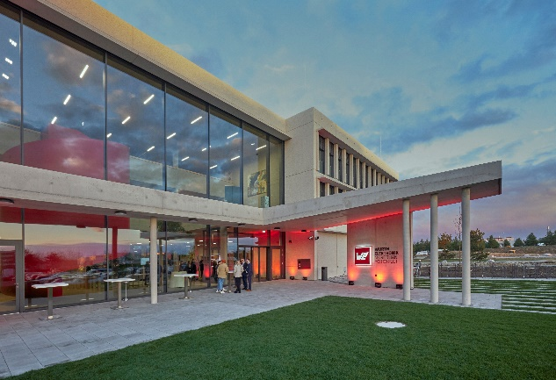  Image source: FloHagena/fotolevel  Würth Elektronik's Hightech Innovation Center in Munich

About the Würth Elektronik group of companies
Founded in Niedernhall, Baden-Württemberg, Germany, the Würth Elektronik Group of companies has about 7,300 employees worldwide and generated global sales of €1.06 Billion in 2025.
With more than 23 production locations around the world, Würth Elektronik is one of the most successful companies within the Würth Group.
Würth Elektronik operates internationally across three business units, serving a wide range of markets:
- Electronic & Electromechanical Components (eiSos) (Headquarters: Waldenburg)
Würth Elektronik eiSos is one of Europe's largest manufacturers of electronic and electromechanical components. A global direct sales network of more than 900 sales – unique within the electronics industry – provides customers with excellent on-site design-in support directly from the manufacturer. Production facilities in Germany, Romania, Bulgaria, USA, Mexico, Taiwan, and China ensure high product availability worldwide. All catalog products are available from stock and samples are provided free of charge.
- Printed Circuit Boards (PCBs) (Headquarters: Niedernhall)
Würth Elektronik Circuit Board Technology is one of Europe's leading PCB manufacturers and, with its comprehensive portfolio, a reliable partner for both individual entrepreneurs and large corporations. From basic to high-end technologies, customer-specific requirements are support from the initial design concept through prototype production via the online shop, and ultimately to medium- and high-volume manufacturing in Germany or Asia.
- Intelligent Power & Control Systems (ICS) (Headquarters: Niedernhall-Waldzimmern)
Würth Elektronik ICS supplies intelligent systems and components for signal and power distribution, function control, and display and operating solutions. Its main customers include well-known manufacturers of construction and agricultural machinery, as well as special-purpose and commercial vehicles. Würth Elektronik ICS also serves industries, such as industrial technology and renewable energy, with high-quality standardized or customized solutions. Customers benefit from comprehensive service and expertise- from the initial concept through series production.

Further info at www.we-online.com

Further information:  Würth Elektronik eiSos GmbH & Co. KG  Sarah Hurst  Clarita-Bernhard-Strasse 9  81249 Munich  Germany  Phone: +49 7942 945-5186  E-mail: sarah.hurst@we-online.de  www.we-online.com | Press contact:  HighTech communications GmbH  Brigitte Basilio  Brunhamstrasse 21  81249 Munich  Germany  Phone: +49 89 500778-20  E-mail: b.basilio@htcm.de  www.htcm.de

