PRESS RELEASE

Würth Elektronik introduces its nanocrystalline EMI shielding sheets
Quick and Easy Shielding
Waldenburg (Germany), June 17, 2026 – Würth Elektronik is expanding its EMC product portfolio with nanocrystalline WE-FNCS sheets. The extremely flexible and thin nanocrystalline layers, protected by a PET cover layer, are supplied in the form of adhesive tapes and strips. They attenuate electromagnetic interference signals in the frequency range from around 10 Hz to 120 MHz. The sheets can be used as a simple, cost-effective way to make housings for electronic devices EMC compliant without the need for mu-metal.
Both emissions and external interference are challenges for developers during EMC testing, when demonstrating compliance with standards such as CISPR 32, especially in the lower frequency range. Components such as power transformers, common-mode chokes (CMCs), DC/DC converters, inverters, switched-mode power supplies, Hall effect sensors, as well as medical systems including MRI scanners, can generate unwanted magnetic fields or be affected by them.
WE-FNCS nanocrystalline sheets offer an effective and easy-to-use solution for suppressing electromagnetic interference (EMI) in such applications. They can also increase the efficiency of wireless power transfer systems by guiding the magnetic flux and reducing stray fields.
Adaptable magnetic permeability
WE‑FNCS is a high-performance magnetic absorber specifically developed to suppress low-frequency EMI. Its nanocrystalline structure ensures exceptionally high magnetic permeability and flux saturation, ensuring uniform attenuation across the entire low- and mid-frequency range. By adapting the number of internal nanocrystalline layers, the absorption performance can be scaled to meet the requirements of different applications. Multi-layer configurations with tailored permeabilities help optimize the shielding effectiveness of a solution while keeping it thin, flexible and easy to integrate. This is particularly beneficial in applications where space is limited.
A black PET cover layer provides the necessary electrical insulation on the upper side, while an acrylic adhesive layer on the underside simplifies mounting the sheet in production or in finished devices. Both the upper and lower layers are protected by foil, which is removed when the absorber is applied.
Würth Elektronik can supply WE-FNCS with customized formats and layer configurations. Technical support for product integration is also provided on request.

Available images
The following images can be downloaded from the Internet in printable quality: https://kk.htcm.de/press-releases/wuerth/
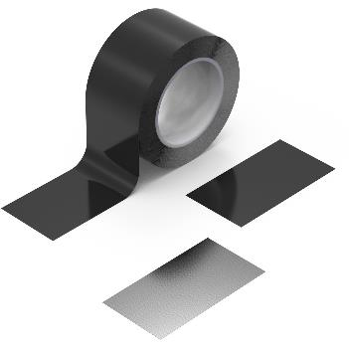  Image source: Würth Elektronik  WE-FNCS (Flexible Nanocrystalline Sheets) – a simple and cost-effective EMC solution. | 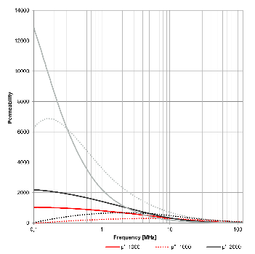  Image source: Würth Elektronik  Performance of the nanocrystalline sheets.

About the Würth Elektronik eiSos Group
Würth Elektronik eiSos Group is a manufacturer of electronic and electromechanical components for the electronics industry and a technology company that spearheads pioneering electronic solutions. Würth Elektronik eiSos is one of the largest European manufacturers of passive components and is active in 50 countries. Production sites in Europe, Asia and North America supply a growing number of customers worldwide.
The product range includes passive components, power modules, digital isolators, optoelectronics, electromechanical components, thermal management solutions, sensors and wireless modules. The portfolio is rounded off by customer-specific solutions.

The unrivaled service orientation of the company is characterized by the availability of all catalog components from stock without minimum order quantity, free samples and extensive support through technical sales staff and selection tools.
Würth Elektronik is part of the Würth Group, the global market leader in the development, production, and sale of fastening and assembly materials, and employs around 7,300 people. In 2025, the Würth Elektronik Group generated sales of 1.06 Billion Euro.
Würth Elektronik: more than you expect!
Further information at www.we-online.com

Further information:  Würth Elektronik eiSos GmbH & Co. KG  Sarah Hurst  Clarita-Bernhard-Strasse 9  81249 Munich  Germany  Phone: +49 7942 945-5186  E-mail: sarah.hurst@we-online.de  www.we-online.com | Press contact:  HighTech communications GmbH  Brigitte Basilio  Brunhamstrasse 21  81249 Munich  Germany  Phone: +49 89 500778-20  E-mail: b.basilio@htcm.de  www.htcm.de

