PRESS RELEASE

Würth Elektronik presents a new power inductor for automotive electronics
Ultra-low losses and highest current capability
Waldenburg (Germany), March 24, 2026 – With the WE-MXGA inductor Würth Elektronik presents an AEC-Q200-certified component qualified for automotive applications with several impressive properties. The inductor features R_{DC} values up to 25 percent lower and a saturation current up to 47 percent higher compared to other components currently available on the market. The compact inductor is well suited for use in lighting, infotainment systems, DC/DC converters (48 V/12 V), battery-management systems, ADAS modules, and LED headlights.
The compact, magnetically shielded SMT storage inductor WE-MXGA with the highest power density is particularly well suited for high-frequency switch-mode power supplies in modern power electronics, especially for switching regulators based on the new GaN and SiC transistor technologies. The inductor‘s low losses and high efficiency are the result of an optimized wire geometry and the innovative pressed nanocrystalline powder core material.
Two form factors
The new power inductors are available in two versions, in form factor 4020 with inductances of 0.16 to 4.7 µH and in form factor 5030 with inductances of 0.22 to 15 µH. With a current capability of up to 28 A and an operating voltage up to 80 V_{DC,} the inductor has an operating temperature range from -40 °C up to 125 °C.
The WE-MXGA 4020 and WE-MXGA 5030 components are now available ex stock. Free-of-charge samples are available on request.

Available images
The following images can be downloaded from the Internet in printable quality: https://kk.htcm.de/press-releases/wuerth/

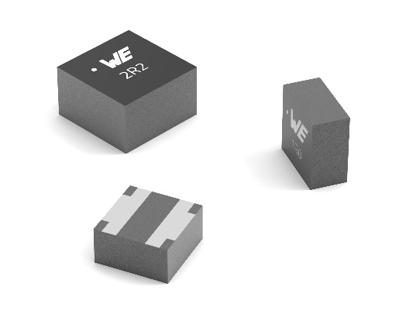
Image source: Würth Elektronik
Compared to other inductors currently available on the market, the WE-MXGA is characterized by an ultra-high saturation current and an ultra-low resistance suited for automotive applications.

Available videos
You can find videos on this topic on our YouTube channel:
https://www.youtube.com/watch?v=v29hlaBFhZE
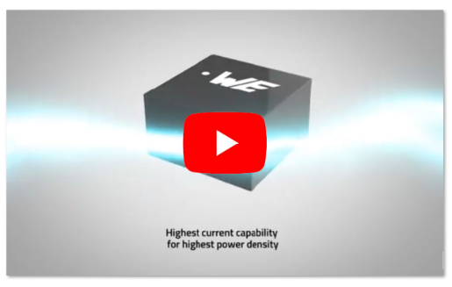Source: Würth Elektronik
Video: WE-MXGA SMT Power Inductor

About the Würth Elektronik eiSos Group
Würth Elektronik eiSos Group is a manufacturer of electronic and electromechanical components for the electronics industry and a technology company that spearheads pioneering electronic solutions. Würth Elektronik eiSos is one of the largest European manufacturers of passive components and is active in 50 countries. Production sites in Europe, Asia and North America supply a growing number of customers worldwide.

The product range includes passive components, power modules, digital isolators, optoelectronics, electromechanical components, thermal management solutions, sensors and wireless modules. The portfolio is rounded off by customer-specific solutions.
The unrivaled service orientation of the company is characterized by the availability of all catalog components from stock without minimum order quantity, free samples and extensive support through technical sales staff and selection tools.
Würth Elektronik is part of the Würth Group, the global market leader in the development, production, and sale of fastening and assembly materials, and employs around 7,300 people. In 2025, the Würth Elektronik Group generated sales of 1.06 Billion Euro.
Würth Elektronik: more than you expect!
Further information at www.we-online.com

Further information:  Würth Elektronik eiSos GmbH & Co. KG  Sarah Hurst  Clarita-Bernhard-Strasse 9  81249 Munich  Germany  Phone: +49 7942 945-5186  E-mail: sarah.hurst@we-online.de  www.we-online.com | Press contact:  HighTech communications GmbH  Brigitte Basilio  Brunhamstrasse 21  81249 Munich  Germany  Phone: +49 89 500778-20  E-mail: b.basilio@htcm.de  www.htcm.de

