PRESS RELEASE


Würth Elektronik at embedded world 2026
Secure Wireless Connectivity for Embedded Systems
March 10-12, 2026
Hall 2, Stand 110
Waldenburg (Germany), January 29, 2026 – The Würth Elektronik eiSos Group is exhibiting at embedded world in Nuremberg, March 10-12, 2026 (Hall 2, Booth 110). This year, the manufacturer of electronic and electromechanical components is focusing on secure and high-performance wireless solutions for embedded systems. Würth Elektronik positions itself as a “one-stop shop for RF connectivity”. Its partners on the 200-square-meter booth include STMicroelectronics and Analog Devices, they will present live demos and collaborative reference designs. Another guest is renowned simulation software developer Mike Engelhardt, who will be giving a QSPICE demo.
Würth Elektronik offers a broad portfolio of compact, energy-saving wireless modules, including FeatherWing variants for prototyping. At embedded world, the company will present Proteus-IV and Ophelia-IV, its two high-performance RF modules based on the latest Nordic Semiconductor nRF54L15 system on a chip (SoC). Würth Elektronik also positions itself as a partner for developers seeking customized wireless solutions for specific applications. “When it comes to decentralized sensors and actuators in an IoT application, suitable hardware alone is not sufficient. Cybersecurity also plays an increasingly critical role, as wireless networks must not become an entry point for cyberattacks. Security by Design can secure an application at an early stage through its firmware and a proprietary wireless protocol. We’re happy to help,” says Alexander Gerfer, CTO of the Würth Elektronik eiSos Group.
The antenna? That’s just the beginning!
Besides hardware, the company offers a range of specialized services that support customers throughout the development process. These services include antenna matching, certification support, custom firmware development, and expert guidance in selecting the protocol best suited to the application to ensure connectivity and compliance, complemented by cybersecurity solutions. To support complete wireless solutions, Würth Elektronik complements its modules with coaxial connectors, RF inductors for antenna matching, and dedicated chip and rod antennas.
QSPICE demo station with Mike Engelhardt
The latest version of the LTspice simulation software now also supports the latest wide bandgap components such as silicon carbide and gallium nitride semiconductors. QSPICE will be presented and explained by its developer, Mike Engelhardt. He has been programming physical simulators since 1975, holds eight important patents, and has already given lectures on SPICE simulation (Simulation Program with Integrated Circuit Emphasis) in 48 countries.
Conference presentation
Dr. Heinz Zenkner will present a seminar on “Safeguarding Industrial Interfaces – Reliable Protection against Transient Overvoltage” on Tuesday, March 10, 2026, at 2.00 pm. Participants will learn about various protection mechanisms against overvoltage. Würth Elektronik will also take part in Student Day on Thursday, March 12, 2026, with its own program at the booth.
Further information on Würth Elektronik’s trade show appearance can be found at www.we-online.com/embedded6.

Available images
The following images can be downloaded from the Internet in printable quality: https://kk.htcm.de/press-releases/wuerth/
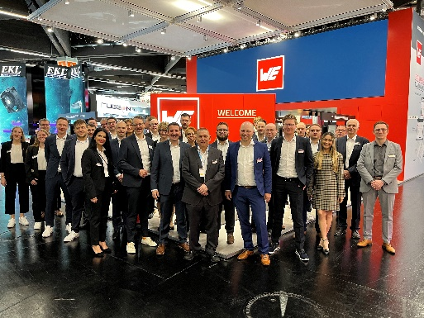  Image source: Würth Elektronik  Würth Elektronik looks forward to welcoming numerous visitors at its booth. | Image source: Würth Elektronik  Mike Engelhardt, SPICE specialist, presents the QSPICE simulation tool at the Würth Elektronik booth.

About the Würth Elektronik eiSos Group
Würth Elektronik eiSos Group is a manufacturer of electronic and electromechanical components for the electronics industry and a technology company that spearheads pioneering electronic solutions. Würth Elektronik eiSos is one of the largest European manufacturers of passive components and is active in 50 countries. Production sites in Europe, Asia and North America supply a growing number of customers worldwide.
The product range includes passive components, power modules, digital isolators, optoelectronics, electromechanical components, thermal management solutions, sensors and wireless modules. The portfolio is rounded off by customer-specific solutions.
The unrivaled service orientation of the company is characterized by the availability of all catalog components from stock without minimum order quantity, free samples and extensive support through technical sales staff and selection tools.
Würth Elektronik is part of the Würth Group, the global market leader in the development, production, and sale of fastening and assembly materials, and employs around 7,500 people. In 2024, the Würth Elektronik Group generated sales of 1.02 Billion Euro.
Würth Elektronik: more than you expect!
Further information at www.we-online.com

Further information:  Würth Elektronik eiSos GmbH & Co. KG  Sarah Hurst  Clarita-Bernhard-Strasse 9  81249 Munich  Germany  Phone: +49 7942 945-5186  E-mail: sarah.hurst@we-online.de  www.we-online.com | Press contact:  HighTech communications GmbH  Brigitte Basilio  Brunhamstrasse 21  81249 Munich  Germany  Phone: +49 89 500778-20  E-mail: b.basilio@htcm.de  www.htcm.de

