PRESS RELEASE

Würth Elektronik presents a differential pressure sensor
Highly accurate and very versatile
Waldenburg (Germany), March 17, 2026 – Würth Elektronik proudly presents their latest product, the WSEN-PDMS, a new highly accurate differential pressure sensor for a multitude of operating scenarios. The sensor operates with an accuracy of ±1 mbar and a resolution of 16 bits, supports a broad voltage range from 3.0 V up to 5.5 V, and is compatible both with digital I²C and SPI communication interfaces as well as an analog interface. Two different casing versions make the sensor particularly versatile: they are available with vertical straight nozzles for connection with pressure adapters and with horizontal barbed nozzles for tube connection. This flexibility makes both system integration as well as prototype development much easier to accomplish.
These features ensure the WSEN-PDMS sensor is compatible with a broad range of microcontrollers and embedded systems. The sensor delivers fully calibrated differential-pressure data as well as optional temperature measurements, and operates reliably in a temperature range from -25°C up to +85°C. Optionally the transmitted measurement results can be complemented by additional CRC bits, thus enabling a reliable and robust communication.
Advanced development
The WSEN-PDMS is based on the robust design of the time-tested WSEN-PDUS sensor, which will remain part of our product portfolio. Just like its predecessor, the new sensor is suited for a broad range of applications – from heating, ventilation, and air-conditioning technology, filter-status monitoring, gas-leak detection, and industrial automation, all the way to medical devices such as inhalation equipment.
Like all the sensor products supplied by Würth Elektronik, the WSEN-PDMS series is also available ex stock without any minimum order quantity. It is also possible to develop versions according to the customer’s own specifications to meet special application requirements. Würth Elektronik offers evaluation boards and an extensive Software Development Kit on GitHub to facilitate a swift development and evaluation process, enabling engineers to put the sensor to use quickly, to test its functionality, and to integrate it into their systems with maximum ease.

Available images
The following images can be downloaded from the Internet in printable quality: https://kk.htcm.de/press-releases/wuerth/
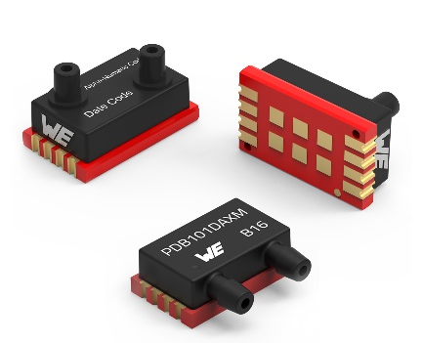
Image source: Würth Elektronik
The WSEN-PDMS differential pressure sensor is available in two different casings.

About the Würth Elektronik eiSos Group
Würth Elektronik eiSos Group is a manufacturer of electronic and electromechanical components for the electronics industry and a technology company that spearheads pioneering electronic solutions. Würth Elektronik eiSos is one of the largest European manufacturers of passive components and is active in 50 countries. Production sites in Europe, Asia and North America supply a growing number of customers worldwide.
The product range includes passive components, power modules, digital isolators, optoelectronics, electromechanical components, thermal management solutions, sensors and wireless modules. The portfolio is rounded off by customer-specific solutions.
The unrivaled service orientation of the company is characterized by the availability of all catalog components from stock without minimum order quantity, free samples and extensive support through technical sales staff and selection tools.

Würth Elektronik is part of the Würth Group, the global market leader in the development, production, and sale of fastening and assembly materials, and employs around 7,300 people. In 2025, the Würth Elektronik Group generated sales of 1.06 Billion Euro.
Würth Elektronik: more than you expect!
Further information at www.we-online.com

Further information:  Würth Elektronik eiSos GmbH & Co. KG  Sarah Hurst  Clarita-Bernhard-Strasse 9  81249 Munich  Germany  Phone: +49 7942 945-5186  E-mail: sarah.hurst@we-online.de  www.we-online.com | Press contact:  HighTech communications GmbH  Brigitte Basilio  Brunhamstrasse 21  81249 Munich  Germany  Phone: +49 89 500778-20  E-mail: b.basilio@htcm.de  www.htcm.de

