PRESS RELEASE

Würth Elektronik expands its MagI³C-VDMM MicroModule series
Pin-Compatible Variants
Waldenburg (Germany), November 5, 2025 – The MagI³C-VDMM power module product family from Würth Elektronik continues to grow: The three variable step-down MicroModules for input voltages from 2.5 V to 5.5 V and adjustable output voltages from 0.6 V to 4 V are available in pin-compatible 1 A, 2 A, and 3 A versions. The modules achieve a peak efficiency of up to 96 percent. With their low quiescent current of 4 µA, they are also suitable for battery-powered applications.
MagI³C-VDMM power modules represent a fully integrated DC-DC power supply that includes a switching regulator with integrated MOSFETs, as well as a controller, compensation, and a shielded inductor – all in a single package. The modules, which can replace linear regulators, are equipped with integrated protection circuits. They protect against thermal overload and electrical damage caused by overcurrent, short circuit and undervoltage. Depending on the load, they automatically switch between pulse frequency modulation (PFM) and pulse width modulation (PWM) modes. These mode transitions ensure optimal efficiency and output voltage ripple at all load currents. To save energy, the power module can be set to resting mode using an additional pin. Together, the Power-GOOD and EN functions also enable power sequencing. The new MagI³C-VDMM power modules are highly compact with their 3.5 x 3.5 x 1.5 mm LGA-9 package.
Applications
Variable step-down MicroModules are suitable for point-of-load DC-DC applications, industrial and medical equipment, test and measurement devices, for powering digital signal processors (DSPs), field-programmable gate arrays (FPGAs), microcontroller units (MCUs) and microprocessor units (MPUs), as well as I/O interfaces. The MagI³C-VDMM series features excellent electromagnetic compatibility. The modules comply with EN55032 (CISPR-32) Class B for radiated emissions. Their operating temperature range extends from -40°C to 105°C.
The new members of the MagI³C-VDMM family are available from stock, even in larger quantities. Free samples can be requested at any time.

Available images
The following images can be downloaded from the Internet in printable quality: https://kk.htcm.de/press-releases/wuerth/
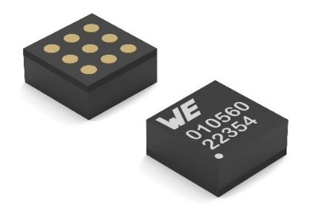
Image source: Würth Elektronik
The new MagI³C-VDMM power module with adjustable output voltage from 0.6 V to 4 V is available in pin-compatible 1 A, 2 A, and 3 A versions.

About the Würth Elektronik eiSos Group
Würth Elektronik eiSos Group is a manufacturer of electronic and electromechanical components for the electronics industry and a technology company that spearheads pioneering electronic solutions. Würth Elektronik eiSos is one of the largest European manufacturers of passive components and is active in 50 countries. Production sites in Europe, Asia and North America supply a growing number of customers worldwide.
The product range includes passive components, power modules, digital isolators, optoelectronics, electromechanical components, thermal management solutions, sensors and wireless modules. The portfolio is rounded off by customer-specific solutions.
The unrivaled service orientation of the company is characterized by the availability of all catalog components from stock without minimum order quantity, free samples and extensive support through technical sales staff and selection tools.
Würth Elektronik is part of the Würth Group, the global market leader in the development, production, and sale of fastening and assembly materials, and employs around 7,500 people. In 2024, the Würth Elektronik Group generated sales of 1.02 Billion Euro.

Würth Elektronik: more than you expect!
Further information at www.we-online.com

Further information:  Würth Elektronik eiSos GmbH & Co. KG  Sarah Hurst  Clarita-Bernhard-Strasse 9  81249 Munich  Germany  Phone: +49 7942 945-5186  E-mail: sarah.hurst@we-online.de  www.we-online.com | Press contact:  HighTech communications GmbH  Brigitte Basilio  Brunhamstrasse 21  81249 Munich  Germany  Phone: +49 89 500778-20  E-mail: b.basilio@htcm.de  www.htcm.de

