PRESS RELEASE

Würth Elektronik introduces heat sinks for power-electronics and IC components
Service-Oriented Entry into Cooling Technology
Waldenburg (Germany), March 31, 2026 – Würth Elektronik expands its product range and launches a comprehensive heat sink portfolio, divided into three specialized product groups: The WE-HTO heat sinks are designed for THT-TO packages like the TO-220 and TO-247. WE-HIC includes classic finned heat sinks for components with flat surfaces, such as CPUs or DC/DC converters. The WE-HTOI and WE-HICI variants are supplied from the factory pre-coated with thermal interface material. This eliminates the air gap between the component and the heat sink, thus maximizing cooling performance. As a special service, Würth Elektronik provides technical support, detailed heat-sink characteristics, simulation options, as well as customer-specific modifications.
The WE-HTO heat sinks are available in various shapes and with different surface structures to enable tailored cooling performance. These include variants with curved sheet metal and with cooling fins, which dissipate more heat through their increased surface area. In addition, matching M3 screws, nuts, and insulating sleeves for mounting on the WE-HTO and WE-HTOI heat sinks can also be ordered.
Cooling fins for different airflow conditions
WE-HIC is available in two variants: with continuous and interrupted fins. The design with continuous fins is designed for applications in which the airflow is aligned with the fins. The variant with interrupted fins, however, is ideal when airflow in the installation environment cannot be clearly defined. Heat sinks for ICs are available in sizes ranging from 20 × 20 to 40 × 40 mm.
“We’ve been offering thermal interface materials for quite some time now, and in our design-in support for customers we always pay close attention to thermal management as well as EMC. So it’s only logical that we’re now expanding our offering to include heat sinks – after all, preventing overheating contributes to the performance and service life of components,” explains Maria Cuesta-Martin, Product Manager EMC Shielding & Thermal Materials at Würth Elektronik eiSos GmbH & Co. KG.
The heat sinks from Würth Elektronik are now available from stock without a minimum order quantity. Free samples are available on request.

Available images
The following images can be downloaded from the Internet in printable quality: https://kk.htcm.de/press-releases/wuerth/
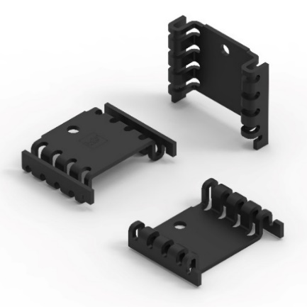  Image source: Würth Elektronik  The WE-HTO heat sinks are designed for THT-TO packages like the TO-220 and TO-247. Here, curved sheet metal increases the surface area for heat dissipation. | 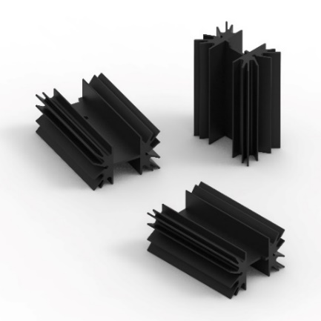  Image source: Würth Elektronik  Cooling fins for TO components
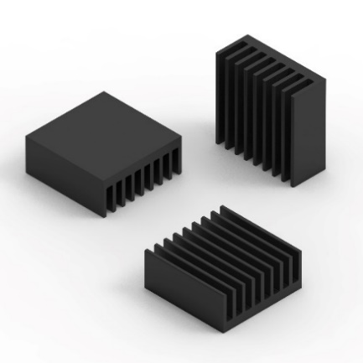Image source: Würth Elektronik  WE- HIC with continuous fins for applications in which the defined airflow is clearly aligned with the fins. | 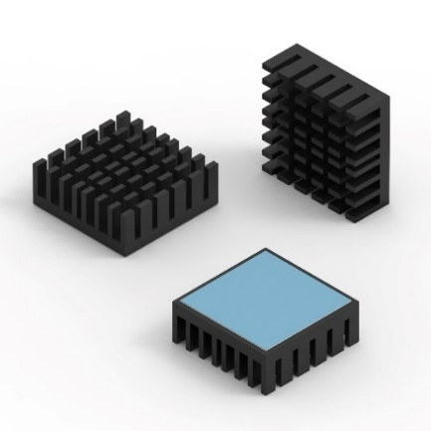Image source: Würth Elektronik  Cooling fins for diffuse airflow conditions, in the version with thermal interface material

About the Würth Elektronik eiSos Group
Würth Elektronik eiSos Group is a manufacturer of electronic and electromechanical components for the electronics industry and a technology company that spearheads pioneering electronic solutions. Würth Elektronik eiSos is one of the largest European manufacturers of passive components and is active in 50 countries. Production sites in Europe, Asia and North America supply a growing number of customers worldwide.
The product range includes passive components, power modules, digital isolators, optoelectronics, electromechanical components, thermal management solutions, sensors and wireless modules. The portfolio is rounded off by customer-specific solutions.
The unrivaled service orientation of the company is characterized by the availability of all catalog components from stock without minimum order quantity, free samples and extensive support through technical sales staff and selection tools.
Würth Elektronik is part of the Würth Group, the global market leader in the development, production, and sale of fastening and assembly materials, and employs around 7,300 people. In 2025, the Würth Elektronik Group generated sales of 1.06 Billion Euro.
Würth Elektronik: more than you expect!
Further information at www.we-online.com

Further information:  Würth Elektronik eiSos GmbH & Co. KG  Sarah Hurst  Clarita-Bernhard-Strasse 9  81249 Munich  Germany  Phone: +49 7942 945-5186  E-mail: sarah.hurst@we-online.de  www.we-online.com | Press contact:  HighTech communications GmbH  Brigitte Basilio  Brunhamstrasse 21  81249 Munich  Germany  Phone: +49 89 500778-20  E-mail: b.basilio@htcm.de  www.htcm.de

