PRESS PRELEASE

Würth Elektronik remains a reliable training partner
Twenty-seven Young Talents Begin Their Careers
Waldenburg (Germany), September 8, 2025 – Würth Elektronik continues to demonstrate its commitment to fostering young talent and maintaining high standards in training in 2025. On September 1, 27 new trainees and students embarked on 14 different training and study programs at the Waldenburg and Munich locations. Their journey began with the traditional Welcome Week, featuring a mix of training sessions, workshops and interactive activities designed to immerse newcomers in the company's culture and values.
The first day began at the Carmen Würth Forum, where all new trainees and students of the Würth Group gathered. The Young Talents participated in a dynamic Welcome Week in Waldenburg, gaining valuable insights into various departments and building valuable relationships with mentors and peers from previous years. The goal is to provide orientation, foster community, and inspire enthusiasm for the next steps in their careers.
Team spirit: Football with the Schwäbisch Hall Unicorns
The Welcome Week concluded with a joint excursion for all Young Talent cohorts. Thanks to Würth Elektronik’s partnership with the Schwäbisch Hall Unicorns, participants enjoyed a joint football training session - a sporting event that brought team spirit and camaraderie to life, setting the perfect tone for the training period ahead.
Many Paths to Personal Success
Würth Elektronik offers an extensive selection of over 18 apprenticeships, dual study programs, and the cooperative “Studium PLUS Ausbildung” model, which combines a Chamber of Industry and Commerce apprenticeship with a university degree. Whether commercial, technical, or IT fields, talented individuals find tailored development paths and the opportunity to develop their strengths and take on responsibility.
"We see training as a promise of trust: We support our young talents personally, challenge and encourage them individually and give them the stage to develop their potential. The fact that many graduate with distinction and stay with us confirms our approach and motivates us to continue to invest reliably in training," says Sabine Lindner from the Young Talent Acquisition Team at Würth Elektronik.

A Reliable Training Partner in the Region
Even in challenging economic times, Würth Elektronik remains a stable training partner in the region. Personal support from experienced trainers, clear structures from the start and individualized guidance are hallmarks of the company’s training philosophy. The results speak for themselves: around one-third of trainees graduate with distinction, 93% remain with the company after completing their programs.
Orientation, information, exchange
Pupils and students interested in learning more can arrange interviews with the Young Talents at Würth Elektronik or gain hands-on experience through one of the many available internships. All information on apprenticeships, dual study programs and “Studium PLUS Ausbildung” can be found at www.we-online.com/karriere.

Available images
The following images can be downloaded from the Internet in printable quality: https://kk.htcm.de/press-releases/wuerth/
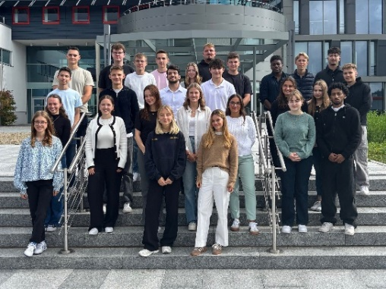
Image source: Würth Elektronik
Young Talents 2025 at Würth Elektronik: After the Welcome Week, they start their apprenticeship networked, well prepared and with a lot of team spirit.

About the Würth Elektronik eiSos Group
Würth Elektronik eiSos Group is a manufacturer of electronic and electromechanical components for the electronics industry and a technology company that spearheads pioneering electronic solutions. Würth Elektronik eiSos is one of the largest European manufacturers of passive components and is active in 50 countries. Production sites in Europe, Asia and North America supply a growing number of customers worldwide.
The product range includes passive components, power modules, digital isolators, optoelectronics, electromechanical components, thermal management solutions, sensors and wireless modules. The portfolio is rounded off by customer-specific solutions.
The unrivaled service orientation of the company is characterized by the availability of all catalog components from stock without minimum order quantity, free samples and extensive support through technical sales staff and selection tools.
Würth Elektronik is part of the Würth Group, the global market leader in the development, production, and sale of fastening and assembly materials, and employs around 7,500 people. In 2024, the Würth Elektronik Group generated sales of 1.02 Billion Euro.
Würth Elektronik: more than you expect!
Further information at www.we-online.com

Further information:  Würth Elektronik eiSos GmbH & Co. KG  Sarah Hurst  Clarita-Bernhard-Strasse 9  81249 Munich  Germany  Phone: +49 7942 945-5186  E-mail: sarah.hurst@we-online.de  www.we-online.com | Press contact:  HighTech communications GmbH  Brigitte Basilio  Brunhamstrasse 21  81249 Munich  Germany  Phone: +49 89 500778-20  E-mail: b.basilio@htcm.de  www.htcm.de

