PRESS RELEASE
Würth Elektronik stages its virtual conference from October 20 to 23
Digital WE Days 2025
Waldenburg (Germany), September 11, 2025 – Würth Elektronik is once again hosting its popular online conference this year: Specialists from the manufacturer of passive components and its partner companies present interesting and current topics from a wide range of areas in the electronics industry. Registration is free and is now open at www.we-online.com/digitalwedays2025.
“Innovation needs knowledge transfer. That’s why the Digital WE Days event is far more than just a conference for us – it’s a platform where we share expertise, put trends into context, and provide fresh impetus for the future of the electronics industry,” stresses Alexander Gerfer, CTO of the Würth Elektronik eiSos Group. “Our goal is to make knowledge available where it’s needed – digitally, freely accessible, and always in step with the times. This is exactly how we fulfill our claim: more than you expect."
Online presentations and discussions
From October 20 to 23, 2025, experts will share their latest electronics insights, discuss current developments, and present practical challenges and solutions. Partner presentations from Rohde & Schwarz, Analog Devices, Infineon, and Cambridge GaN Devices round off the program. The online presentations in English last around 30 minutes, after which participants will have the opportunity to ask questions. The target group for the event is developers as well as other interested parties from across the electronics industry.
Varied presentation program
The focus topics of this year’s Digital WE Days are:
- Power electronics today and in the future
- EMC in practice
- Data and signal integrity
- Wireless connectivity and sensors
- Helpful tips for component selection
Digital WE Days is a free service from Würth Elektronik. All presentations can be booked individually. Registration for the virtual conference is now open. The full presentation program, along with a link to register, is available at www.we-online.com/digitalwedays2025.

Available images
The following images can be downloaded from the Internet in printable quality: https://kk.htcm.de/press-releases/wuerth/
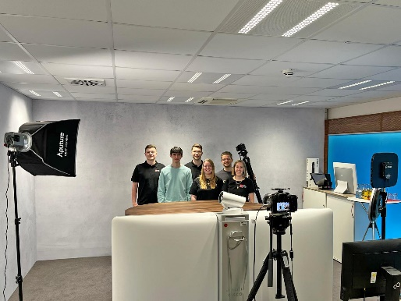  Image source: Würth Elektronik  Live broadcast from the Würth Elektronik studio: A well-established team ensures smooth running | 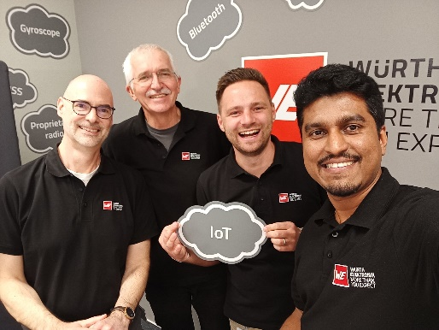  Image source: Würth Elektronik  In-depth technical knowledge first-hand: Speakers at Digital WE Days

About the Würth Elektronik eiSos Group
Würth Elektronik eiSos Group is a manufacturer of electronic and electromechanical components for the electronics industry and a technology company that spearheads pioneering electronic solutions. Würth Elektronik eiSos is one of the largest European manufacturers of passive components and is active in 50 countries. Production sites in Europe, Asia and North America supply a growing number of customers worldwide.
The product range includes passive components, power modules, digital isolators, optoelectronics, electromechanical components, thermal management solutions, sensors and wireless modules. The portfolio is rounded off by customer-specific solutions.
The unrivaled service orientation of the company is characterized by the availability of all catalog components from stock without minimum order quantity, free samples and extensive support through technical sales staff and selection tools.
Würth Elektronik is part of the Würth Group, the global market leader in the development, production, and sale of fastening and assembly materials, and employs around 7,500 people. In 2024, the Würth Elektronik Group generated sales of 1.02 Billion Euro.

Würth Elektronik: more than you expect!
Further information at www.we-online.com

Further information:  Würth Elektronik eiSos GmbH & Co. KG  Sarah Hurst  Clarita-Bernhard-Strasse 9  81249 Munich  Germany  Phone: +49 7942 945-5186  E-mail: sarah.hurst@we-online.de  www.we-online.com | Press contact:  HighTech communications GmbH  Brigitte Basilio  Brunhamstrasse 21  81249 Munich  Germany  Phone: +49 89 500778-20  E-mail: b.basilio@htcm.de  www.htcm.de

