PRESS RELEASE
Würth Elektronik eiSos Opens Successful Childcare Initiative to Non-Employees
Kitz@eiSos Childcare Now Welcomes All Families
Waldenburg (Germany), September 16, 2025 – For over ten years, the company daycare center Kitz@eiSos has offered loving, flexible, and reliable care to young families at the Waldenburg site. Previously reserved for Würth Elektronik eiSos employees, the popular Kitz childcare concept is now also open to families outside the company: it is available to anyone who is interested.
Since 2013, Würth Elektronik eiSos has operated Kitz@eiSos in Waldenburg-Hohebuch in close cooperation with the association kit, Familiäre Kindertagesbetreuung Hohenlohekreis e. V. Located in a specially renovated apartment on the grounds of the Hohebuch adult education center, the daycare provides children under the age of three with a welcoming second home. The facility features lovingly furnished rooms, dedicated caregivers, and freshly prepared meals each day. Play, fun and exercise are an integral part of the daily routine, allowing young explorers to experience nature and explore their surroundings in a protected environment.
For a better work-life balance
Kitz@eiSos was established to support Würth Elektronik employees in returning to work after parental leave. The benefits are clear: flexible and reliable childcare hours from 7:00 am to 6:00 pm, or until 12:30 pm on Fridays, provide families with valuable planning security. Minimal closing days further help parents balance family and career. With a comfortable childcare ratio of three children per caregiver and a family-like atmosphere, hosting a maximum of ten children at a time, Kitz@eiSos offers a welcoming and nurturing environment for young children. As a result, the daycare has become an integral part of Würth Elektronik’s family-friendly corporate culture. Now, for the first time, Kitz@eiSos is also open to families outside the company.
Open Enrollment for 2025 – Learn More Today
“In recent years, Kitz@eiSos has helped many parents at Würth Elektronik to balance family and career,” says Vanessa Stein, program coordinator for Kitz@eiSos. "So we know from our own experience how valuable a reliable childcare service is for young families. That's why it's a great step that families outside the company can now also benefit from our Kitz@eiSos." Anyone interested in enrolling can find more information at https://kit-hohenlohekreis.de/waldenburg.html.

Available images
The following images can be downloaded from the Internet in printable quality: https://kk.htcm.de/press-releases/wuerth/
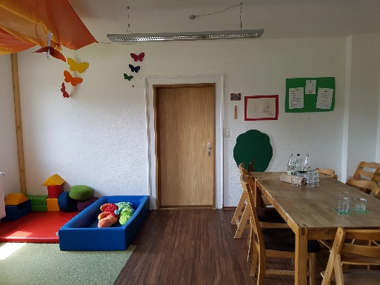  Image source: Würth Elektronik  Growing together: Kitz@eiSos offers loving and reliable care for children under the age of 3. | 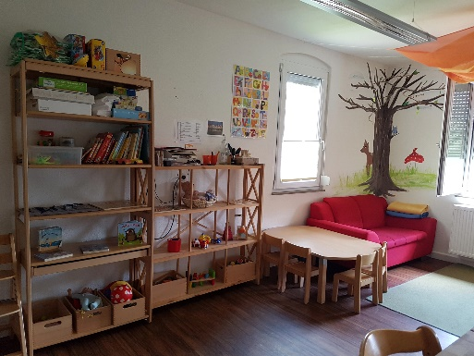  Image source: Würth Elektronik  A feel-good place for the little ones: with lots of variety, but fixed caregivers.

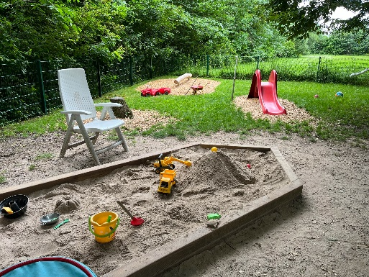  Image source: Würth Elektronik  Nature on the doorstep: a large garden awaits little explorers at Kitz@eiSos. | 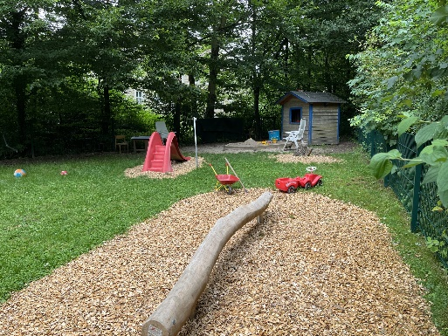  Image source: Würth Elektronik  Fresh air: The little ones can live out their urge to move outdoors.

About the Würth Elektronik eiSos Group
Würth Elektronik eiSos Group is a manufacturer of electronic and electromechanical components for the electronics industry and a technology company that spearheads pioneering electronic solutions. Würth Elektronik eiSos is one of the largest European manufacturers of passive components and is active in 50 countries. Production sites in Europe, Asia and North America supply a growing number of customers worldwide.

The product range includes passive components, power modules, digital isolators, optoelectronics, electromechanical components, thermal management solutions, sensors and wireless modules. The portfolio is rounded off by customer-specific solutions.
The unrivaled service orientation of the company is characterized by the availability of all catalog components from stock without minimum order quantity, free samples and extensive support through technical sales staff and selection tools.
Würth Elektronik is part of the Würth Group, the global market leader in the development, production, and sale of fastening and assembly materials, and employs around 7,500 people. In 2024, the Würth Elektronik Group generated sales of 1.02 Billion Euro.
Würth Elektronik: more than you expect!
Further information at www.we-online.com

Further information:  Würth Elektronik eiSos GmbH & Co. KG  Sarah Hurst  Clarita-Bernhard-Strasse 9  81249 Munich  Germany  Phone: +49 7942 945-5186  E-mail: sarah.hurst@we-online.de  www.we-online.com | Press contact:  HighTech communications GmbH  Brigitte Basilio  Brunhamstrasse 21  81249 Munich  Germany  Phone: +49 89 500778-20  E-mail: b.basilio@htcm.de  www.htcm.de

