PRESS RELEASE

Würth Elektronik launches its partner program
Together on Course for Innovation
Waldenburg (Germany), February 5, 2026 – Würth Elektronik, a manufacturer of passive components, has launched onboarding for its new partner program with a kick-off event held at the Premium Partner Texas Instruments. The three-tier model provides clearly structured support to participating companies across four levels.
“More than ever before, partnerships offer the opportunity to accelerate innovation through synergies and to actively shape the future together,” emphasizes Alexander Gerfer, CTO of the Würth Elektronik eiSos Group. “We launched our partner program to create a dynamic, high-growth innovation ecosystem in the electronics industry.” The program was officially presented at a kick-off event at the end of September, where Texas Instruments was presented as the first Premium Partner. The globally semiconductor manufacturer Nexperia has also signed up as a Silver Partner.
Three partnership tiers
The Würth Elektronik partner program is divided into three tiers. Entry is possible with just a non-disclosure agreement, a brand license, and a business model. Based on clearly defined criteria – such as brand commitment, shared growth objectives, and the integration of Würth Elektronik components into their own designs – participating companies can then progressively advance from Entry Level through Silver to Premium Partner status.
Four support pillars
Würth Elektronik offers a dedicated service and support program based on the three partnership tiers. It consists of four pillars: technical support, products and tools, marketing support, and knowledge transfer and training. This creates a high-performance network that brings together technology leaders, business units, and stakeholders. Partners can unlock new market potential, accelerate product innovation, and offer their customers a seamless one-stop-shop concept.
“True to our mission of ‘creating together,’ partnership is at the heart of our success strategy,” concludes Alexander Gerfer. “Joint development, mutual trust, and shared success are the driving forces behind our continued growth. This partner program brings expertise together, builds bridges within the industry, and forms a solid foundation for shared business success.”
Further information on the Würth Elektronik partner program and the possibilities for participation can be found at:
https://www.we-online.com/en/support/collaboration/partner-program

Available images
The following images can be downloaded from the Internet in printable quality: https://kk.htcm.de/press-releases/wuerth/
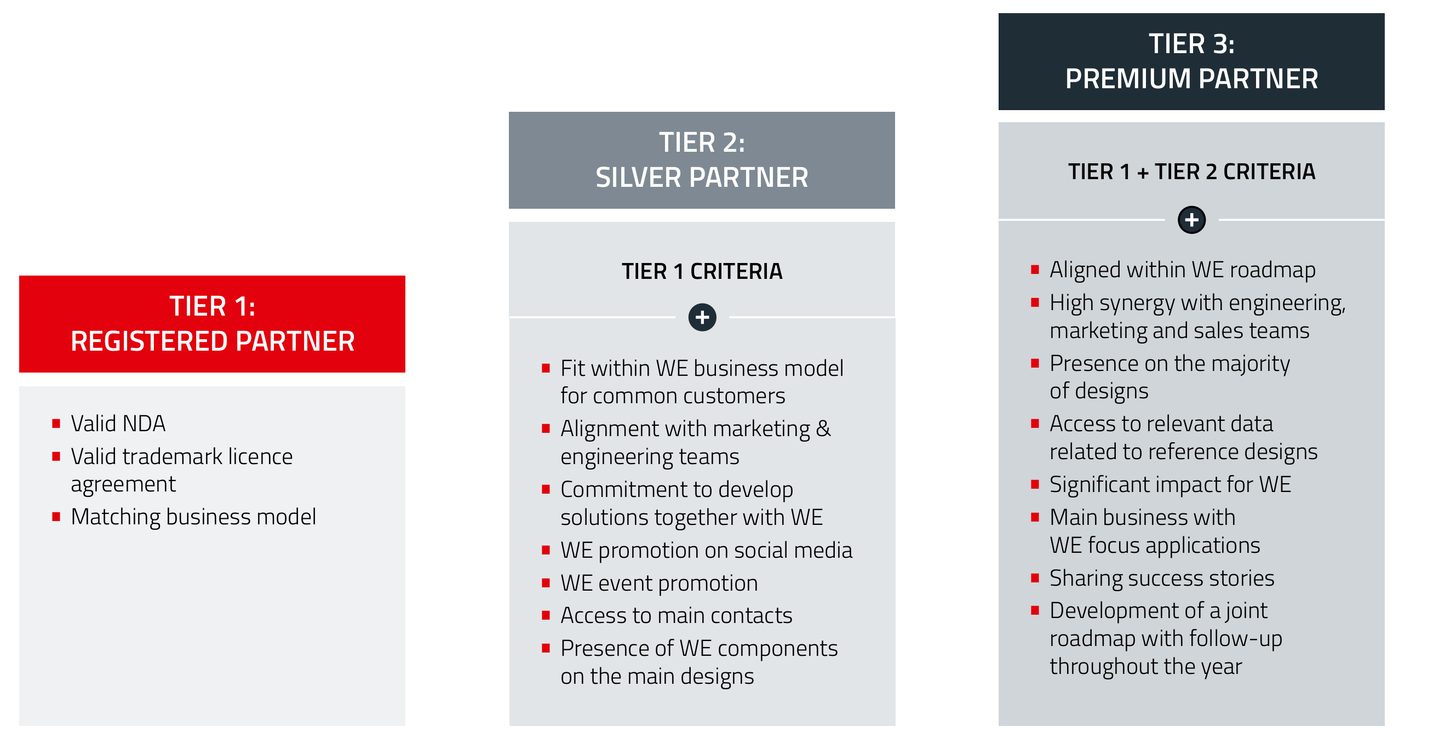Image source: Würth Elektronik
Würth Elektronik’s three-tier partner program: dynamic innovation ecosystem in the electronics industry

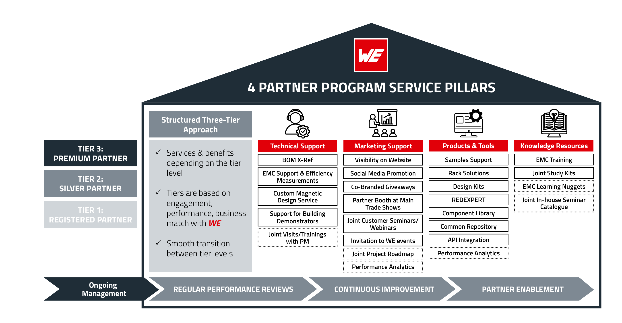Image source: Würth Elektronik
Comprehensive support program: Depending on their partnership level, participants receive expert support in four areas.

About the Würth Elektronik eiSos Group
Würth Elektronik eiSos Group is a manufacturer of electronic and electromechanical components for the electronics industry and a technology company that spearheads pioneering electronic solutions. Würth Elektronik eiSos is one of the largest European manufacturers of passive components and is active in 50 countries. Production sites in Europe, Asia and North America supply a growing number of customers worldwide.
The product range includes passive components, power modules, digital isolators, optoelectronics, electromechanical components, thermal management solutions, sensors and wireless modules. The portfolio is rounded off by customer-specific solutions.
The unrivaled service orientation of the company is characterized by the availability of all catalog components from stock without minimum order quantity, free samples and extensive support through technical sales staff and selection tools.
Würth Elektronik is part of the Würth Group, the global market leader in the development, production, and sale of fastening and assembly materials, and employs around 7,500 people. In 2024, the Würth Elektronik Group generated sales of 1.02 Billion Euro.
Würth Elektronik: more than you expect!
Further information at www.we-online.com

Further information:  Würth Elektronik eiSos GmbH & Co. KG  Sarah Hurst  Clarita-Bernhard-Strasse 9  81249 Munich  Germany  Phone: +49 7942 945-5186  E-mail: sarah.hurst@we-online.de  www.we-online.com | Press contact:  HighTech communications GmbH  Brigitte Basilio  Brunhamstrasse 21  81249 Munich  Germany  Phone: +49 89 500778-20  E-mail: b.basilio@htcm.de  www.htcm.de

