PRESS RELEASE

Würth Elektronik at the VDS 2025
Startup support at the Global Tech Hub
Waldenburg (Germany), October 30, 2025 – At the international tech conference, VDS, Würth Elektronik, a well-known manufacturer of passive components, presented itself as a competent partner for startup companies. The company unveiled its latest collaboration with hydrop systems, a newly established startup focused on smart water solutions. Together, they introduced a cutting-edge reader for water meters that enables precise consumption tracking and early leak detection.
Since 2018, the Valencia Digital Summit (VDS), organized by Startup Valencia, has united leading startups, influential companies, and visionary investors from around the world. The 2025 VDS edition brought together more than 3,000 startups and over 800 investors, each showcasing advancements in deep tech, artificial intelligence, sustainability, smart cities, healthcare, and security technologiesSince 2019, Würth Elektronik has operated a lab for electronic and electromechanical components at the University of Valencia Science Park.
hydropmeter: Save Water, Detect Leaks Early
At VDS 2025, the startup hydrop systems introduced a straightforward, yet impactful, solution: the hydropmeter. This device attaches directly to the existing water meter and transmits the flow data to an Internet server via a wireless connection. The readings can then be accessed via Android and iOS apps or smart home systems.
The hydropmeter installs in under two minutes and supports more responsible water usage while helping prevent costly damage. Research shows that increasing awareness alone can reduce individual water consumption by up to 23%. The hydropmeter also detects leaks at an early stage, helping to avoid water damage; an issue that leads for approximately €4.5 billion in renovation costs annually in Germany alone.
The panel discussion, “Finding the Leak: How innovation and electronics sparked a water revolution,” with Alexander Gerfer, CTO at the Würth Elektronik eiSos Group, and Katrin Kreidel, co-founder of hydrop systems, moderated by Florian Reiter, editor-in-chief of FOCUS online Earth, attracted a great deal of interest. The founder and the CTO both emphasized the central importance of cooperation between industry and startups, especially when it comes to challenges such as the electromagnetic compatibility of IoT solutions.

Proven, Multidimensional Startup Support Concept
Würth Elektronik supports promising startups through a proven, multidimensional approach rooted in its “Electronics for Positive Impact” philosophy. Development support is not only based on commercial success, but also prioritizes the environmental and societal value of each idea.
During the development phase, Würth Elektronik supplied hydrop systems with evaluation boards and LEDs for internal lighting. The hydropmeter’s electromagnetic compatibility was verified through pre-compliance testing in internal laboratories. Through targeted circuit adjustments, the prototype was refined into a marketable product now available in stores. Previously manufactured units were easily upgraded using a special shielding foil from Würth Elektronik.
Würth Elektronik also connected the startup with early adopters its own organization. These users purchased the product and provided valuable feedback based on their personal experience.
“Great ideas sometimes stumble over small details,” emphasizes Alexander Gerfer. “Our collaboration with the start-up hydrop systems is a best-practice example, where we founda few technical hurdles, fixed them, and brought a fully realized product to market.”
Steffi Czerny, Managing Director of DLD Media and main host of the DLD "Tech in Action Dinner" within the conference, explains: “Today, I visited the Harbour in Valencia – a vibrant startup hub unlike any other. The secret sauce? Founders here are explorers, just like the sailors who once set out from this very coast, driven by curiosity and courage. I’m thankful to our dear DLD friend, Alexander Gerfer, for bringing his spirit of innovation here and sharing it with me, Christian Teichmann, and all of us tonight.”
“During my studies, I realized that many environmental problems are only addressed when it is already too late because solutions are too expensive or there is insufficient awareness of the issue,” says Katrin Kreidel. "As we are seeing today in our neighboring countries, water is the next big problem, and we are already developing a proactive solution for the respectful use of this resource. Our main focus is on ensuring that the company can grow sustainably and that the product can be manufactured sustainably. That's why we rely on Würth Elektronik, a strong partner from our region."

Note: We will be happy to send you a detailed fact sheet on this topic upon request.

Available images
The following images can be downloaded from the Internet in printable quality: https://kk.htcm.de/press-releases/wuerth/
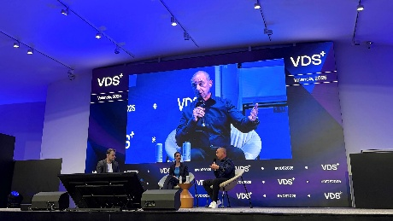Image source: Würth Elektronik  Panel discussion with Alexander Gerfer (right), CTO at the Würth Elektronik eiSos Group, and Katrin Kreidel, co-founder of hydrop systems, moderated by Florian Reiter, editor-in-chief of FOCUS online Earth: Facts about the hydropmeter clearly communicated. | 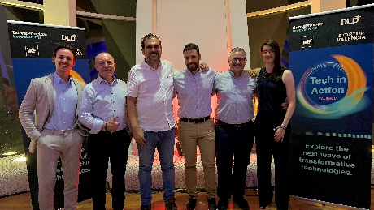Image source: Würth Elektronik  Meeting at the VDS (from left): Max Goegele, Tech Advisor to the CTO at Würth Elektronik eiSos Group, Alexander Gerfer, CTO at the Würth Elektronik eiSos Group. Jorge Victoria, Antonio Alcarria, Sebastian Mirasol-Menacho (all Würth Elektronik eiSos, Valencia), and Katrin Kreidel, Head of Management, Financial Planning, and Sales at hydrop systems

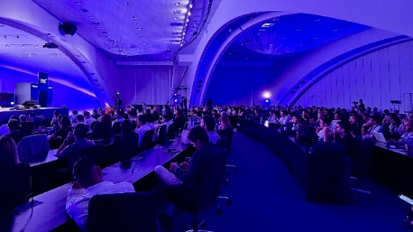
Image source: Würth Elektronik
Lively audience interest in the panel discussion: Presentations at conferences are part of Würth Elektronik's startup support program.

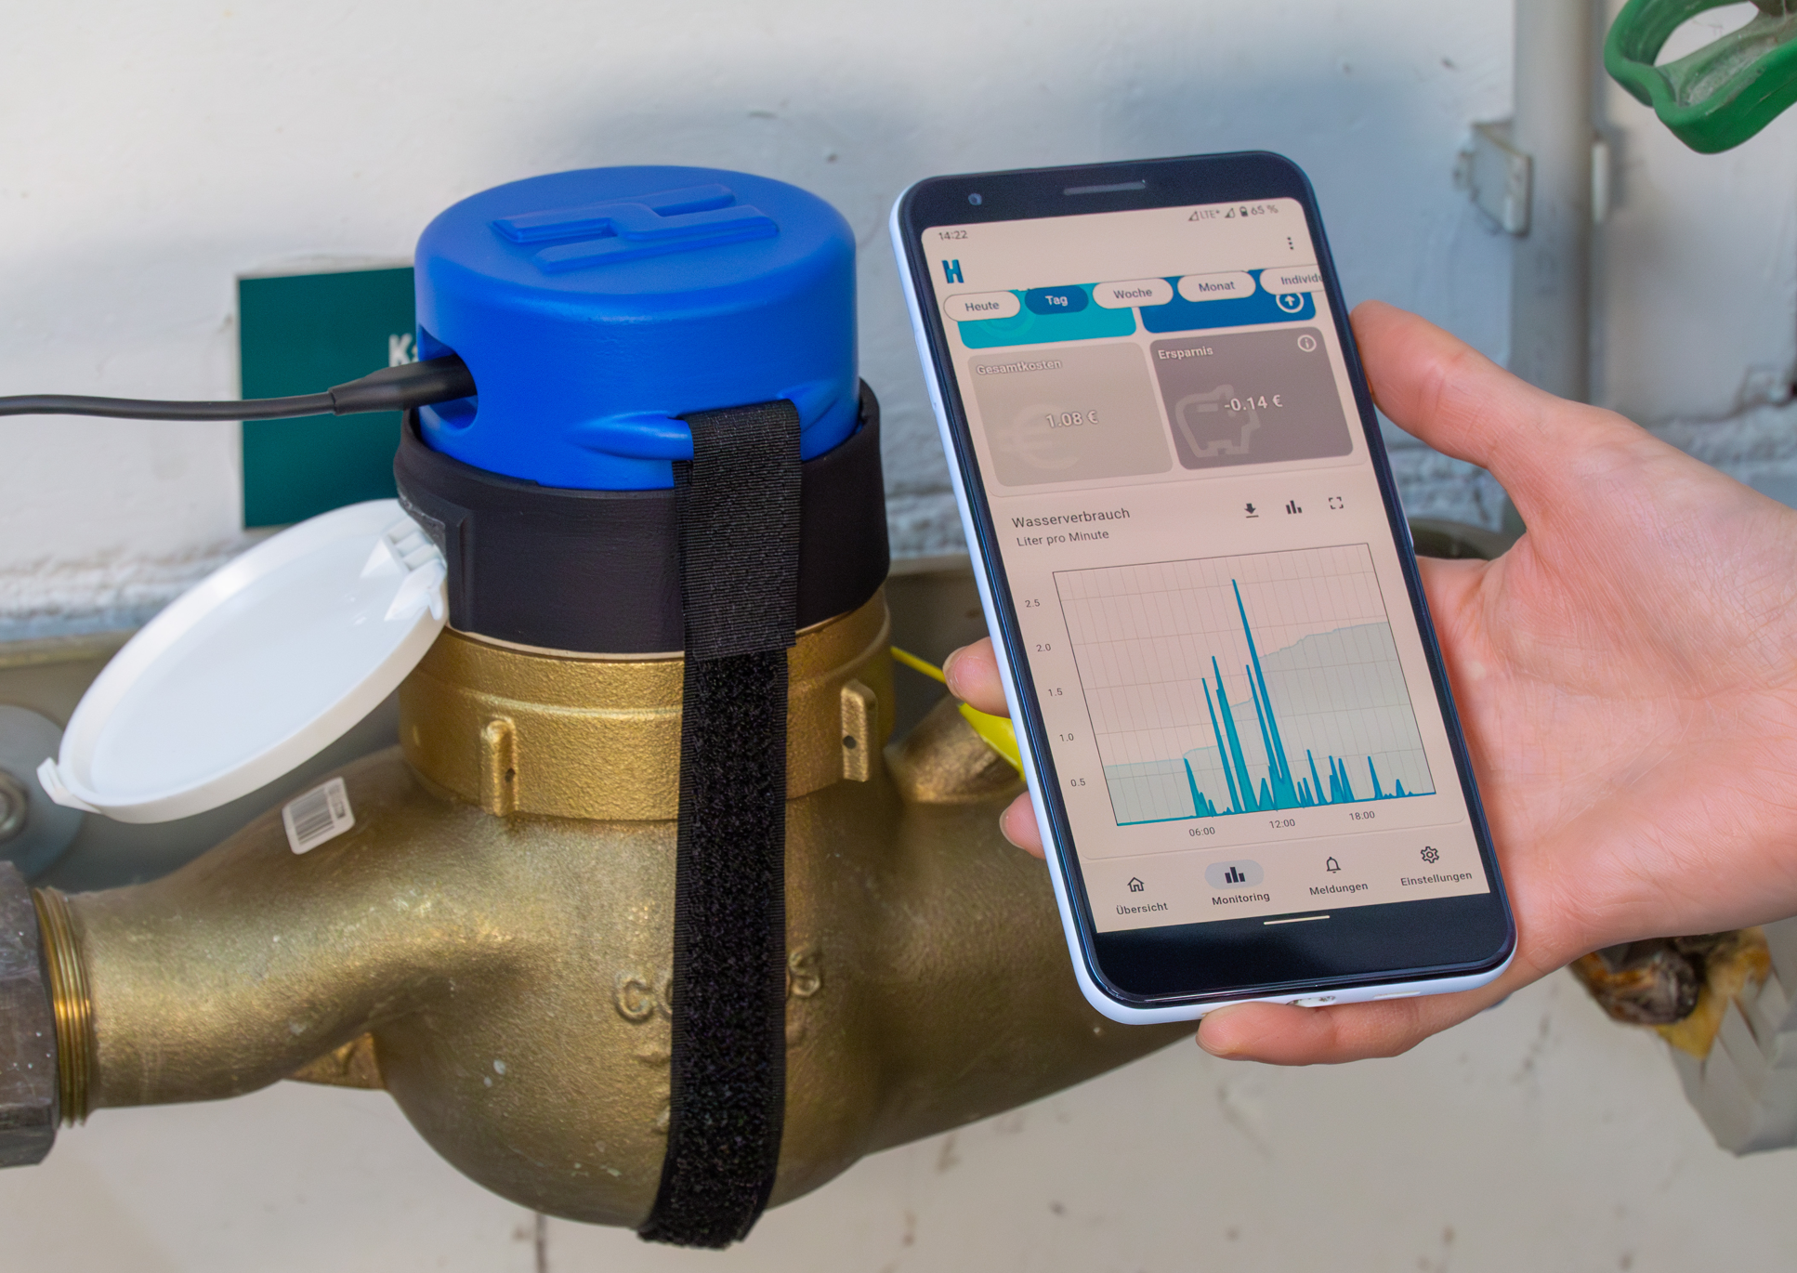  Image source: hydrop systems  hydropmeter and app: Any user can install the reader themselves in less than two minutes. This allows them to keep an eye on their water consumption at all times and receive immediate warnings in the event of water damage. | 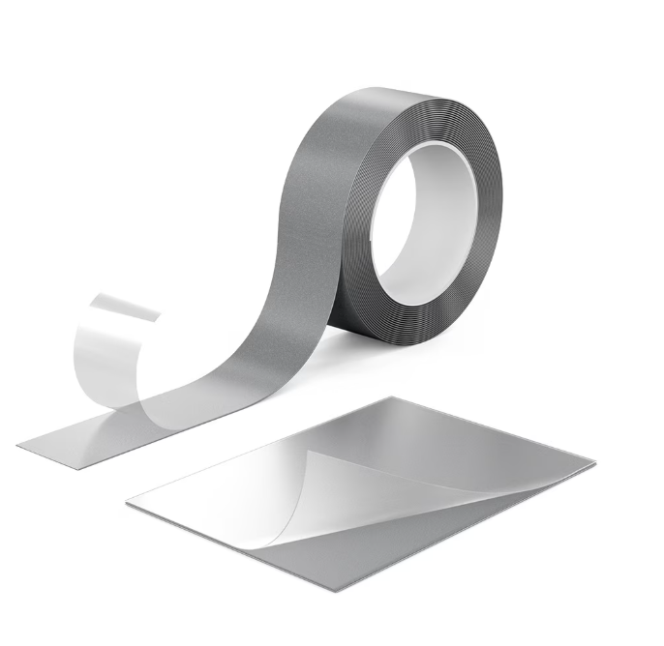  Image source: Würth Elektronik  WE-EMIP EMI Patch: highly flexible and easy-to-process shielding foil made of hybrid material with absorber and metal layers.
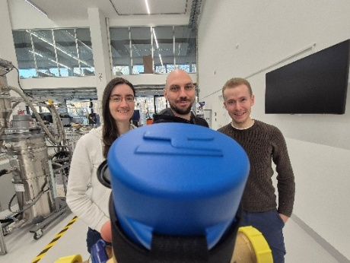  Image source: hydrop systems  Interdisciplinary founding team of hydrop systems: Katrin Kreidel, Raimund Koop, and Moritz Emberger (from left to right). | 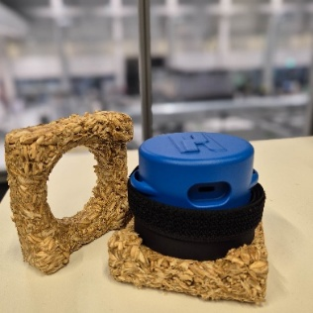  Image source: hydrop systems  Environmentally friendly transport protection: The hydropmeter is delivered in compostable packaging made from grain processing waste.

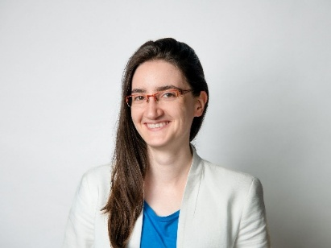
Image source: hydrop systems, Dominik Tryba
Katrin Kreidel, Head of Management, Financial Planning and Sales at hydrop systems: "We are working on a proactive solution for the careful use of the precious resource of water."

About the Würth Elektronik eiSos Group
Würth Elektronik eiSos Group is a manufacturer of electronic and electromechanical components for the electronics industry and a technology company that spearheads pioneering electronic solutions. Würth Elektronik eiSos is one of the largest European manufacturers of passive components and is active in 50 countries. Production sites in Europe, Asia and North America supply a growing number of customers worldwide.
The product range includes passive components, power modules, digital isolators, optoelectronics, electromechanical components, thermal management solutions, sensors and wireless modules. The portfolio is rounded off by customer-specific solutions.
The unrivaled service orientation of the company is characterized by the availability of all catalog components from stock without minimum order quantity, free samples and extensive support through technical sales staff and selection tools.
Würth Elektronik is part of the Würth Group, the global market leader in the development, production, and sale of fastening and assembly materials, and employs around 7,500 people. In 2024, the Würth Elektronik Group generated sales of 1.02 Billion Euro.
Würth Elektronik: more than you expect!
Further information at www.we-online.com

Further information:  Würth Elektronik eiSos GmbH & Co. KG  Sarah Hurst  Clarita-Bernhard-Strasse 9  81249 Munich  Germany  Phone: +49 7942 945-5186  E-mail: sarah.hurst@we-online.de  www.we-online.com | Press contact:  HighTech communications GmbH  Brigitte Basilio  Brunhamstrasse 21  81249 Munich  Germany  Phone: +49 89 500778-20  E-mail: b.basilio@htcm.de  www.htcm.de

