PRESS RELEASE

Würth Elektronik presents its Tarvos-e and Olis-e radio modules
Minimal Size, Maximum Flexibility
Waldenburg (Germany), September 30, 2025 – Würth Elektronik introduces two new highly compact radio modules. They give developers maximum freedom in designing proprietary wireless solutions that go beyond standard protocols. The hardware of the Tarvos-e and Olis-e modules, measuring just 12 × 8 × 2 mm, is identical to that of the Metis-e radio module and is based on the Texas Instruments SoC CC1310 chipset, operating in the 868 MHz frequency band. Metis-e was introduced at the end of 2024 as a solution specifically for radio transmission of meter readings (wireless M-Bus). Not only their compact design but also the energy-efficient operating modes make the radio modules ideal for use in battery-powered devices. In the Standby and Shutdown power-saving modes, the modules require only 1.6 µA and 200 nA, respectively.
The Tarvos-e module uses Würth Elektronik’s proprietary WE-ProWare radio protocol and is compatible with Tarvos-III and Thebe-II. It allows targeted optimization of wireless communication – either for high data rates up to 400 kbps or for a range up to 2.7 km. It offers maximum flexibility and is ideal for applications for which standard protocols reach their limits. The module delivers an RF output power of 14 dBm and uses a UART interface for communication.
The Olis-e module offers even more design flexibility by allowing you to build your own firmware. Using the TI SIMPLELINK CC13x0 software development kit, developers can implement their application directly on the SoC (System on Chip) – including custom wireless protocols and system logic.
Proprietary radio protocols as a potent alternative to Bluetooth® LE
The radio modules use proprietary protocols and thus offer an especially attractive solution for applications in which both the transmitter and receiver sides are individually developed. Compared to Bluetooth, the module impresses with its greater range – especially indoors – thanks to use of its 868 MHz frequency band instead of 2.4 GHz. This enables more reliable communication, even through walls and other building structure obstacles.
In addition to the standard version in the 868 MHz range, the radio module is also available in a specially adapted variant for the 915 MHz frequency range upon customer request. This option opens up use in markets such as the USA, in which the 915 MHz band can be used license-free.

All three versions (Metis-e, Tarvos-e, Olis-e) include evaluation boards with a USB interface for connecting to a PC, a comprehensive user manual, as well as software tools.

Available images
The following images can be downloaded from the Internet in printable quality: https://kk.htcm.de/press-releases/wuerth/
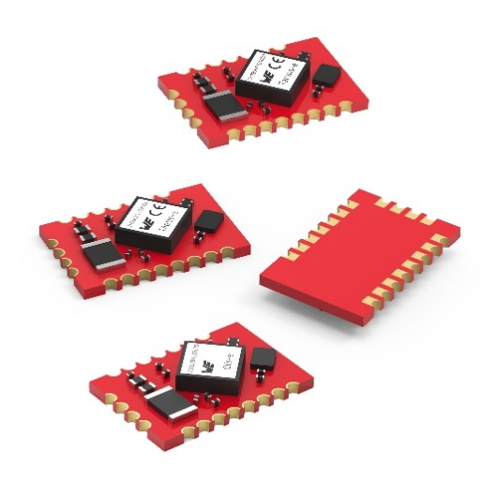
Image source: Würth Elektronik
One highly compact hardware platform, three variants: the Metis-e, Tarvos-e and Olis-e radio modules from Würth Elektronik

About the Würth Elektronik eiSos Group
Würth Elektronik eiSos Group is a manufacturer of electronic and electromechanical components for the electronics industry and a technology company that spearheads pioneering electronic solutions. Würth Elektronik eiSos is one of the largest European manufacturers of passive components and is active in 50 countries. Production sites in Europe, Asia and North America supply a growing number of customers worldwide.
The product range includes passive components, power modules, digital isolators, optoelectronics, electromechanical components, thermal management solutions, sensors and wireless modules. The portfolio is rounded off by customer-specific solutions.
The unrivaled service orientation of the company is characterized by the availability of all catalog components from stock without minimum order quantity, free samples and extensive support through technical sales staff and selection tools.
Würth Elektronik is part of the Würth Group, the global market leader in the development, production, and sale of fastening and assembly materials, and employs around 7,500 people. In 2024, the Würth Elektronik Group generated sales of 1.02 Billion Euro.
Würth Elektronik: more than you expect!
Further information at www.we-online.com

Further information:  Würth Elektronik eiSos GmbH & Co. KG  Sarah Hurst  Clarita-Bernhard-Strasse 9  81249 Munich  Germany  Phone: +49 7942 945-5186  E-mail: sarah.hurst@we-online.de  www.we-online.com | Press contact:  HighTech communications GmbH  Brigitte Basilio  Brunhamstrasse 21  81249 Munich  Germany  Phone: +49 89 500778-20  E-mail: b.basilio@htcm.de  www.htcm.de

