PRESS RELEASE

Accuris Expands Supply Chain Intelligence with Real-Time Data from Würth Elektronik
Würth Elektronik provides component data for the Accuris library
Waldenburg (Germany), February 18, 2026 – Würth Elektronik is now supplying Accuris – a trusted provider of engineering intelligence – with live, structured data for more than 22,000 of its electronic and electromechanical components. The comprehensive product information is transmitted via a direct customer API and help Accuris customers make faster and smarter sourcing decisions.
Würth Elektronik’s data is the latest addition to the Accuris library of 1.2 billion parts records, giving customers of Accuris Parts Intelligence and BOM Intelligence immediate access to accurate, current information. All data flows automatically to Accuris from Würth Elektronik’s systems through a flexible API, eliminating manual imports and the risks of outdated information.
“Developers, purchasers and component managers rely on Accuris in their daily work,” explains Alexander Friebe, Platform Partner Manager at Würth Elektronik eiSos. “It’s part of our company philosophy not only to supply components, but also to proactively support innovation. So it’s only logical for us to integrate online platforms and partners into our service network. We provide our customers with all the data they need through a transparent process. Our goal is to ensure consistent data quality – from our Würth Elektronik website through to external partners and their tools.”
Manufacturer-Verified Data Updated Every Week
Each component record supplied to Accuris includes:
• Detailed technical product specifications
• Actual lifecycle status and estimated longevity
• Supply-chain essentials like REACH, RoHS, Country of Origin and more
With Würth Elektronik’s data embedded in Accuris Parts Intelligence and BOM Intelligence, sourcing and engineering teams gain faster insight into part availability, alternates, compliance considerations, and lifecycle. All Würth Elektronik components are available from stock and can also be requested as free laboratory samples.
Accuris provides vital intelligence to engineers worldwide, safeguarding the technologies of today and enabling the breakthroughs of tomorrow. Trusted by top innovators, Accuris unites the world’s largest library of engineering standards and supply chain data with intelligent systems purpose-built to tackle engineering’s toughest challenges.
Further information at
https://www.we-online.com/en/support/network/partner-platforms

Available images
The following images can be downloaded from the Internet in printable quality: https://kk.htcm.de/press-releases/wuerth/
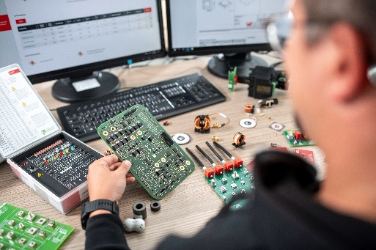 Image source: Würth Elektronik
Important tools for developers: Würth Elektronik provides partner databases with extensive information on around 22,000 of its components via an API.

About the Würth Elektronik eiSos Group
Würth Elektronik eiSos Group is a manufacturer of electronic and electromechanical components for the electronics industry and a technology company that spearheads pioneering electronic solutions. Würth Elektronik eiSos is one of the largest European manufacturers of passive components and is active in 50 countries. Production sites in Europe, Asia and North America supply a growing number of customers worldwide.
The product range includes passive components, power modules, digital isolators, optoelectronics, electromechanical components, thermal management solutions, sensors and wireless modules. The portfolio is rounded off by customer-specific solutions.
The unrivaled service orientation of the company is characterized by the availability of all catalog components from stock without minimum order quantity, free samples and extensive support through technical sales staff and selection tools.

Würth Elektronik is part of the Würth Group, the global market leader in the development, production, and sale of fastening and assembly materials, and employs around 7,300 people. In 2025, the Würth Elektronik Group generated sales of 1.06 Billion Euro.
Würth Elektronik: more than you expect!
Further information at www.we-online.com

Further information:  Würth Elektronik eiSos GmbH & Co. KG  Sarah Hurst  Clarita-Bernhard-Strasse 9  81249 Munich  Germany  Phone: +49 7942 945-5186  E-mail: sarah.hurst@we-online.de  www.we-online.com | Press contact:  HighTech communications GmbH  Brigitte Basilio  Brunhamstrasse 21  81249 Munich  Germany  Phone: +49 89 500778-20  E-mail: b.basilio@htcm.de  www.htcm.de

