PRESS RELEASE

Würth Elektronik power inductors in a performance version
Improved Properties for Demanding Designs
Waldenburg (Germany), June 25, 2025 – The new WE-XHMI Performance series extends Würth Elektronik’s successful family of power inductors with improved versions in sizes 1010, 1060, 6030, and 6060. The magnetically shielded flat-wire inductors support high saturation currents while reducing DC losses for even more efficient operation.
The WE-XHMI Performance SMT inductors impress with their ability to withstand saturation currents of up to 114 A while also handling high transient current peaks. This makes them particularly suitable for use in DC/DC converters, point-of-load converters and high-current filters, as well as in industrial computers, mainboards and graphics cards. These latest improvements now enable Würth Elektronik to meet the growing demand for low-loss solutions at high switching frequencies and maximum power density, driven by GaN and SiC transistor technologies.
Low DC losses at higher rated current
The new generation of molded WE-XHMI flat-wire inductors outperforms other products of the same size by offering the lowest R_{DC} combined with low AC losses. Compared to the standard products in the series, the new “Performance” models feature an extended inductance range, a higher operating temperature (-55°C to +150°C), up to 30 percent lower resistance, and up to 50 percent higher rated currents. Thanks to their significantly reduced DC losses compared to inductors of the same size, the new models enable more efficient operation with lower self-heating. Low DC losses at higher rated currents help raise the efficiency of switching regulators.
The new inductors are now available from stock without a minimum order quantity. Developers can receive free samples.

Available images
The following images can be downloaded from the Internet in printable quality: https://kk.htcm.de/press-releases/wuerth/
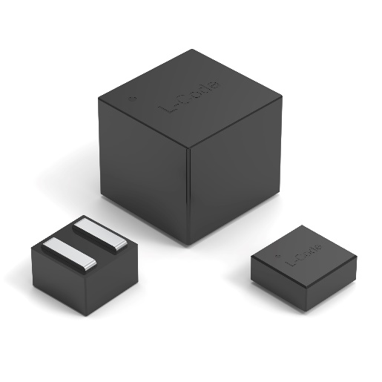
Image source: Würth Elektronik
Molded flat-wire inductors from the WE-XHMI series with particularly high-performance new additions

Available videos
You can find videos on this topic on our YouTube channel: https://youtube.com/shorts/4AM1K3XdhOU
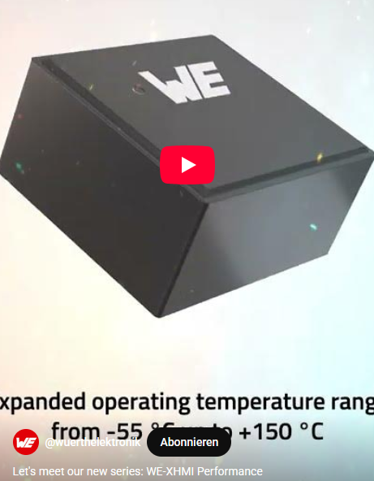Source: Würth Elektronik
New WE-XHMI Performance series

About the Würth Elektronik eiSos Group
Würth Elektronik eiSos Group is a manufacturer of electronic and electromechanical components for the electronics industry and a technology company that spearheads pioneering electronic solutions. Würth Elektronik eiSos is one of the largest European manufacturers of passive components and is active in 50 countries. Production sites in Europe, Asia and North America supply a growing number of customers worldwide.
The product range includes passive components, power modules, digital isolators, optoelectronics, electromechanical components, thermal management solutions, sensors and wireless modules. The portfolio is rounded off by customer-specific solutions.
The unrivaled service orientation of the company is characterized by the availability of all catalog components from stock without minimum order quantity, free samples and extensive support through technical sales staff and selection tools.
Würth Elektronik is part of the Würth Group, the global market leader in the development, production, and sale of fastening and assembly materials, and employs around 7,500 people. In 2024, the Würth Elektronik Group generated sales of 1.02 Billion Euro.
Würth Elektronik: more than you expect!
Further information at www.we-online.com

Further information:  Würth Elektronik eiSos GmbH & Co. KG  Sarah Hurst  Clarita-Bernhard-Strasse 9  81249 Munich  Germany  Phone: +49 7942 945-5186  E-mail: sarah.hurst@we-online.de  www.we-online.com | Press contact:  HighTech communications GmbH  Brigitte Basilio  Brunhamstrasse 21  81249 Munich  Germany  Phone: +49 89 500778-20  E-mail: b.basilio@htcm.de  www.htcm.de

