PRESS RELEASE

LTspice models for Würth Elektronik ESD products
Diode Model Based on Measurement Data
Waldenburg (Germany), May 21, 2025 – Würth Elektronik, in cooperation with the Institute of Electronics (IFE) at Graz University of Technology, now offers an LTspice model for its TVS diodes and ESD suppressors for ESD protection, based on real measurement data using TLP (Transmission Line Pulsing). This enables the actual behavior of the components to be measured under electrostatic discharge (ESD) conditions. The ready-to-use simulation files facilitate integration into SPICE-based analyses and help shorten design cycles and time-to-market.
Conventional models of components for ESD protection typically rely on simplified approximations. The new models developed by Würth Elektronik and the IFE at Graz University of Technology, based on measurement data, however, reflect the actual transient properties, including snapback behavior. The snapback effect allows the voltage to be clamped to a lower level after a transient overvoltage than is possible with standard PN diodes. This is a key aspect of ESD protection, as it reduces both the overvoltage and the resulting thermal stress on sensitive electronic components, so the ability to simulate it is a critical improvement to the development process.
Ensuring robust ESD protection
Simulating real transient behavior offers assurance in testing circuits under realistic conditions. Reliable simulations shorten testing and development cycles, and also reduce the risk of product recalls resulting from ESD vulnerabilities. At the same time, they provide insights into component behavior, enabling design optimization to ensure consistent ESD robustness across all applications, from consumer electronics to industrial equipment.
LTspice models for realistic modelling of real component behavior during ESD events for products from the WE-TVS and WE-VE product series are now available in Würth Elektronik’s online catalog to download.

Available images
The following images can be downloaded from the Internet in printable quality: https://kk.htcm.de/press-releases/wuerth/
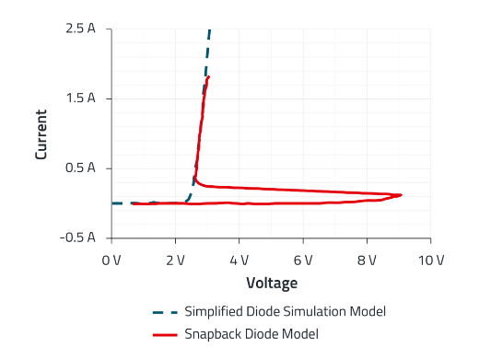
Image source: Würth Elektronik
Conventional models often use simplified approximations, as shown by the dashed line, whereas Würth Elektronik’s new LTspice models reflect the actual transient properties, including snapback.

About the Würth Elektronik eiSos Group
Würth Elektronik eiSos Group is a manufacturer of electronic and electromechanical components for the electronics industry and a technology company that spearheads pioneering electronic solutions. Würth Elektronik eiSos is one of the largest European manufacturers of passive components and is active in 50 countries. Production sites in Europe, Asia and North America supply a growing number of customers worldwide.
The product range includes passive components, power modules, digital isolators, optoelectronics, electromechanical components, thermal management solutions, sensors and wireless modules. The portfolio is rounded off by customer-specific solutions.
The unrivaled service orientation of the company is characterized by the availability of all catalog components from stock without minimum order quantity, free samples and extensive support through technical sales staff and selection tools.
Würth Elektronik is part of the Würth Group, the global market leader in the development, production, and sale of fastening and assembly materials, and employs around 7,500 people. In 2024, the Würth Elektronik Group generated sales of 1.02 Billion Euro.
Würth Elektronik: more than you expect!
Further information at www.we-online.com

Further information:  Würth Elektronik eiSos GmbH & Co. KG  Sarah Hurst  Clarita-Bernhard-Strasse 9  81249 Munich  Germany  Phone: +49 7942 945-5186  E-mail: sarah.hurst@we-online.de  www.we-online.com | Press contact:  HighTech communications GmbH  Brigitte Basilio  Brunhamstrasse 21  81249 Munich  Germany  Phone: +49 89 500778-20  E-mail: b.basilio@htcm.de  www.htcm.de

