PRESS RELEASE

Würth Elektronik presents its Skoll-I Bluetooth® module
Two Radio Protocols – One Module
Waldenburg (Germany), June 3, 2025 – Manufacturer of electronic and electromechanical components, introduces Skoll-I, a compact wireless module that combines both Bluetooth® Classic and Bluetooth® LE (Low Energy) version 5.4 in a single solution. Measuring just 16.6 × 12 × 1.7 mm, the module is already certified for conformity in all major target markets, accelerating the launch of new applications.
Würth Elektronik’s new Bluetooth® Classic / Bluetooth® LE module with integrated antenna is suitable for use in medical devices, industrial automation and control systems, in security technology and IoT clients such as cost-efficient predictive maintenance. These applications typically require energy-efficient operation.
Small and versatile
Combining Bluetooth® Classic and Bluetooth® LE in a compact module offers a unique opportunity for developing devices that need to connect to both legacy and modern devices. Skoll-I also offers an easy way to replace the Puck-I Bluetooth® module, which can no longer be qualified for new developments due to the withdrawal of the Bluetooth 2.0 specification.
Skoll-I complies with Bluetooth® Core Specification Version 5.4 and supports BR, EDR 2/3 Mbps, Bluetooth® LE, and LE 1/2 Mbps. The module is certified to CE, FCC, IC, TELEC, and ETA-WPC standards.
Compelling all-in-one package
The WE Bluetooth® LE Terminal App provides a quick and easy way of testing as well as the basis for developing new, custom apps. Additional services include the Wireless Connectivity software development kit (SDK), the WE UART terminal, and an evaluation board that can be easily connected to a PC to provide access to all module pins for testing.
Immediately available
Skoll-I is now available from stock with no minimum order quantity and is suitable for SMT assembly thanks to its tape-and-reel packaging. Free samples can be requested at any time.

Available images
The following images can be downloaded from the Internet in printable quality: https://kk.htcm.de/press-releases/wuerth/
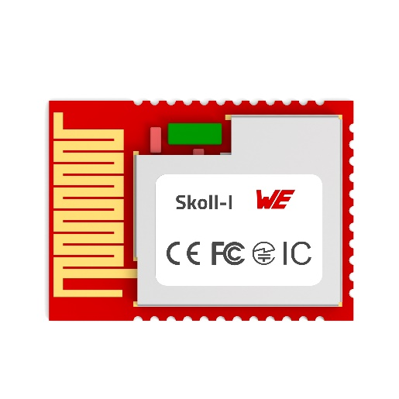  Image source: Würth Elektronik  Compact and versatile: The Skoll-I wireless module combines Bluetooth® Classic und Bluetooth® LE in a compact module. | 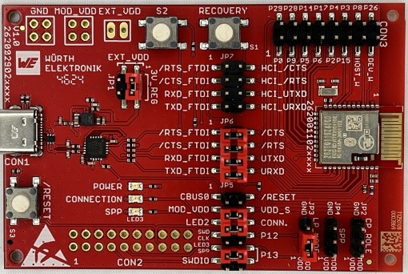Image source: Würth Elektronik  Product-related service: A dedicated evaluation board and various software tools are available for the Skoll-I wireless module.

About the Würth Elektronik eiSos Group
Würth Elektronik eiSos Group is a manufacturer of electronic and electromechanical components for the electronics industry and a technology company that spearheads pioneering electronic solutions. Würth Elektronik eiSos is one of the largest European manufacturers of passive components and is active in 50 countries. Production sites in Europe, Asia and North America supply a growing number of customers worldwide.
The product range includes passive components, power modules, digital isolators, optoelectronics, electromechanical components, thermal management solutions, sensors and wireless modules. The portfolio is rounded off by customer-specific solutions.
The unrivaled service orientation of the company is characterized by the availability of all catalog components from stock without minimum order quantity, free samples and extensive support through technical sales staff and selection tools.
Würth Elektronik is part of the Würth Group, the global market leader in the development, production, and sale of fastening and assembly materials, and employs around 7,500 people. In 2024, the Würth Elektronik Group generated sales of 1.02 Billion Euro.

Würth Elektronik: more than you expect!
Further information at www.we-online.com

Further information:  Würth Elektronik eiSos GmbH & Co. KG  Sarah Hurst  Clarita-Bernhard-Strasse 9  81249 Munich  Germany  Phone: +49 7942 945-5186  E-mail: sarah.hurst@we-online.de  www.we-online.com | Press contact:  HighTech communications GmbH  Brigitte Basilio  Brunhamstrasse 21  81249 Munich  Germany  Phone: +49 89 500778-20  E-mail: b.basilio@htcm.de  www.htcm.de

