PRESS RELEASE

Würth Elektronik expands its range of coaxial connectors
High-Frequency Connectors for Antenna Cables
Waldenburg (Germany), July 9, 2025 – Würth Elektronik introduces additional coaxial connectors for 50-Ω cables of types 1.13, 1.32, and 1.37 mm. The plugs and receptacles – suitable for use in such equipment as wireless communication devices, GPS systems, and IoT devices – feature gold-plated contacts and have all passed a 48-hour salt spray test. The easy-to-install connectors WR-SMA, WR-SMB, WR-MCX and WR-MMCX are now available from stock without a minimum order quantity.
“WR-SMA Right Angle Bulkhead Jack Cable Connector”: The right-angle receptacle for applications up to 6 GHz features a very space-saving design and reduced cable strain. The new model in the WR-SMA series for crimp assembly is also available in an IP67-rated version.
The “WR-SMB Straight Plug Cable Connector” is similar in size to the SMA version, but is straight and features a snap-lock mechanism. The connector for applications up to 4 GHz is particularly suitable for applications such as test equipment that require repeated mating cycles.
The “WR-MCX Straight and Right Angle Plug Cable Connectors” feature a snap-lock mechanism and are suitable for applications up to 6 GHz. The connectors take up very little space and remain rotatable, which provides added flexibility for the right-angle plug connectors. The connectors have been tested for at least 500 mating cycles. WR-MCX has a connector diameter of 4.5 mm, while the WR-MMCX version has an even smaller diameter of just 3.5 mm. The smaller connector also requires less force both for mating and unmating.

Available images
The following images can be downloaded from the Internet in printable quality: https://kk.htcm.de/press-releases/wuerth/

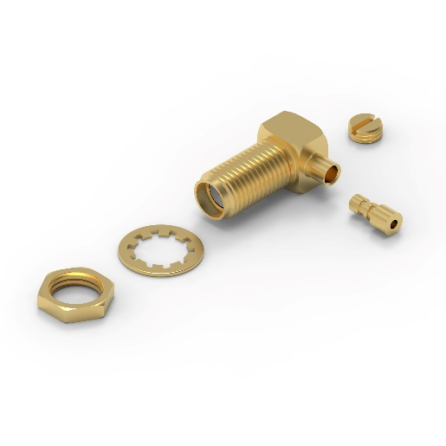Image source: Würth Elektronik  WR-SMA Right Angle Bulkhead Jack Cable Connector | 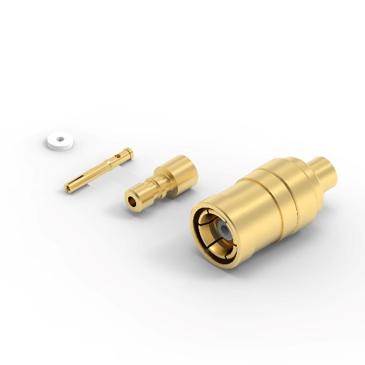Image source: Würth Elektronik  WR-SMB Straight Plug Cable Connector

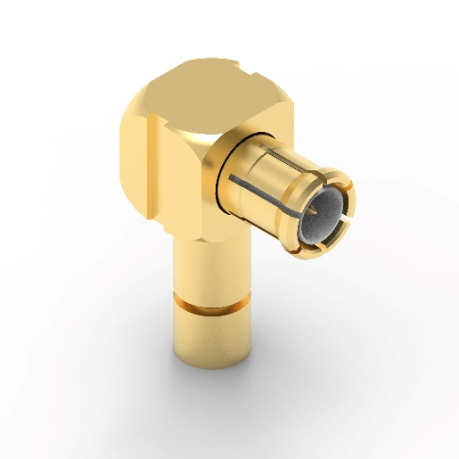Image source: Würth Elektronik  WR-MCX Right Angle Plug Cable Connector | 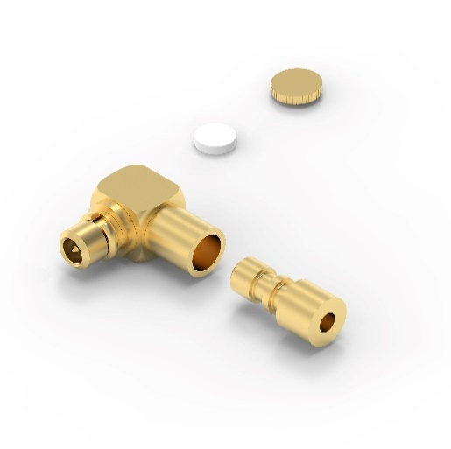  Image source: Würth Elektronik  WR-MMCX Right Angle Plug Cable Connector

About the Würth Elektronik eiSos Group
Würth Elektronik eiSos Group is a manufacturer of electronic and electromechanical components for the electronics industry and a technology company that spearheads pioneering electronic solutions. Würth Elektronik eiSos is one of the largest European manufacturers of passive components and is active in 50 countries. Production sites in Europe, Asia and North America supply a growing number of customers worldwide.
The product range includes passive components, power modules, digital isolators, optoelectronics, electromechanical components, thermal management solutions, sensors and wireless modules. The portfolio is rounded off by customer-specific solutions.

The unrivaled service orientation of the company is characterized by the availability of all catalog components from stock without minimum order quantity, free samples and extensive support through technical sales staff and selection tools.
Würth Elektronik is part of the Würth Group, the global market leader in the development, production, and sale of fastening and assembly materials, and employs around 7,500 people. In 2024, the Würth Elektronik Group generated sales of 1.02 Billion Euro.
Würth Elektronik: more than you expect!
Further information at www.we-online.com

Further information:  Würth Elektronik eiSos GmbH & Co. KG  Sarah Hurst  Clarita-Bernhard-Strasse 9  81249 Munich  Germany  Phone: +49 7942 945-5186  E-mail: sarah.hurst@we-online.de  www.we-online.com | Press contact:  HighTech communications GmbH  Brigitte Basilio  Brunhamstrasse 21  81249 Munich  Germany  Phone: +49 89 500778-20  E-mail: b.basilio@htcm.de  www.htcm.de

