PRESS RELEASE

Nano SIM and SD card connectors from Würth Elektronik
High Mating Cycle Count
Waldenburg (Germany), June 12, 2025 – Würth Elektronik introduces four new SMT-mountable card connectors and expands its range with solutions for the smallest packages. The four Nano SIM and microSD card connectors feature high-quality workmanship with partially gold-plated contacts and their impressive number of mating cycles mean they have a very long service life.
The new card connectors from Würth Elektronik are each available in two mechanical versions. The WR-CRD Nano SIM Card Connector Push-Push features the familiar spring mechanism, whereby the card is pressed deeper into the slot to release the mechanism. It can be actuated at least 3,000 times. The WR-CRD Nano SIM Card Connector Hinge has a mechanism that withstands no fewer than 5,000 mating cycles.
The microSD cards are available in the WR-CRD MicroSD Card Connector Push-Pull and WR-CRD MicroSD Card Connector Push-Push versions. The Push-Pull version in which the card is held in the connector by friction alone withstands 5,000 mating cycles. Würth Elektronik’s Push-Push version featuring card detection achieves a durability of 10,000 mating cycles.
Compact and robust
Besides telecommunications applications, SIM cards also play a major role in the Internet of Things, as decentralized IoT devices and sensors often use mobile networks to connect to the internet. SD cards frequently serve as exchangeable local storage media for these devices. To address the demands of industrial applications, Würth Elektronik ensures a robust design for its card connectors. The liquid crystal polymer insulating material conforms with the UL94 V-0 flammability class, and the operating temperature range extends from -25 to +85°C – with one version of the WR-CRD MicroSD Card Connector Push-Push even rated for -40 to +85°C.

Available images
The following images can be downloaded from the Internet in printable quality: https://kk.htcm.de/press-releases/wuerth/
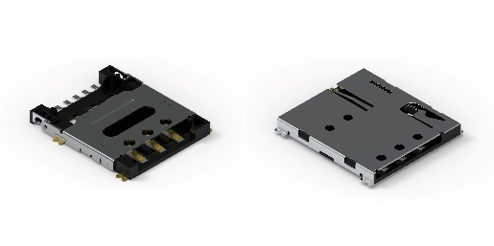Image source: Würth Elektronik  Card connectors WR-CRD Nano SIM Card Connector Hinge (left) and WR-CRD Nano SIM Card Connector Push-Push | 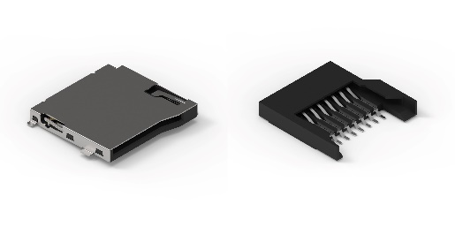  Image source: Würth Elektronik  Card connectors WR-CRD MicroSD Card Connector Push-Push (left) and WR-CRD MicroSD Card Connector Push-Pull

About the Würth Elektronik eiSos Group
Würth Elektronik eiSos Group is a manufacturer of electronic and electromechanical components for the electronics industry and a technology company that spearheads pioneering electronic solutions. Würth Elektronik eiSos is one of the largest European manufacturers of passive components and is active in 50 countries. Production sites in Europe, Asia and North America supply a growing number of customers worldwide.
The product range includes passive components, power modules, digital isolators, optoelectronics, electromechanical components, thermal management solutions, sensors and wireless modules. The portfolio is rounded off by customer-specific solutions.
The unrivaled service orientation of the company is characterized by the availability of all catalog components from stock without minimum order quantity, free samples and extensive support through technical sales staff and selection tools.
Würth Elektronik is part of the Würth Group, the global market leader in the development, production, and sale of fastening and assembly materials, and employs around 7,500 people. In 2024, the Würth Elektronik Group generated sales of 1.02 Billion Euro.
Würth Elektronik: more than you expect!
Further information at www.we-online.com

Further information:  Würth Elektronik eiSos GmbH & Co. KG  Sarah Hurst  Clarita-Bernhard-Strasse 9  81249 Munich  Germany  Phone: +49 7942 945-5186  E-mail: sarah.hurst@we-online.de  www.we-online.com | Press contact:  HighTech communications GmbH  Brigitte Basilio  Brunhamstrasse 21  81249 Munich  Germany  Phone: +49 89 500778-20  E-mail: b.basilio@htcm.de  www.htcm.de

