PRESS RELEASE

Würth Elektronik introduces its coupled inductor for high-performance applications
Specifically Designed for TLVR Topology
Waldenburg (Germany), May 15, 2025 – Würth Elektronik introduces its WE-HCMD (High Current Multiphase Dual) high-current inductor, specially developed for use in TLVR (Trans-Inductor Voltage Regulator) topologies. This coil with MnZn core is characterized by its high permeability and extremely low R_{DC} values. So, it achieves excellent power density and very high efficiency. In the finished device, it excels with its fast transient response and low voltage drop. The new component also reduces application costs and saves space, as it allows for a smaller nominal output capacitor.
When designing power supplies for processors today, developers are confronted with increasingly high and significantly varying load transients – for example, in FPGAs used in AI applications. The innovation in TLVRs in this field calls for a new generation of components that achieve consistent efficiency even at high temperatures. Optimal efficiency is key here and must be ensured even at the highest currents. The selection of materials for the new inductor significantly improves efficiency and allows the potential of the new TLVR topology to be fully exploited.
WE-HCMD is ideal for TLVR applications that are specifically designed for sudden load transients. Areas of application for the coupled inductor include multiphase voltage regulators for CPU motherboards, FPGAs, GPUs, AI chips, servers, or high-power ASIC applications.
Dependable up to 125°C
The WE-HCMD family from Würth Elektronik offers coupled inductors with a coupling factor of up to 0.98 and an inductance range from 70 nH to 200 nH. The saturation current goes up to 190 A at a rated current of 78 A. The internal resistance is just 0.125 mΩ. The inductor is designed for operating temperatures up to 125°C.
Maximum efficiency and inductance stability
Internal measurements show that at the high-temperatures resulting from heavy loads, significantly better stability is achieved than for existing solutions on the market. In direct comparison, the inductor stands out through its superior current-dependent inductance stability as well as higher efficiency.
The family of SMT-mountable high-current inductors for TLVR applications includes four versions in a 0910 package and six in a 1111 package. WE-HCMD is now available from stock without a minimum order quantity. Free samples can be requested.

Available images
The following images can be downloaded from the Internet in printable quality: https://kk.htcm.de/press-releases/wuerth/
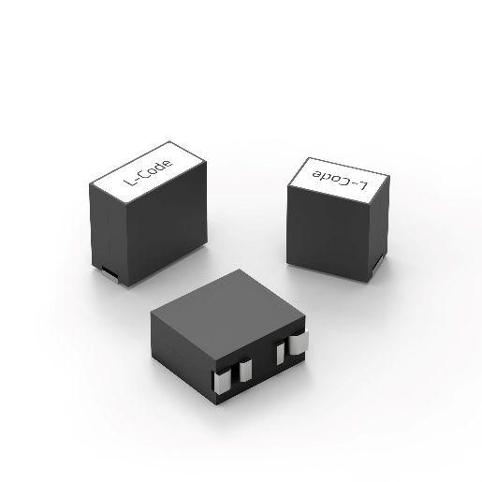Image source: Würth Elektronik  The WE-HCMD (High Current Multiphase Dual) inductor is specifically designed for use in TLVR topologies. | 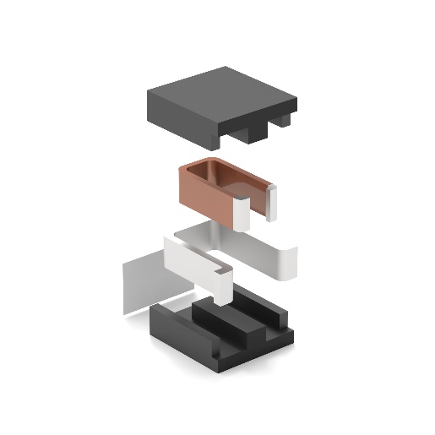  Image source: Würth Elektronik  The coils are made of flat wire, with the inner wire insulated. The core material is manganese-zinc-ferrite.

About the Würth Elektronik eiSos Group
Würth Elektronik eiSos Group is a manufacturer of electronic and electromechanical components for the electronics industry and a technology company that spearheads pioneering electronic solutions. Würth Elektronik eiSos is one of the largest European manufacturers of passive components and is active in 50 countries. Production sites in Europe, Asia and North America supply a growing number of customers worldwide.
The product range includes passive components, power modules, digital isolators, optoelectronics, electromechanical components, thermal management solutions, sensors and wireless modules. The portfolio is rounded off by customer-specific solutions.

The unrivaled service orientation of the company is characterized by the availability of all catalog components from stock without minimum order quantity, free samples and extensive support through technical sales staff and selection tools.
Würth Elektronik is part of the Würth Group, the global market leader in the development, production, and sale of fastening and assembly materials, and employs around 7,500 people. In 2024, the Würth Elektronik Group generated sales of 1.02 Billion Euro.
Würth Elektronik: more than you expect!
Further information at www.we-online.com

Further information:  Würth Elektronik eiSos GmbH & Co. KG  Sarah Hurst  Clarita-Bernhard-Strasse 9  81249 Munich  Germany  Phone: +49 7942 945-5186  E-mail: sarah.hurst@we-online.de  www.we-online.com | Press contact:  HighTech communications GmbH  Brigitte Basilio  Brunhamstrasse 21  81249 Munich  Germany  Phone: +49 89 500778-20  E-mail: b.basilio@htcm.de  www.htcm.de

