PRESS RELEASE

Würth Elektronik celebrates strong growth in training
A successful Start to the Future
Waldenburg (Germany), September 19, 2024 - Würth Elektronik is starting the 2024 training year with a strong increase in trainees and students. A total of 31 young talents began their careers in 19 different professions and courses of study. For the first time, the manufacturer of electronic and electromechanical components is offering training in the pioneering Data Science & Artificial Intelligence degree program to actively shape digital change. The interactive “Welcome Week,” with numerous activities and encounters, marks a successful start to the training period and highlights the importance of promoting young talent within the company.
On September 1, 2024, the new young talents started their professional careers at Würth Elektronik. Twenty-four of the starters began their training at the headquarters in Waldenburg, while seven others looked forward to new challenges at the Munich site. The progress in the Bavarian capital is especially gratifying, as this marks only the second year that young professionals have embarked on their careers at the newly established Hightech Innovation Center. The clear upward trend in 2024 is a strong indicator of the attractiveness of both the location and the training programs at Würth Elektronik
New paths in training
In addition to traditional commercial and technical apprenticeships, such as industrial clerk (m/f/d), electronics technician (m/f/d), or technical product designer (m/f/d), Würth Elektronik is offering apprenticeships in the Data Science & Artificial Intelligence degree program. In doing so, the company is focusing on key technologies of digital change and responding to the growing demand for highly qualified specialists in these areas. The training is embedded in a concept that focuses on personal support and individual development - an approach that has proven its worth. Around a third of trainees graduate with distinction, and 93% remain with the company after graduation.
A welcome week for success
To kick off the new training year, Würth Elektronik organized an interactive welcome week for the young talents. The new trainees were introduced to the company in a creative way, including an escape room, a scavenger hunt, and workshops to get to understand the corporate culture. One highlight was the “Meet the Management Team” discussion, where the Young Talents were able to make direct contact with the management team. The culmination of the week was the Young Talent excursion on September 13 with a total of 90 participants, including Young Talents from all year groups, tutors and the training team.
Looking to the future: Apply now for 2025!
Following the successful introduction of Young Talents 2024, Würth Elektronik is looking ahead to the coming year. Whether classic vocational training, a cooperative study program, or a dual study program, the company offers young talents numerous opportunities to experience the ideal mix of theory and practice. Interested parties can find the wide range of opportunities at www.we-online.com/karriere and become part of the next generation of young talent.

Available images
The following images can be downloaded from the Internet in printable quality: https://kk.htcm.de/press-releases/wuerth/
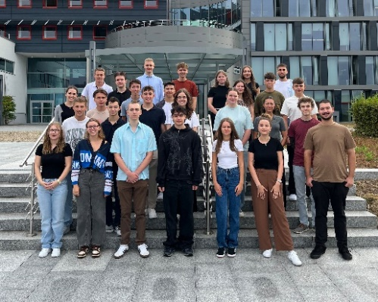Source: Würth Elektronik  31 new talents: Würth Elektronik starts training year with great success. | 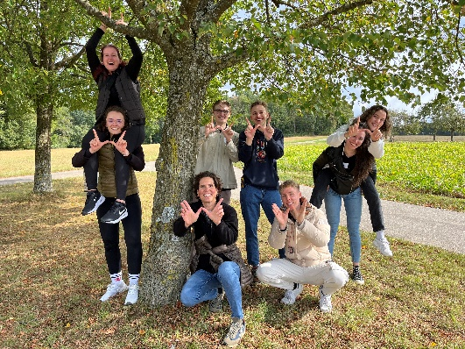  Source: Würth Elektronik  W for Würth Elektronik: The Young Talents 2024 start their training with motivation.

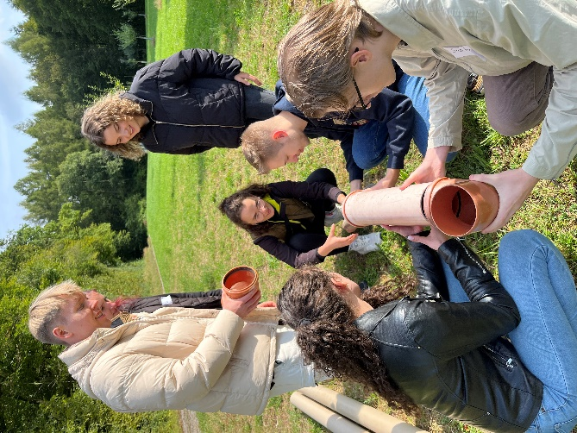Source: Würth Elektronik  Achieving more together: Würth Elektronik's Young Talent excursion was all about teamwork. |   Source: Würth Elektronik  Let's go: The professional career of 31 trainees began with an interactive welcome week.

About the Würth Elektronik eiSos Group
Würth Elektronik eiSos Group is a manufacturer of electronic and electromechanical components for the electronics industry and a technology company that spearheads pioneering electronic solutions. Würth Elektronik eiSos is one of the largest European manufacturers of passive components and is active in 50 countries. Production sites in Europe, Asia and North America supply a growing number of customers worldwide.
The product range includes EMC components, inductors, transformers, RF components, varistors, capacitors, resistors, quartz crystals, oscillators, power modules, Wireless Power Transfer, LEDs, sensors, radio modules, connectors, power supply elements, switches, push-buttons, connection technology, fuse holders and solutions for wireless data transmission. The portfolio is complemented by customized solutions.
The unrivaled service orientation of the company is characterized by the availability of all catalog components from stock without minimum order quantity, free samples and extensive support through technical sales staff and selection tools.

Würth Elektronik is part of the Würth Group, the global market leader in the development, production, and sale of fastening and assembly materials, and employs 7,900 people. In 2023, the Würth Elektronik Group generated sales of 1.24 Billion Euro.
Würth Elektronik: more than you expect!
Further information at www.we-online.com

Further information:  Würth Elektronik eiSos GmbH & Co. KG  Sarah Hurst  Clarita-Bernhard-Strasse 9  81249 Munich  Germany  Phone: +49 7942 945-5186  E-mail: sarah.hurst@we-online.de  www.we-online.com | Press contact:  HighTech communications GmbH  Brigitte Basilio  Brunhamstrasse 21  81249 Munich  Germany  Phone: +49 89 500778-20  E-mail: b.basilio@htcm.de  www.htcm.de

