PRESS RELEASE

Würth Elektronik at DLD Nature: new cooperation with the deep-tech startup Hula Earth
Working together for biodiversity with electronics and AI
Waldenburg (Germany), September 24, 2024 – “How can we counteract the decline in biodiversity?” This question was discussed extensively at DLD Nature, which took place from September 12 to 13, 2024 in Munich, Germany. At the conference and for the first time, Würth Elektronik presented in the Tech Talk with new cooperation partner, Hula Earth, a deep-tech start-up that specializes in the real-time monitoring of biodiversity. Their presentation was titled “Electronics for Innovation in Nature Protection.”
Real-time measurement data from Hula Earth forms the basis for issuing biodiversity certificates that can be credited in accordance with the CSRD (Corporate Sustainability Reporting Directive), monetizes species protection, and enables sustainable investments. Equally important is the concept of insetting, which involves optimizing operational processes in an environmentally-friendly manner and verifying these actions through concrete measurements.
For real-time measurement, Hula Earth uses solar-powered BioT sensors that continuously collect various biodiversity-relevant data and transmit it via a wireless network. This also works in remote forest areas. The results are combined with satellite data, analyzed using artificial intelligence, and integrated into a user-friendly platform.
Cooperation for a sustainable future
Würth Elektronik and Hula Earth are now working together to optimize the handmade prototypes of the BioT sensors so that they can be produced efficiently in large quantities. Würth Elektronik is supporting the startup in a variety of ways including the following:
- The component manufacturer is contributing products and expertise and provides advice in all relevant areas such as EMC safety, energy management, functionality, scalability, and energy efficiency. Many of the components previously used will be replaced with more suitable ones to ensure longevity and reliability. For example, the WSEN-HIDS humidity and temperature sensor and the ADRASTEA wireless module for wireless data traffic between sensors and an evaluation computer in the cloud will be used.
- The start-up is also receiving support with prototyping and testing. Examples of this are pre-compliance tests, in which devices are optimized so that they immediately pass the test in an accredited laboratory, saving time and costs.
- Würth Elektronik provides design-in support, including for circuit board design, interface planning, and the communication software.
“Hula Earth is a startup that tackles the problems of our time and enables real-time monitoring of biodiversity for the first time,” praised Alexander Gerfer, CTO at Würth Elektronik eiSos. “And, we are going to get involved: We take responsibility for our habitat and our future, we promote technologies that are not only innovative but also sustainable.”
Würth Elektronik has the expertise, the manpower, and the technology to drive our idea forward together,” David Schmider, CTO of Hula Earth, replies. “For us, the global player is the ideal cooperation partner in every respect”.

Available images
The following images can be downloaded from the Internet in printable quality: https://kk.htcm.de/press-releases/wuerth/
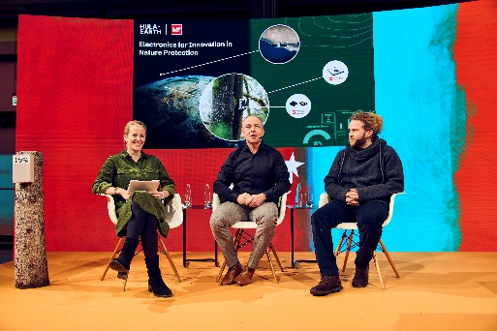  Image source: Dominik Gigler for DLD / Hubert Burda Media  Linda Hinz, Focus online Earth, Alexander Gerfer, CTO at Würth Elektronik eiSos, David Schmider, CTO at Hula Earth (from left to right) in the tech talk entitled “Electronics for Innovation in Nature Protection” during DLD Nature. | 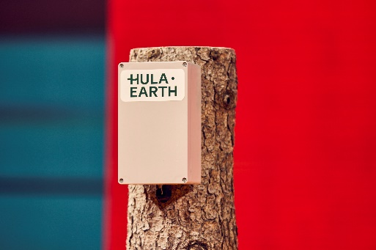  Image source: Dominik Gigler for DLD / Hubert Burda Media  Prototype of a BioT sensor: Hula Earth uses electronics and artificial intelligence to revolutionize the measurement of biodiversity.
  Image source: Dominik Gigler for DLD / Hubert Burda Media  David Schmider, CTO of Hula Earth (right) explains to the audience how the real-time measurement works and how solar-powered BioT sensors continuously collect various biodiversity-relevant data and transmit it via a wireless network. | 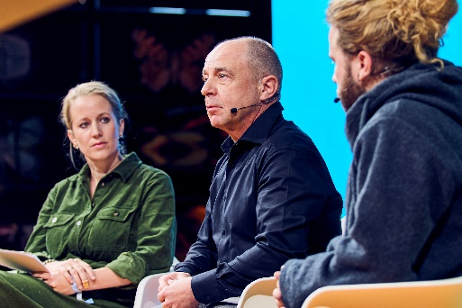  Image source: Dominik Gigler for DLD / Hubert Burda Media  Alexander Gerfer, CTO at Würth Elektronik eiSos (center): “Hula Earth is a startup that is tackling the problems of our time - and we will be joining in.”

About the Würth Elektronik eiSos Group
Würth Elektronik eiSos Group is a manufacturer of electronic and electromechanical components for the electronics industry and a technology company that spearheads pioneering electronic solutions. Würth Elektronik eiSos is one of the largest European manufacturers of passive components and is active in 50 countries. Production sites in Europe, Asia and North America supply a growing number of customers worldwide.
The product range includes EMC components, inductors, transformers, RF components, varistors, capacitors, resistors, quartz crystals, oscillators, power modules, Wireless Power Transfer, LEDs, sensors, radio modules, connectors, power supply elements, switches, push-buttons, connection technology, fuse holders and solutions for wireless data transmission. The portfolio is complemented by customized solutions.
The unrivaled service orientation of the company is characterized by the availability of all catalog components from stock without minimum order quantity, free samples and extensive support through technical sales staff and selection tools.
Würth Elektronik is part of the Würth Group, the global market leader in the development, production, and sale of fastening and assembly materials, and employs 7,900 people. In 2023, the Würth Elektronik Group generated sales of 1.24 Billion Euro.
Würth Elektronik: more than you expect!
Further information at www.we-online.com

Further information:  Würth Elektronik eiSos GmbH & Co. KG  Sarah Hurst  Clarita-Bernhard-Strasse 9  81249 Munich  Germany  Phone: +49 7942 945-5186  E-mail: sarah.hurst@we-online.de  www.we-online.com | Press contact:  HighTech communications GmbH  Brigitte Basilio  Brunhamstrasse 21  81249 Munich  Germany  Phone: +49 89 500778-20  E-mail: b.basilio@htcm.de  www.htcm.de

