PRESS RELEASE

Würth Elektronik in United States Embarks on New Milestone with State-of-the-Art Headquarters
“Construction Begins on New 70,000-Square-Foot Headquarters”
Watertown, SD (USA), May 15, 2024 – Würth Elektronik in the United States, a leading manufacturer of electronic and electromechanical components as well as custom magnetics, has announced the commencement of construction on a new 70,000-square-foot headquarters. This new facility underscores the company’s commitment to innovation and grow in the electronics industry.
The state-of-the-art building will feature an eco-friendly design, an employee fitness room, and an outdoor terrace. “The building was designed around our people, specifically with the employee experience in mind: maximized daylight accessibility, alternative workspaces, and an outdoor terrace are some of the most exciting features,” says Toby Kangas, Project Manager of the new building at Würth Elektronik. The company also plans to pursue Leadership in Energy and Environmental Design (LEED) Silver certification for the new facility, demonstrating its commitment to sustainable practices.
This investment is a testament to Würth Elektronik’s dedication to providing an employee-forward workspace for its staff and facilitating growth toward 225 employees in Watertown, nearly doubling the current staff capacity over the next 10-15 years.
As the headquarters for Würth Elektronik, the Watertown location employs various disciplines, including engineering, sales, R&D, marketing, and more. It also serves as the warehouse for both North America and South America. The company hosts an annual employee conference for a week each summer, where over 200 employees travel to Watertown from around the Americas.
“We are thrilled to embark on this exciting new milestone for our company and mark this as another step toward the completion of our Vision 2030,” said Don Rigdon, President of Würth Elektronik in the United States. “The construction of our new headquarters underscores our unwavering commitment to build loyalty with our employees, customers, and partners. This will enable us to further enhance our capabilities and deliver an exceptional employee experience.”
Co-op Architecture, from Sioux Falls, SD, USA, spearheads the design after winning a unique design competition hosted by the local Watertown business. Gray Construction, also out of Watertown, contracts the build oversight, and construction is slated to begin in May 2024, with expected completion at the end of 2025.
In conjunction with the commencement of construction, Würth Elektronik hosted a groundbreaking ceremony on April 26, open to the public. Prior to the groundbreaking ceremony, employees gathered for a farewell party, reminiscing about their experiences at the original building. During the event, employees opened a 10-year-old time capsule, enjoyed ice cream, and left their mark on the walls with memories, stories, and signatures, celebrating the past while looking forward to the future.

Available images
The following images can be downloaded from the Internet in printable quality: https://kk.htcm.de/press-releases/wuerth/
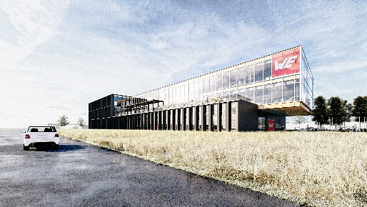Image source: Wurth Electronics  New 70,000-square-foot headquarters: commitment to innovation and grow in the electronics industry | 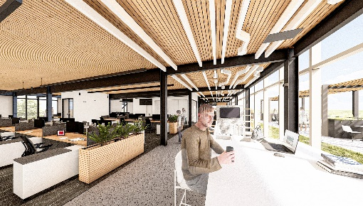Image source: Wurth Electronics  Room for expansion: employee-forward workspace

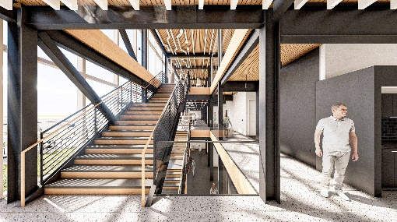Image source: Wurth Electronics  Maximized daylight accessibility: a bright future for Wurth Electronics | 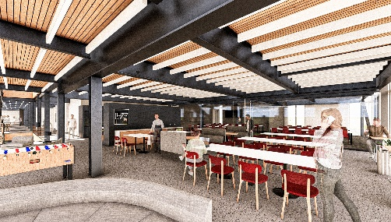  Image source: Wurth Electronics  Unwavering commitment to build loyalty: with employees, customers, and partners

About the Würth Elektronik eiSos Group
Würth Elektronik eiSos Group is a manufacturer of electronic and electromechanical components for the electronics industry and a technology company that spearheads pioneering electronic solutions. Würth Elektronik eiSos is one of the largest European manufacturers of passive components and is active in 50 countries. Production sites in Europe, Asia and North America supply a growing number of customers worldwide.
The product range includes EMC components, inductors, transformers, RF components, varistors, capacitors, resistors, quartz crystals, oscillators, power modules, Wireless Power Transfer, LEDs, sensors, radio modules, connectors, power supply elements, switches, push-buttons, connection technology, fuse holders and solutions for wireless data transmission. The portfolio is complemented by customized solutions.
The unrivaled service orientation of the company is characterized by the availability of all catalog components from stock without minimum order quantity, free samples and extensive support through technical sales staff and selection tools.
Würth Elektronik is part of the Würth Group, the global market leader in the development, production, and sale of fastening and assembly materials, and employs 7,900 people. In 2023, the Würth Elektronik Group generated sales of 1.24 Billion Euro.
Würth Elektronik: more than you expect!
Further information at www.we-online.com

Further information:  Wurth Electronics Midcom, Inc.  Amelia Thompson  121 Airport Drive  PO Box 1330  Watertown, SD 57201 USA  Phone: +1 605 886 4385  Toll-free (in the U.S.):  Phone: +1 800 643 2661  E-mail: amelia.thompson@we-online.com  www.we-online.com | Press contact:  HighTech communications GmbH  Brigitte Basilio  Brunhamstrasse 21  81249 Munich  Germany  Phone: +49 89 500778-20  E-mail: b.basilio@htcm.de  www.htcm.de

