PRESS RELEASE

Würth Elektronik Thailand: The company opens its 33rd branch office
Office in the heart of Southeast Asia
Waldenburg (Germany), September 17, 2024 - On August 14, the first Thai Würth Elektronik eiSos branch was opened in the Rama 9 business center in Bangkok. This gives the up-and-coming Asian business a secure base and new impetus for growth.
“We are located in the geographical center of an economic area that analysts agree has a great future ahead of it,” said Würth Elektronik eiSos CTO Alexander Gerfer in his speech, summing up the advantages of the location. “The very positive market and business development here was the reason for us to establish our own local base in Bangkok for the entire Thailand business.”
The new location in the heart of the vibrant business district has excellent public transport connections.
Würth Elektronik's corporate history in Thailand began back in 2006 - with the support of the Würth Elektronik eiSos team in Singapore. The first Field Sales Engineer was then hired in September 2010. The Thailand business developed extremely positively. Würth Elektronik employs 13 people.
Solid distribution base
Under the leadership of Regional Sales Manager Chantwut Zukzwang, General Manager Sebastian Tan and thirteen employees are now driving Würth Elektronik's Thailand business forward. The new location can already rely on a stable sales base that also includes major EMS customers.
“Würth Elektronik is a very special employer,” said Zukzwang, ”the family-owned company's consistently customer-centric business concept is internationally successful, and we will ensure that passive components and Würth Elektronik's unparalleled service turn ideas into market-ready products in Thailand as well.”
CTO Gerfer thanked the founding team for their successful development work and even brought a gift: the screen print “Realizeaction” by Portuguese artist José de Guimarães, known for his intense symbolism and bold colors. With this print, we hope to bring a touch of this inspiration to our new team in Thailand. May it serve as a reminder to keep our vision bold and our actions impactful as we begin this new chapter together.

Available images
The following images can be downloaded from the Internet in printable quality: https://kk.htcm.de/press-releases/wuerth/
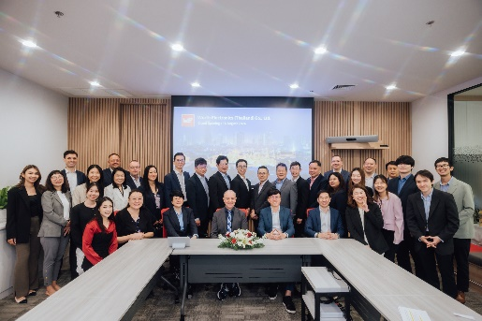  Image source: Würth Elektronik  A spirit of new beginnings: Würth Elektronik eiSos Thailand branch opens in Bangkok | 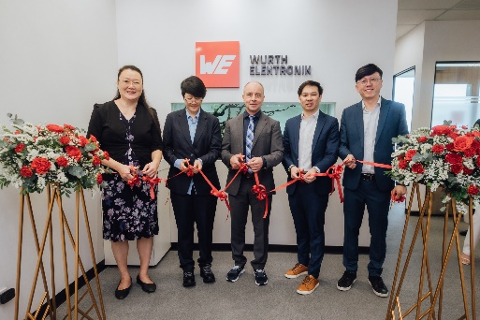  Image source: Würth Elektronik  CTO Alexander Gerfer among the founding team: “Very positive market and business development.”

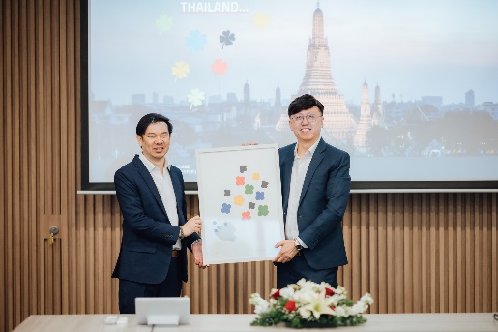
Image source: Würth Elektronik
Creative gift: screen print “Realizeaction” by Portuguese artist José de Guimarães

About the Würth Elektronik eiSos Group
Würth Elektronik eiSos Group is a manufacturer of electronic and electromechanical components for the electronics industry and a technology company that spearheads pioneering electronic solutions. Würth Elektronik eiSos is one of the largest European manufacturers of passive components and is active in 50 countries. Production sites in Europe, Asia and North America supply a growing number of customers worldwide.
The product range includes EMC components, inductors, transformers, RF components, varistors, capacitors, resistors, quartz crystals, oscillators, power modules, Wireless Power Transfer, LEDs, sensors, radio modules, connectors, power supply elements, switches, push-buttons, connection technology, fuse holders and solutions for wireless data transmission. The portfolio is complemented by customized solutions.
The unrivaled service orientation of the company is characterized by the availability of all catalog components from stock without minimum order quantity, free samples and extensive support through technical sales staff and selection tools.
Würth Elektronik is part of the Würth Group, the global market leader in the development, production, and sale of fastening and assembly materials, and employs 7,900 people. In 2023, the Würth Elektronik Group generated sales of 1.24 Billion Euro.
Würth Elektronik: more than you expect!
Further information at www.we-online.com

Further information:  Würth Elektronik eiSos GmbH & Co. KG  Sarah Hurst  Clarita-Bernhard-Strasse 9  81249 Munich  Germany  Phone: +49 7942 945-5186  E-mail: sarah.hurst@we-online.de  www.we-online.com | Press contact:  HighTech communications GmbH  Brigitte Basilio  Brunhamstrasse 21  81249 Munich  Germany  Phone: +49 89 500778-20  E-mail: b.basilio@htcm.de  www.htcm.de

