PRESS RELEASE

Würth Elektronik at Smart Green Island Makeathon 2024
The Practical Pioneers of Gran Canaria
Waldenburg (Germany), March 18, 2024 – A special kind of educational event was staged in Gran Canaria from February 28 to March 2, 2024. Several teams of students generated innovative solutions and built technological prototypes within a short period of time. These next generation of developers were supported with Würth Elektronik components and expertise.
Where others go on vacation, young talents from various universities hatched innovative solutions for industry in smart farming, smart green energy and mobility, smart automation, IoT, robotics, smart production, smart shipping, and the circular economy.
The Makeathon 2024 focused on practical aspects, in which each team had to come up with a solution to a specific problem and then develop and build a prototype. Over 600 participants formed 24 teams from 29 countries took part in the challenge. The partner companies provided the necessary equipment.
In the seminar “Get the right Voltage: Understand and Setup your Power Supply with Stepdown Converters”, the Makeathon participants were not only provided with the familiar Würth tools, but also with components from the Würth Elektronik eiSos Group, as well as relevant knowledge. The company supported the event with two experienced members of staff.
“The guiding principle of the Makeathon is ‘hands-on’. So of course we’re part of it,” stresses Alexander Gerfer, CTO at Würth Elektronik eiSos. “True to our ‘Creating Together’ mission, we supported this innovative event with expertise and components. Implementation of new ideas takes a reliable partner, so we’re happy to offer our services – as well as to inspire young talents in choosing a career at Würth Elektronik of course. In our efforts to preserve or even improve our living space, everyone has to pitch in. Or putting it in today’s language: Making things happen is like learning – only it takes it to the next level.”

Available images
The following images can be downloaded from the Internet in printable quality: https://kk.htcm.de/press-releases/wuerth/

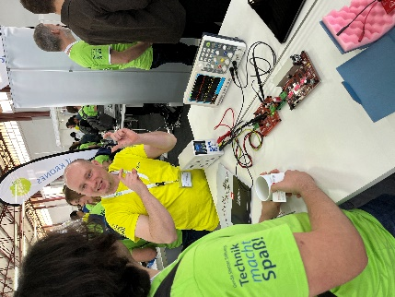  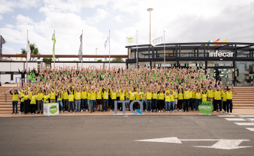Image source: ITQ GmbH  Makeathon 2024: Over 600 participants from 29 countries came together in 24 teams in Gran Canaria to develop innovative solutions and prototypes. | Image source: Würth Elektronik  Competent support: Max Schmenger, Field Application Engineer at Würth Elektronik eiSos, was on hand to provide the participants with help and advice.

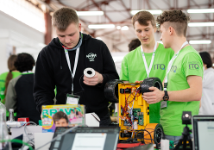  Image source: ITQ GmbH  Equipment for practical pioneers: The young designers were supported with the familiar Würth tools and components from the Würth Elektronik eiSos Group. | 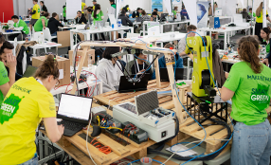  Image source: ITQ GmbH  Hands-on in Gran Canaria: Designing and building prototypes was also part of Makeathon 2024.

About the Würth Elektronik eiSos Group
Würth Elektronik eiSos Group is a manufacturer of electronic and electromechanical components for the electronics industry and a technology company that spearheads pioneering electronic solutions. Würth Elektronik eiSos is one of the largest European manufacturers of passive components and is active in 50 countries. Production sites in Europe, Asia and North America supply a growing number of customers worldwide.
The product range includes EMC components, inductors, transformers, RF components, varistors, capacitors, resistors, quartz crystals, oscillators, power modules, Wireless Power Transfer, LEDs, sensors, radio modules, connectors, power supply elements, switches, push-buttons, connection technology, fuse holders and solutions for wireless data transmission. The portfolio is complemented by customized solutions.
The unrivaled service orientation of the company is characterized by the availability of all catalog components from stock without minimum order quantity, free samples and extensive support through technical sales staff and selection tools.
Würth Elektronik is part of the Würth Group, the global market leader in the development, production, and sale of fastening and assembly materials, and employs 7,900 people. In 2023, the Würth Elektronik Group generated sales of 1.24 Billion Euro.
Würth Elektronik: more than you expect!
Further information at www.we-online.com

Further information:  Würth Elektronik eiSos GmbH & Co. KG  Sarah Hurst  Clarita-Bernhard-Strasse 9  81249 Munich  Germany  Phone: +49 7942 945-5186  E-mail: sarah.hurst@we-online.de  www.we-online.com | Press contact:  HighTech communications GmbH  Brigitte Basilio  Brunhamstrasse 21  81249 Munich  Germany  Phone: +49 89 500778-20  E-mail: b.basilio@htcm.de  www.htcm.de

