PRESS RELEASE

Würth Elektronik at the embedded world 2024
Components and service for optimal use
9–11 April 2024
Hall 2, Stand 110
Waldenburg (Germany), March 6, 2024 – The Würth Elektronik eiSos Group is taking part of the embedded world exhibition in Nuremberg from 9 through 11 of April 2024. Occupying the 200m² Stand #110 in Hall 2, the company will be presenting components from all its divisions, not only including electronic and electromechanical components, but also the Wireless Connectivity and Sensors division, which are particularly interesting for IoT solutions. The presentation focuses on components, and also on the comprehensive spectrum of dedicated services Würth Elektronik has to offer; including design-in support.
At the embedded world 2024 exhibition, Würth Elektronik will be showcasing all divisions to present itself as a service-orientated partner for developers. Its partnership with IC suppliers will also be discussed as two semiconductor manufacturers will be on hand on the booth each day of the exhibition to present reference designs in cooperation with Würth Elektronik.
Exhibition highlights
Brand-new products include the WL-ICLED RGB LEDs with integrated circuits (IC). These pixel-controlled components combine red, green, and blue LED chips and a pre-programmed IC. SMT-capable digital isolators for signal transmission applications up to 150 Mbps will also be displayed to the public for the first time. Other product highlights include the WE-MAPI, WE-HEPC, and WE-XHMI high-temperature power inductors, and the WE-BMS transformer for battery-management systems. Further eye-catching points of the presentation will be the WRIS-RSKS thick-film resistors, whose high degree of sulfur resistance making them ideal for industrial applications. Additionally, in the area of mechanical components, the lead-free SMT spacers make it considerably easier to manufacture stacked circuit boards. Also shown will be four new series of products in the portfolio of durable aluminium hybrid polymer capacitors.
Because the IQD Frequency Products company is a co-exhibitor this year, further attention-drawing products include quartz crystals and oscillators. This Würth Elektronik eiSos Group affiliate will be presenting a series of quartz crystals embedded in 4-pad SMT ceramic cases with an extended operating-temperature range from -40°C to 125°C.
The service area also has a novel feature to present: The REDEXPERT online simulation tool; now expanded with the MagI³C power module designer feature, which enables the swift and simple integration of a power module into an application without the need for specialist DC/DC converter skills.
Conference paper on EMC
The company’s resident EMC expert, Dr. Heinz Zenkner, will also make Würth Elektronik’s special contribution at the embedded world conference. The paper, titled “EMC Compliant Industrial Electronic Design“, will be presented on April 11, 2024 from 9:30am to 1:00pm. This technical article discusses interface electronics and EMC filter concepts that suppress both transient interferences as well as interference emissions at frequencies above 1 GHz.
“We see ourselves as the developer’s partner of choice, and not only do we deliver components ex stock without minimum order volumes, we also provide tools like REDEXPERT and personal support right from the circuit design stage, to help create high-quality and sustainable products hand in hand with our customers. This is why we attach such great importance to service and support,” says Alexander Gerfer, CTO of the Würth Elektronik eiSos Group, describing the thematic orientation of the company’s embedded world presentation.
April 11 2024 is Student Day at the exhibition, and here, Würth Elektronik will be offering a special programme. Information and registration options can be retrieved at the following link: https://www.we-online.com/en/news-center/events/student-day
Aside from its presence at the exhibition stand, Würth Elektronik will have its Show Truck in attendance. Located in the Exhibition Park, this will be a further popular venue for talks and encounters.

Available images
The following images can be downloaded from the Internet in printable quality: https://kk.htcm.de/press-releases/wuerth/
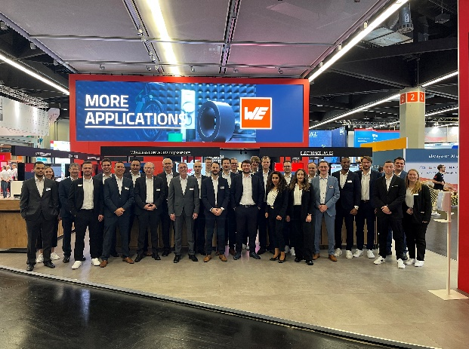
Image source: Würth Elektronik
The Würth Elektronik team looks forward to interesting encounters at the embedded world exhibition stand.

About the Würth Elektronik eiSos Group
Würth Elektronik eiSos Group is a manufacturer of electronic and electromechanical components for the electronics industry and a technology company that spearheads pioneering electronic solutions. Würth Elektronik eiSos is one of the largest European manufacturers of passive components and is active in 50 countries. Production sites in Europe, Asia and North America supply a growing number of customers worldwide.
The product range includes EMC components, inductors, transformers, RF components, varistors, capacitors, resistors, quartz crystals, oscillators, power modules, Wireless Power Transfer, LEDs, sensors, radio modules, connectors, power supply elements, switches, push-buttons, connection technology, fuse holders and solutions for wireless data transmission. The portfolio is complemented by customized solutions.
The unrivaled service orientation of the company is characterized by the availability of all catalog components from stock without minimum order quantity, free samples and extensive support through technical sales staff and selection tools.
Würth Elektronik is part of the Würth Group, the global market leader in the development, production, and sale of fastening and assembly materials, and employs 7,900 people. In 2023, the Würth Elektronik Group generated sales of 1.24 Billion Euro.
Würth Elektronik: more than you expect!
Further information at www.we-online.com

Further information:  Würth Elektronik eiSos GmbH & Co. KG  Sarah Hurst  Clarita-Bernhard-Strasse 9  81249 Munich  Germany  Phone: +49 7942 945-5186  E-mail: sarah.hurst@we-online.de  www.we-online.com | Press contact:  HighTech communications GmbH  Brigitte Basilio  Brunhamstrasse 21  81249 Munich  Germany  Phone: +49 89 500778-20  E-mail: b.basilio@htcm.de  www.htcm.de

