PRESS RELEASE

Würth Elektronik Partners with Gator Motorsports as a Key Partner of UFSAE Student Chapter
To support young engineers: high-quality components for free
Watertown (USA), February 8, 2024 – Würth Elektronik, a leading global provider of electronic and electromechanical components, is proud to announce its partnership with Gator Motorsports, the University of Florida's Society of Automotive Engineers (UFSAE) student chapter. As a partner, Würth Elektronik is supporting UFSAE in its objective to design and build a high-performance electric racecar for international collegiate competitions.
UFSAE is a dynamic organization comprising interdisciplinary students who collaborate to create a cutting-edge Electric Formula-style racecar. Throughout the year, team members meticulously design, test, and manufacture nine different essential systems for the vehicle, including aerodynamics, suspension, chassis, brakes, drivetrain, cockpit, electrical hardware, firmware, and accumulator. Their goal is to maximize the performance, reliability, and safety of the racecar with a cost-effective approach.
In the 2022–2023 season, Gator Motorsports faced the challenging task of transitioning to an electric powertrain and tractive system. During this season, the team competed in the FSAE Electric competition for the first time. Although the car did not participate in dynamic events, Gator Motorsports achieved a commendable 25th place out of 68 teams in the competition, with an impressive 13th place ranking in the design aspect.
Gator Motorsports, established in 1991, has a rich history of competing annually at the Michigan International Speedway in Brooklyn, Michigan, in the FSAE Electric Collegiate Design Competition. This competition is a proving ground for innovation and engineering excellence, and Gator Motorsports has consistently demonstrated its commitment to pushing the boundaries of electric vehicle technology.
Melissa Hansen, Customer Outreach Specialist at Würth Elektronik, expressed her enthusiasm for supporting student-run organizations, stating, "Würth Elektronik takes pride in backing student-run organizations. A team like Gator Motorsports fits right into our niche of e-mobility and transforming the future."
As part of their partnership, Würth Elektronik is providing Gator Motorsports with free samples upon request. This partnership underscores Würth Elektronik's commitment to fostering innovation in the field of electric vehicle technology and empowering the next generation of engineers.

Available images
The following images can be downloaded from the Internet in printable quality: https://kk.htcm.de/press-releases/wuerth/
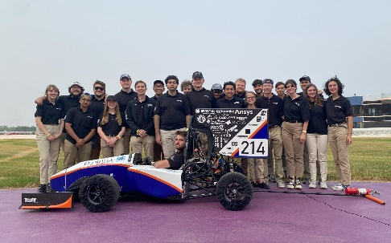  Image source: Wurth Electronics  Gator Motorsports, a FSAE team supported by Würth Elektronik. | 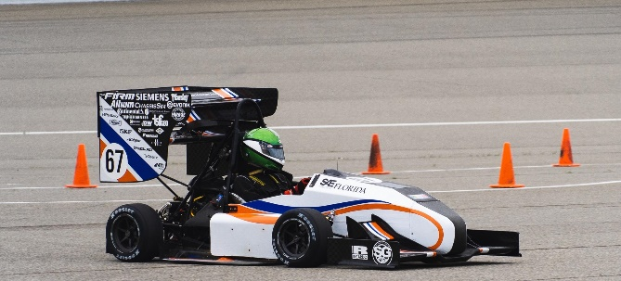  Image source: Wurth Electronics  Würth Elektronik is supporting UFSAE in its objective to design and build a high-performance electric racecar for international collegiate competitions.

About the Würth Elektronik eiSos Group
Würth Elektronik eiSos Group is a manufacturer of electronic and electromechanical components for the electronics industry and a technology company that spearheads pioneering electronic solutions. Würth Elektronik eiSos is one of the largest European manufacturers of passive components and is active in 50 countries. Production sites in Europe, Asia and North America supply a growing number of customers worldwide.
The product range includes EMC components, inductors, transformers, RF components, varistors, capacitors, resistors, quartz crystals, oscillators, power modules, Wireless Power Transfer, LEDs, sensors, radio modules, connectors, power supply elements, switches, push-buttons, connection technology, fuse holders and solutions for wireless data transmission. The portfolio is complemented by customized solutions.
The unrivaled service orientation of the company is characterized by the availability of all catalog components from stock without minimum order quantity, free samples and extensive support through technical sales staff and selection tools.
Würth Elektronik is part of the Würth Group, the global market leader in the development, production, and sale of fastening and assembly materials, and employs 7,900 people. In 2023, the Würth Elektronik Group generated sales of 1.24 Billion Euro.
Würth Elektronik: more than you expect!
Further information at www.we-online.com

Further information:  Wurth Electronics Midcom, Inc.  Amelia Thompson  121 Airport Drive  PO Box 1330  Watertown, SD 57201 USA  Phone: +1 605 886 4385  Toll-free (in the U.S.):  Phone: +1 800 643 2661  E-mail: amelia.thompson@we-online.com  www.we-online.com | Press contact:  HighTech communications GmbH  Brigitte Basilio  Brunhamstrasse 21  81249 Munich  Germany  Phone: +49 89 500778-20  E-mail: b.basilio@htcm.de  www.htcm.de

