PRESS RELEASE

Würth Elektronik expands the capabilities of its online design platform REDEXPERT
REDEXPERT accounts for DC bias losses in inductors
Waldenburg (Germany), January 19, 2024 – Würth Elektronik’s online design platform, REDEXPERT, known as having the most accurate ac losses for power inductors under operating conditions, now includes the effects of dc bias on the ac losses. It is a well-established but little understood fact that ac core losses increase when the ac ripple is dc biased. This is the normal operating condition for power converters like the buck regulator.
Normal intuition says that dc bias does not increase ac cores losses because it is a static shift. However, those who have experienced unexpected temperature rise and investigated, have found that the dc bias does in fact change the core’s ac losses. This can be understood by realizing the minor BH loop from the ac ripple follows along the general form of the major BH loop. The permeability and hence inductance are proportional to the slope of the curves. As the minor loop move closer towards saturation, the minor loop’s slope decreases. This decreases inductance resulting in increased ripple current. With the decreased slope and the BH loop becomes elongated, meaning more losses. Thus, as dc bias is increased, the inductance will eventually start to decrease as it moves towards saturation which will in turn increase the ripple and the ac losses. The minor BH loop representing the hysteresis losses increases. REDEXPERT now includes this small but significant change for even more accurate ac losses.

Available images
The following images can be downloaded from the Internet in printable quality: https://kk.htcm.de/press-releases/wuerth/

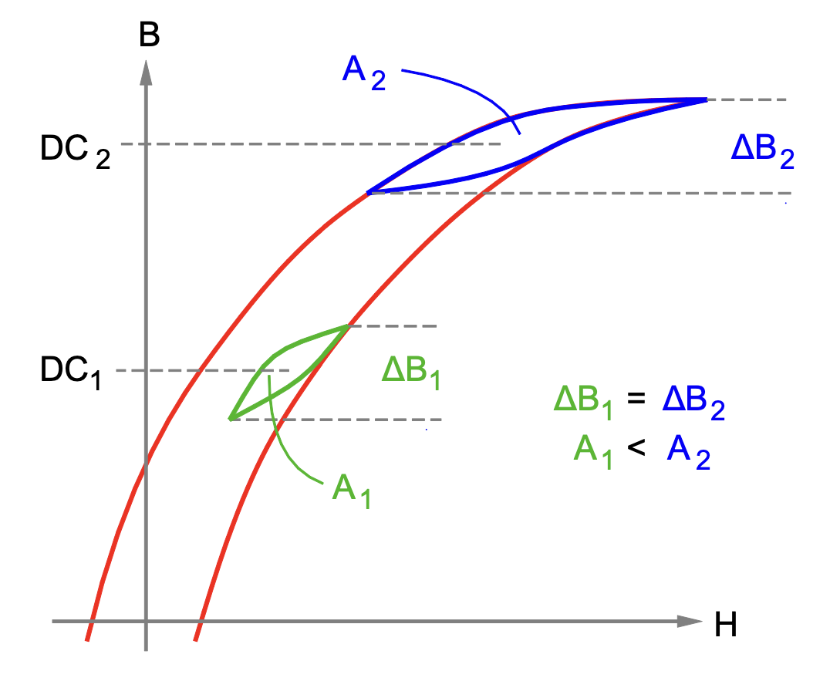Image source: Würth Elektronik
Delta flux B is the same at different dc bias levels, but the loop areas differ resulting in a change of losses.

About the Würth Elektronik eiSos Group
Würth Elektronik eiSos Group is a manufacturer of electronic and electromechanical components for the electronics industry and a technology company that spearheads pioneering electronic solutions. Würth Elektronik eiSos is one of the largest European manufacturers of passive components and is active in 50 countries. Production sites in Europe, Asia and North America supply a growing number of customers worldwide.
The product range includes EMC components, inductors, transformers, RF components, varistors, capacitors, resistors, quartz crystals, oscillators, power modules, Wireless Power Transfer, LEDs, sensors, radio modules, connectors, power supply elements, switches, push-buttons, connection technology, fuse holders and solutions for wireless data transmission. The portfolio is complemented by customized solutions.
The unrivaled service orientation of the company is characterized by the availability of all catalog components from stock without minimum order quantity, free samples and extensive support through technical sales staff and selection tools.
Würth Elektronik is part of the Würth Group, the global market leader in the development, production, and sale of fastening and assembly materials, and employs 8,200 people. In 2022, the Würth Elektronik Group generated sales of 1.33 Billion Euro.
Würth Elektronik: more than you expect!
Further information at www.we-online.com

Further information:  Würth Elektronik eiSos GmbH & Co. KG  Sarah Hurst  Clarita-Bernhard-Strasse 9  81249 Munich  Germany  Phone: +49 7942 945-5186  E-mail: sarah.hurst@we-online.de  www.we-online.com | Press contact:  HighTech communications GmbH  Brigitte Basilio  Brunhamstrasse 21  81249 Munich  Germany  Phone: +49 89 500778-20  E-mail: b.basilio@htcm.de  www.htcm.de

