PRESS RELEASE
Digital WE Days 2023 - Virtual Conference:
Online Expert Knowledge Returns to the Virtual Stage
Waldenburg (Germany), December 5, 2023 – For a fifth time, the Digital WE Days Conference brought in-depth, first-hand electronics expertise to the screen. Over 4,300 participants from all over the world this year benefited from the know-how of recognized specialists from Würth Elektronik and its partner companies. The recorded event can be accessed anytime from the online Würth Elektronik Video Center.
“The fifth staging of the Digital WE Days - Virtual Conference was a complete success,” says Alexander Gerfer, CTO at Würth Elektronik eiSos. “We’ve continuously developed and improved the format since it was first staged three years ago. Digital WE Days is now an important part of our service strategy. The latest record attendance shows that top-flight first-hand technical knowledge is on offer.”
Customer service through knowledge transfer
Over four days, experts from Würth Elektronik and its partner companies, including Rohde&Schwarz, KDPOF (Knowledge Development for Plastic Optical Fibres), STMicroelectronics, and Texas Instruments, presented a varied program with 31 online lectures on topics including EMC, power management and electromechanics, wireless power, and optoelectronics. In supplementary, interactive Q&A sessions, the participants had the chance to delve deeper into the knowledge presented.
The event demonstrates that Würth Elektronik is far more than just a manufacturer of passive components. Moreover, customers are supported proactively in their development work, not only with complimentary lab samples, but with free, ongoing transfer of knowledge. This is how Würth Elektronik actively helps turn ideas into innovations.
Online and offline go hand in hand
The latest participation record underlines that even after the pandemic, online conferences are a contemporary format in which valuable specialist knowledge can be imparted in an environmentally sustainable manner, and without the stress of traveling. Combined with face-to-face gatherings, digital events such as the Digital WE Days are part of Würth Elektronik’s all-round service package.
Accessible any time in the Video Center
For those unable to attend the Digital WE Days live, the recordings of the presentations are available on YouTube:
Digital WE Days 2023 – YouTube
The presentations can also be download from the Würth Elektronik Video Center:
Video Center | From EMC to PCB Design (we-online.com)

Available images
The following images can be downloaded from the Internet in printable quality: https://kk.htcm.de/press-releases/wuerth/
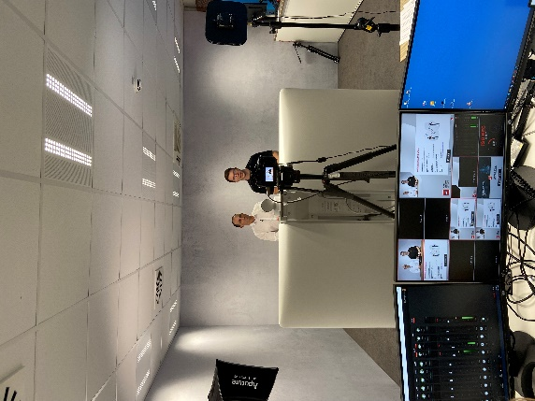  Image source: Würth Elektronik  In-depth electronics knowledge from the video studio: The Digital WE Days – Virtual Conference was held for the fifth time. | 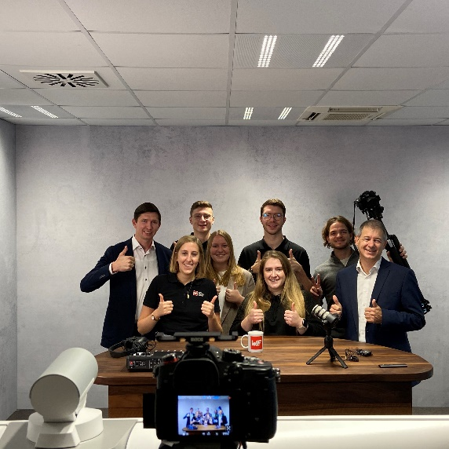  Image source: Würth Elektronik  Record for the Online Team: Over 4,300 participants from all over the world this year benefited from Würth Elektronik’s information offering.

About the Würth Elektronik eiSos Group
Würth Elektronik eiSos Group is a manufacturer of electronic and electromechanical components for the electronics industry and a technology company that spearheads pioneering electronic solutions. Würth Elektronik eiSos is one of the largest European manufacturers of passive components and is active in 50 countries. Production sites in Europe, Asia and North America supply a growing number of customers worldwide.
The product range includes EMC components, inductors, transformers, RF components, varistors, capacitors, resistors, quartz crystals, oscillators, power modules, Wireless Power Transfer, LEDs, sensors, radio modules, connectors, power supply elements, switches, push-buttons, connection technology, fuse holders and solutions for wireless data transmission.
The unrivaled service orientation of the company is characterized by the availability of all catalog components from stock without minimum order quantity, free samples and extensive support through technical sales staff and selection tools.
Würth Elektronik is part of the Würth Group, the global market leader in the development, production, and sale of fastening and assembly materials, and employs 8,200 people. In 2022, the Würth Elektronik Group generated sales of 1.33 Billion Euro.
Würth Elektronik: more than you expect!
Further information at www.we-online.com

Further information:  Würth Elektronik eiSos GmbH & Co. KG  Sarah Hurst  Clarita-Bernhard-Strasse 9  81249 Munich  Germany  Phone: +49 7942 945-5186  E-mail: sarah.hurst@we-online.de  www.we-online.com | Press contact:  HighTech communications GmbH  Brigitte Basilio  Brunhamstrasse 21  81249 Munich  Germany  Phone: +49 89 500778-20  E-mail: b.basilio@htcm.de  www.htcm.de

